SSEC/CIMSS 3D Winds:
Measured from hyperspectral IR sounders and simulated from model grids

PI: David Santek
07 September 2023

Overview
For more than a decade, the Space Science and Engineering Center (SSEC) and the Cooperative Institute for Meteorological Satellite Studies at the University of Wisconsin-Madison have investigated the derivation and evaluation of 3D winds through grants from NASA, NOAA, and internal funding. Here, 3D winds are defined as motion vectors derived from tracking features on pressure surfaces, resulting in a vertical and spatial distribution of wind information. These features are typically tropospheric moisture and stratospheric ozone (retrieved from hyperspectral IR sounder data) and humidity fields from model reanalyses and nature runs. The terms winds and Atmospheric Motion Vectors (AMVs) are used interchangeably.

The following sections provide examples and results of several sensors and grids, using a heritage winds algorithm developed and maintained at SSEC/CIMSS over more than two decades. We are in the process of evaluating WindFlow (Vandal et al. 2022), a machine learning-based system for feature tracking atmospheric motion using optical flow, for use in several projects where high-density winds and expanded geographic coverage are needed.

- Hyperspectral IR retrieval winds: AIRS, CrIS, IASI
- Multispectral microwave retrieval winds: MIRS
- Nature Run and simulated winds: GEOS-5, ECO1280
- Reanalysis simulated winds: ERA5
The validation and evaluation of the 3D winds were done with comparisons to rawinsondes, ERA5 reanalysis, Aeolus, and other AMV sources. In addition, model impact experiments were run using the GEOS-5 and GFS.
Table of Contents
SSEC/CIMSS 3D Winds: 1
Overview 1
AIRS retrieval winds 2
CrIS retrieval winds 10
IASI retrieval winds 13
MIRS retrieval winds 15
GEOS-5 Nature Run simulated winds 19
ECO1280 Nature Run simulated winds 20
ERA5 reanalysis simulated winds 22
A machine learning optical flow system for generating AMVs 23
References 25

AIRS retrieval winds

For more than 20 years, polar winds from the Moderate Resolution Imaging Spectroradiometer (MODIS) imagery have been generated by NOAA CIMSS. The MODIS polar winds product is composed of both infrared window (IR) and water vapor (WV) tracked features. The WV AMVs yield a better spatial distribution than the IR since both cloud and clear-sky features can be tracked in the WV images.

The JPSS era of satellites with the VIIRS instrument has no WV channel, resulting in a data gap with only IR-derived AMVs possible. This scenario provided an opportunity to evaluate hyperspectral infrared moisture retrievals from consecutive overlapping satellite polar passes to extract atmospheric motion from clear-sky regions on constant (and known) pressure surfaces; i.e., estimating winds in retrieval space rather than radiance space. This method provides vertical wind profiles (3D winds), as opposed to the MODIS-derived single-level AMVs.

The winds algorithm was applied to AIRS moisture retrievals from the Aqua satellite. An example over the Arctic is shown in Figure 1. The resulting winds were assimilated into NASA’s GEOS-5 model. The results are encouraging, as the AIRS retrieval polar AMVs have a similar quality as the MODIS AMVs and exhibit a positive impact in the global Day 4.5 to 6.5 forecasts for a one-month experiment in July 2012.
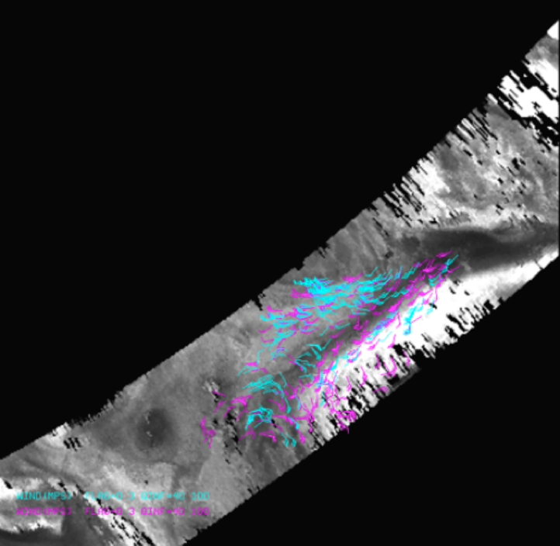
Figure 1: AIRS retrieval AMVs over a 400 hPa AIRS retrieved moisture field from 20 July 2012 0551 UTC. The North Pole is in the center of the picture, with Greenland in the lower left region (not visible). These wind barbs are all moisture- and ozone-tracked AMVs color-coded by pressure level: cyan 400 to 700 hPa; magenta above 400 hPa.
Comparison of AIRS AMVs to MODIS AMVs
For the 14 June to 13 July 2012 time period, 650 wind sets were generated resulting in 164,000 AIRS moisture and 135,000 ozone AMVs. During that same time, nearly 3 million Aqua MODIS winds were generated. To compare co-located vectors from AIRS and MODIS AMVs, the following criteria were used:
- Located within 25 km
- Assigned pressure level within 15 hPa

This resulted in approximately 25,000 matches, or only 8% of the total AIRS winds. This percentage is low for two reasons: the AIRS AMVs are distributed vertically while the MODIS AMVs are at a single level at a specific geographic region and the AIRS dataset contains winds in the stratosphere. Figure 2 depicts the distribution of the speed difference between the 25,000 matched AIRS and MODIS AMVs for the northern hemisphere summer. There is no bias (mean difference is -0.06 ms⁻¹) in this approximately Gaussian distribution.
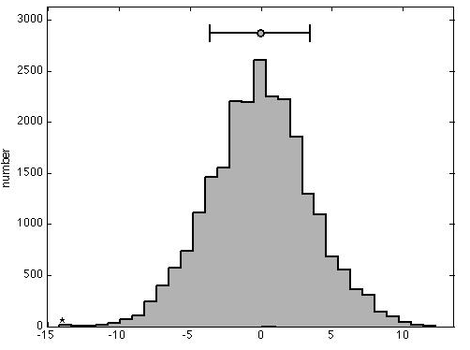
Figure 2. Histogram of the speed difference between co-located Aqua MODIS and AIRS retrieval AMVs for a northern hemisphere summer case: 14 June to 31 July 2012. Mean=-0.06 ms-¹; Standard Deviation=3.54 ms⁻¹.

These results are encouraging, as:
- The MODIS and AIRS co-located AMVs are similar and without a bias. The standard deviation of the speed difference was expected to be several meters per second, due to the different spatial resolution (1 km for MODIS vs. 13.5 km for AIRS).
- Only 8% of the MODIS and AIRS AMVs are co-located within 25 km and 15 hPa, therefore the AIRS AMVs should provide additional observations over the MODIS-only dataset.

Evaluation of AIRS AMVs in the GEOS-5
The GEOS-5 was run on the NASA Center for Climate Simulation (NCCS) ‘discover’ system, with these features and configuration:
- Gridpoint Statistical Interpolation (GSI) analysis at ½° resolution with 72 vertical levels
- 3DVar
- 6-h assimilation cycle
- 7-day forecasts, adjoint-based 24h observations
- Impacts at 0000 UTC (dry energy norm, sfc-150 hPa)
Three experiments were run for a northern hemisphere summer time period (14 June – 31 July 2012). The input AIRS AMVs were from 103 to 201 hPa (ozone) and 359 to 616 hPa (moisture):
- Control: The Control run contained all of the standard data sources, including the MODIS IR and WV AMVs.
- Exp. 1 (AIRS AMVs): Exp. 1 was run identically to the Control, with the addition of the AIRS moisture and ozone AMVs. This allowed the incremental impact due to the addition of AIRS winds to be highlighted, as all other data sources remained constant.
- Exp. 2 and 3 had different configurations, but will not be discussed here.
Assimilation Impact
The measure of how well the AIRS AMVs were assimilated in the GEOS-5 was to compare the winds with the GEOS-5 background and analysis fields. Figure 3 depicts the moisture AMV speed departure from the northern hemisphere background (blue) and northern hemisphere analysis (yellow). Since there is very little moisture in the southern hemisphere during winter (green and red curves), they were not considered for this time period. However, the results of the northern hemisphere analysis are favorable:
- The distribution bias of the speed departure is small (approximately 0.2 ms⁻¹), and
- The standard deviation was reduced from 3.2 (background) to 3.0 ms⁻¹ (analysis), indicating that the AIRS AMVs that were assimilated had a beneficial impact on the analysis.
The impact per observation (Figure 4) is very good for the AIRS moisture AMVs, as they are ranked higher than all other satellite-derived wind datasets. This indicates the winds are of good quality. However, the AIRS ozone AMVs have a negative impact, which is likely a result of the large speed bias.
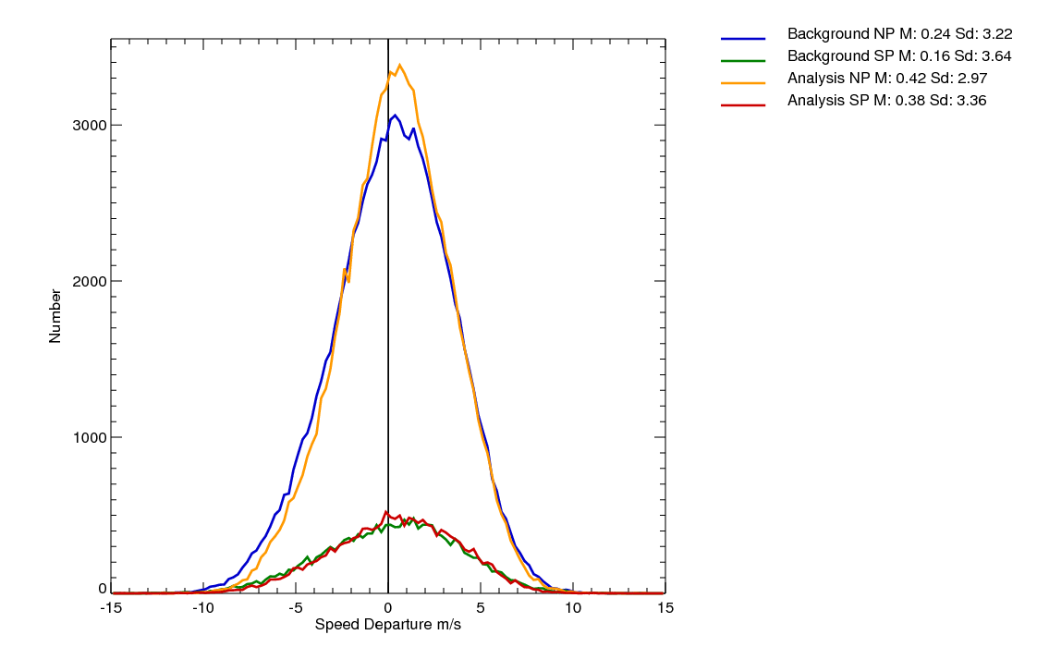
Figure 3. Distribution of speed departure for 01-29 July 2012 for the AIRS moisture AMVs. Compared to background (Arctic - blue; Antarctic - green) and analysis (Arctic - yellow; Antarctic - red).

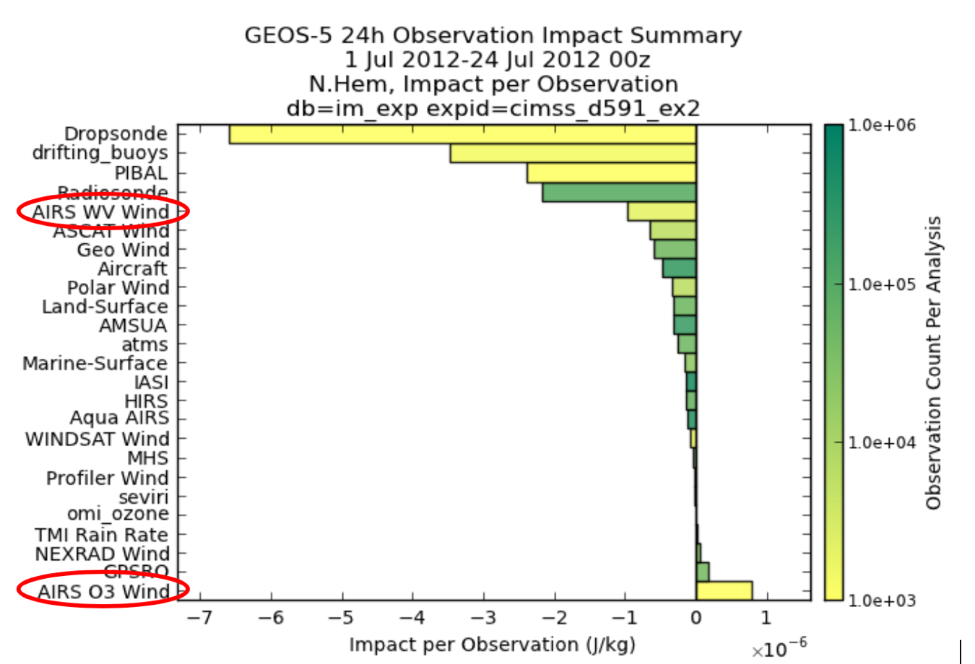
Figure 4. Impact per observation for 01-24 July 2012 0000 UTC for the AIRS WV (moisture) and O3 (ozone) AMVs.

Forecast Impact
The forecast impact was statistically neutral as measured by the ACC score for the first 24 days of July 2012. Figure 5 depicts the 500 hPa die-off curves for the control (blue) and the three experiments:
- Although not statistically significant, the addition of the AIRS AMVs (Exp. 1 in red) shows a slight improvement in the ACC score after Day 4.

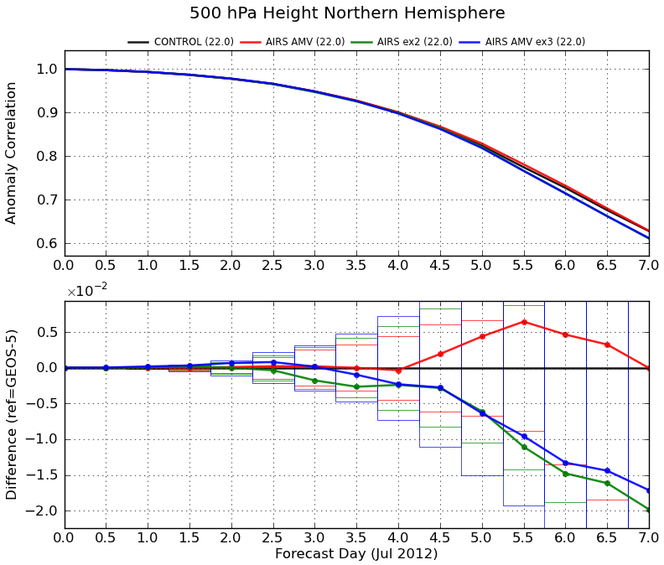
Figure 5: The 500 hPa Northern Hemisphere ACC die-off curves (top) for 1-24 July 2012 00 UTC. The control (black) and three experiments (red, green, and blue) are shown. The lower figure shows the difference between the control and the experiments. A positive difference is an improvement in the forecast; to be statistically significant, the curve must lie outside of its threshold rectangle.

Although the forecast impact was not statistically significant, it was positive especially in Days 4.5 to 6.5 in the one-month experiment. This is very encouraging because the vertical and spatial density of winds is low for the current product and the winds are only in the high latitudes, but they have positive impact in the northern hemisphere correlation scores.

AIRS 3D winds as compared to Aeolus
As part of the NOAA Aeolus calibration/validation effort, we evaluated winds from Aeolus as compared to the AIRS 3D winds. Aeolus is the first mission to directly measure wind profiles throughout the troposphere and lower stratosphere using a Doppler Wind Lidar (DWL) instrument. The Aeolus Rayleigh clear and AIRS wind products are similar in that they provide a 3D distribution of clear-sky (and above cloud) winds in the stratosphere and troposphere. However, there are several differences in the spatial coverage, temporal sampling, and the wind measurement itself from these two methods:
- Aeolus provides the wind component perpendicular to the satellite path (the Horizontal Line-of-Sight (HLOS)) while the AIRS algorithm computes the total wind;
- The Aeolus winds have greater vertical resolution;
- The AIRS winds are distributed spatially across the swath, while Aeolus winds are only along the line-of-sight.
- The Aeolus winds are instantaneous; AIRS AMVs are the average motion over 200 minutes.

To account for these differences, the following were done: (1) The total wind from the AIRS AMVs were adjusted to be equivalent HLOS winds, by using the viewing angle from co-located Aeolus winds; (2) For each AIRS AMV, co-located Aeolus winds were superobbed over space and time.

A two-month period (August through September 2019) of superobbed Aeolus Rayleigh winds were compared with the AIRS 3D Winds. A comparison of all AIRS AMVs (QI > 0.40) to Aeolus superobbed winds has 137,000 co-locations. AIRS has comparatively few higher-quality AMVs (QI > 0.65) due to the low resolution of the AIRS instrument and the large time interval between images.

Figure 6 depicts a density scatter plot of the Aeolus winds vs all the AIRS HLOS-equivalent winds which shows very good agreement (correlation coefficient of 0.91). By considering only higher-quality winds (QI > 0.65), the number of co-locations is reduced to 2600, with an increase of the correlation coefficient to 0.95 (Figure 7).

Figure 6: Density plot of Aeolus HLOS wind speed vs all AIRS HLOS-equivalent wind speed for August through September 2019. Total number of points 137,000. Correlation coefficient of 0.91.

Figure 7: Density plot of Aeolus HLOS wind speed vs AIRS HLOS-equivalent wind speed (QI >= 0.65) for August through September 2019. Total number of points 2,600. Correlation coefficient of 0.95.

An independent validation was performed using the ECMWF ERA5 reanalysis product. The resulting comparisons are quantified in the table and depicted in the figure below. Both the AIRS and Aeolus HLOS wind speeds compare favorably to HLOS-adjusted ERA5 reanalysis wind speeds with nearly equal bias, RMSD, and correlation coefficient (
Table 1). Moreover, the vertical distribution of the bias and RMSD (Figure 8) of the AIRS and Aeolus winds as compared to the ERA5 are equivalent throughout the troposphere and into the stratosphere.

Because of the differences in the active vs. passive instruments and wind derivation methods, there is evidence these two sources of 3D winds may be complementary, with a similar measurement and quality of the resulting wind profiles. This helps to justify a combined mission of a DWL with a hyperspectral IR instrument: The DWL gives high-quality HLOS winds along a path, while the hyperspectral IR will provide potentially similar quality total winds with improved horizontal spatial coverage (although, with reduced vertical resolution).

Table 1: Comparison of AIRS and Aeolus winds to the ERA5 reanalysis for 10 days in August and September 2019 over the polar regions.

HLOS wind speed | AIRS vs ERA5 | Aeolus vs ERA5
Bias | +0.02 m s⁻¹ | +0.17 m s⁻¹
RMSD | 4.57 m s⁻¹ | 4.52 m s⁻¹
Correlation | 0.95 | 0.95

Figure 8: In the left panel, AIRS (blue) and Aeolus (red) wind speed bias (dashed) and RMSD (solid) compared to ERA5. Observation count by pressure in the right panel.

CrIS retrieval winds

The winds retrieval algorithm and processing scripts, developed for AIRS, were updated for use with retrievals from the Cross-track Infrared Sounder (CrIS), on both S-NPP and NOAA-20. Figure 9 depicts the NOAA-20 CrIS-derived 3D winds overlaid on a 390 hPa retrieved humidity field.

Figure 9: All CrIS retrieval AMVs on a 390 hPa CrIS retrieved moisture field from NOAA-20 on 24 August 2021 at 0333 UTC.

CrIS 3D winds validation
A one-day comparison of the S-NPP CrIS AMVs to the AIRS AMVs was done for 25 March 2020, using winds throughout the troposphere and into the stratosphere (up to 100 hPa). There were 4500 co-locations for this one day. The distribution of the speed difference is reasonable (Figure 10), with a bias of 0.7 ms⁻¹ and RMS of 7.5 ms⁻¹.

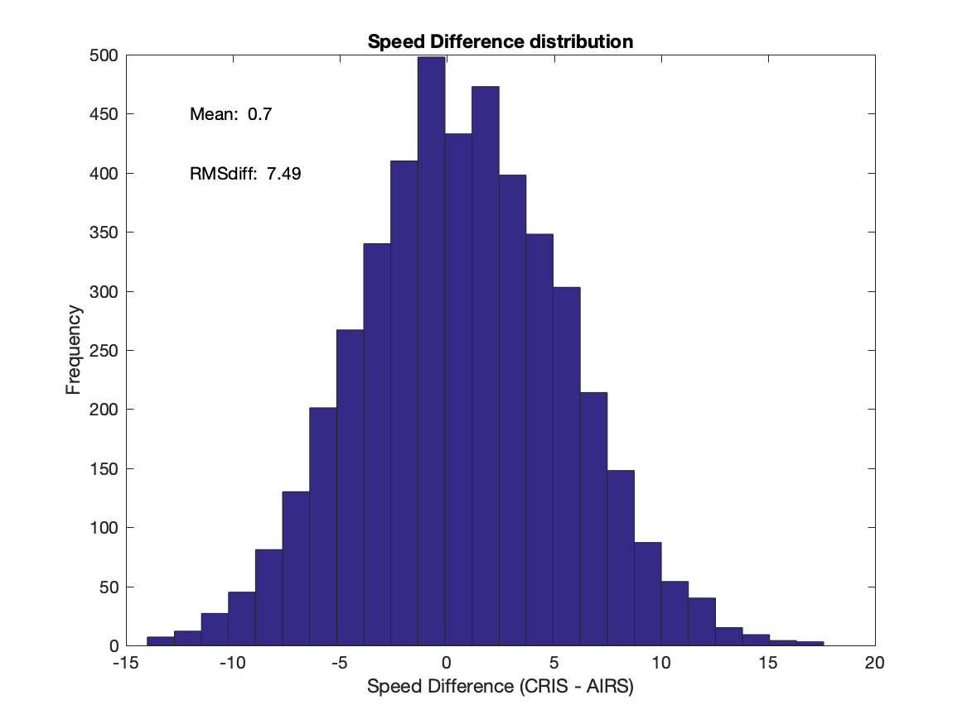
Figure 10: Histogram of speed difference for S-NPP CrIS AMVs vs AIRS AMVs on 25 March 2020.

SNPP AMVs vs JPSS CrIS AMVs
A one-day comparison of the S-NPP CrIS AMVs to those derived from JPSS was done for 25 March 2020, using winds throughout the troposphere and into the stratosphere (up to 100 hPa). There were 7300 co-locations for this one day. The distribution is shown in Figure 11 with differences comparable to the comparisons to the AIRS AMVs (Figure 10): a bias of -0.7 ms⁻¹, RMS of 7.9 ms⁻¹.

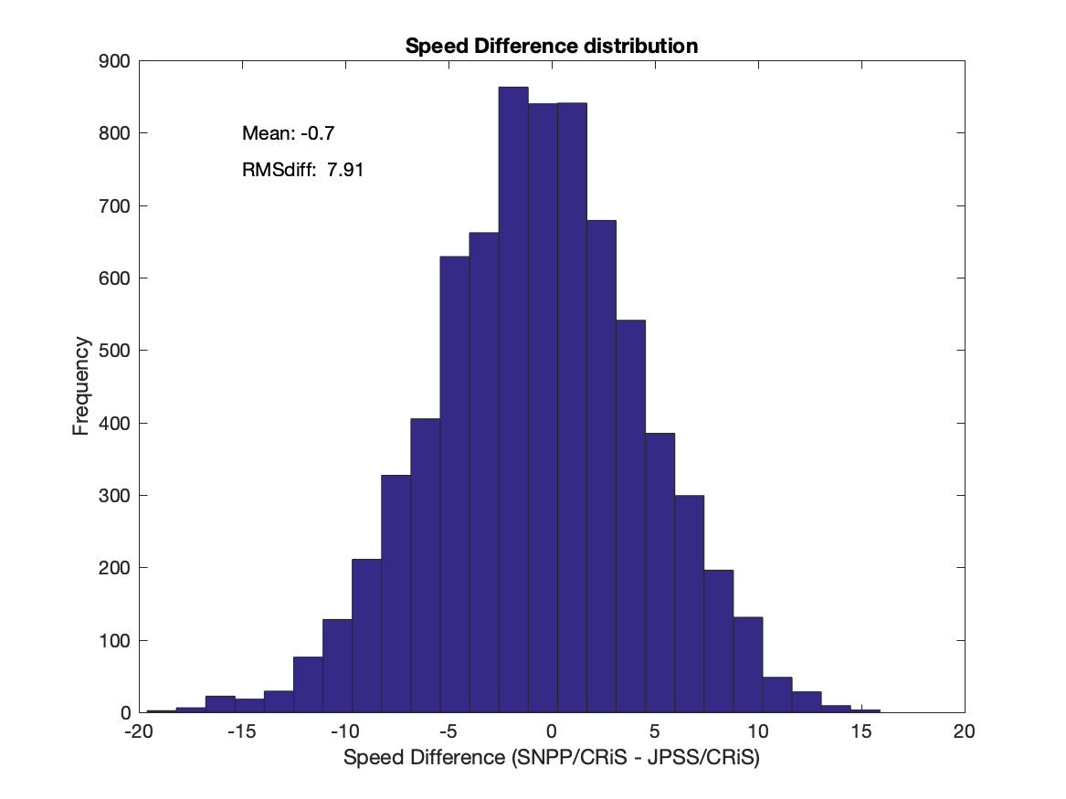
Figure 11: Histogram of speed difference for S-NPP CrIS AMVs vs JPSS CrIS AMVs on 25 March 2020.

CrIS retrieved water vapor information content

To perform a meaningful evaluation of the satellite data - with the goal of obtaining realistic error estimates, information content, and resolution measures - a radiative transfer (or forward) model is used to compute radiances as well as the weighting functions at the instrument’s spectral channels from a known temperature and humidity profile. Here, we use the RTTOV (Radiative Transfer for TOVS) radiative transfer model to compute the CrIS radiance spectrum and associated temperature and water vapor weighting functions from the US. Standard Atmosphere (1976) profile for all CrIS channels at 101 pressure levels. Given an atmospheric profile of temperature, water vapor and, optionally, trace gases, aerosols and hydrometeors, together with surface parameters and a viewing geometry, RTTOV computes the top of atmosphere radiances in each of the channels of the sensor being simulated.

From this analysis, two primary metrics result: Information Content (IC) and Degrees of Freedom (DOF). The DOF gives the number of independent pieces of information that can be measured and indicates the improvement over the background profile; the IC describes the information gained by making a measurement (relative to the a priori).

The water vapor Information Content for CrIS, expressed in ‘bits’, is listed in the second row in
Table 2 for three pressure layers and the total IC. These values can be directly compared with the IC from a different instrument, for example ATMS which is discussed in the next section.

Table 2: CrIS water vapor retrieval Information Content (IC) and Degrees of Freedom (DOF) in three pressure layers and total of the three layers for a US Standard Atmosphere.

Standard Atmosphere | WV  100-400 hPa | WV  400-700 hPa | WV  700-1000 hPa | WV  Total
Information Content | 12.99 | 17.92 | 13.17 | 44.08
Degrees of Freedom | 2.45 | 2.42 | 2.07 | 6.94

The Degrees of Freedom for CrIS (last row in
Table 2) provide a measure of the number of independent pieces of information in the vertical retrieval of water vapor in the three pressure layers. The DOF ranges from 2 to 2.4 in each layer. So, even though the retrieval algorithm provides water vapor on more than 50 pressure levels from 100 to 1000 hPa, there are only about 7 levels of independent information, which could be used in the quality control step to thin the AMVs in the vertical, as assimilation in NWP models assume the data are spatially uncorrelated.

IASI retrieval winds

The algorithm developed for AIRS and CrIS was adapted for use with IASI. An example humidity image with wind barbs is shown in Figure 12. A GFS experiment was run from 01 April to 07 May 2014, which showed primarily a neutral impact in the scorecard (Figure 13).

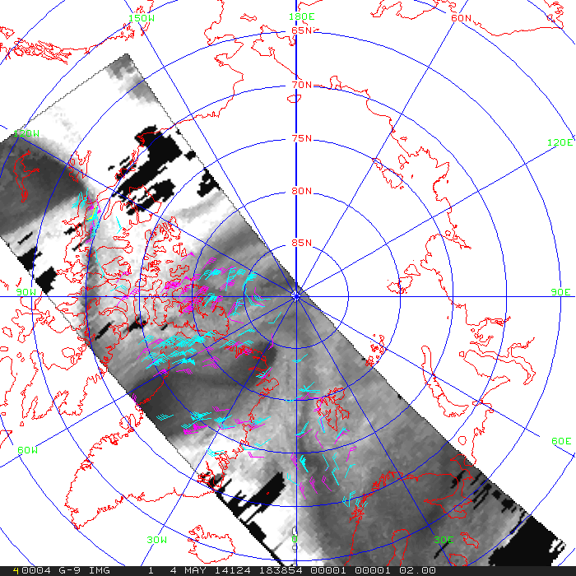
Figure 12: All IASI retrieval AMVs displayed on a 400 hPa IASI retrieved moisture field 4 May 2014
1838 UTC. The winds are color-coded as 400 to 700 hPa (cyan), and above 400 hPa (magenta).
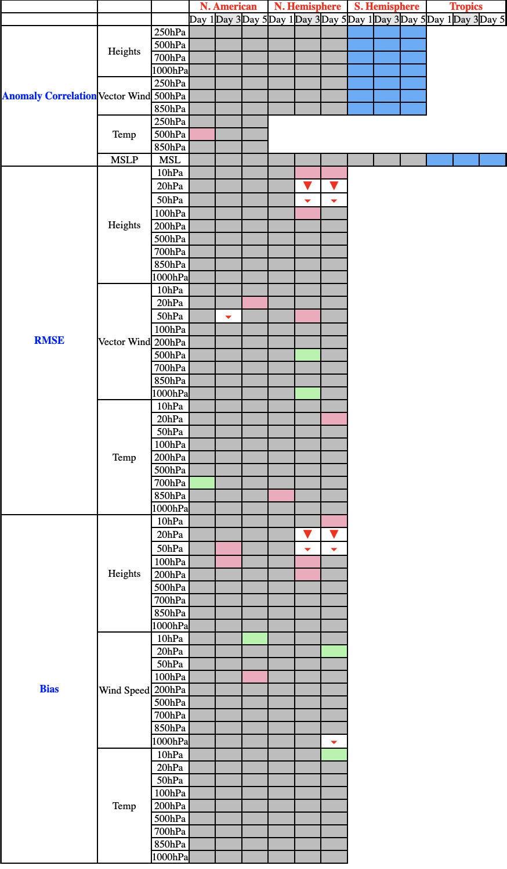
Figure 13: GFS scorecard with the addition of IASI 3D winds for 10 April to 07 May 2014.

MIRS retrieval winds
The scope of this projects was to:
- Adapt the existing AIRS retrieval wind algorithm for use with microwave retrievals, in this case the MIRS product,
- Evaluate the quality of the MIRS AMVs as compared to other 3D winds,
- Compute initial statistics (departures from the background) as compared to a numerical model.

The MIRS product consists of vertical profiles of retrieved temperature and humidity from the ATMS instrument onboard S-NPP and NOAA-20. These data were input to the AMV algorithm, which ran routinely from December 2019 to October 2020. Figure 14 depicts a single moisture retrieval level with winds from all pressure levels plotted.

Figure 14: Humidity image from 12 December 2019 at 500 hPa as derived by the MIRS algorithm. The wind flags are from 17 pressure levels, ranging from 350 to 750 hPa, as derived by the winds algorithm that was developed for the AIRS retrieval winds. The wind flags are color-coded by pressure: yellow (below 700 hPa), cyan (400 to 700 hPa), and magenta (above 400 hPa).

MIRS AMVs vs AIRS AMVs
Scatter plots of MIRS vs AIRS AMV speed for S-NPP and NOAA-20 are shown in Figure 15. The mean difference in speed is near zero meters per second, with a reasonable RMS difference of 5.5 ms⁻¹. These statistics and plots compare favorably with what was found for AIRS vs CrIS AMVs.

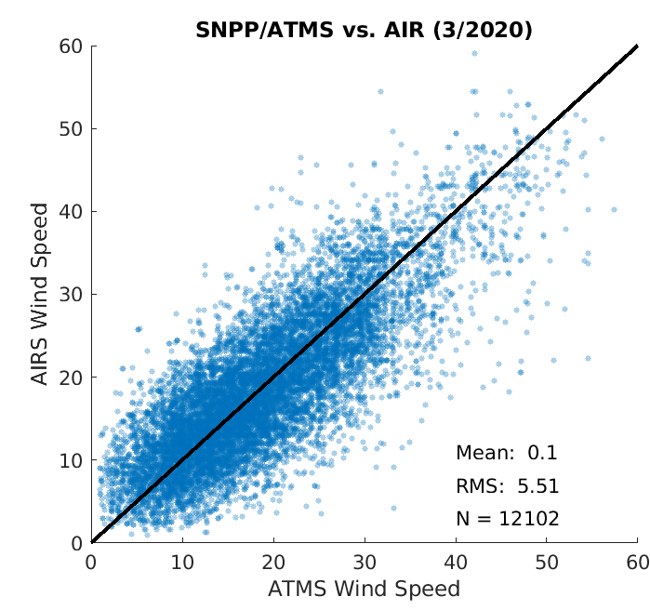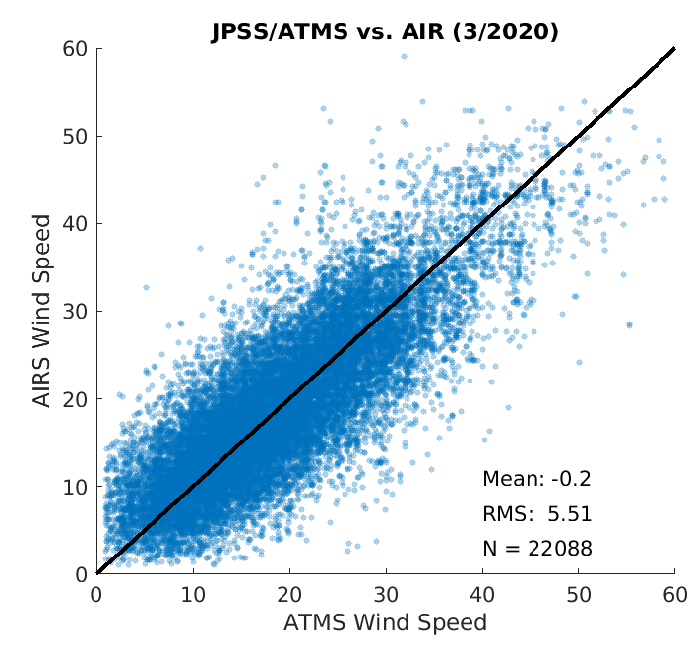
Figure 15: A scatter plot of AIRS vs MIRS AMV speed for March 2020 for S-NPP (left) and NOAA-20 (right).

MIRS AMVs vs rawinsondes
A scatter plot of wind speed MIRS AMVs vs co-located rawinsondes is shown in Figure 16 for NOAA-20. The mean difference is -0.3 ms⁻¹, with an RMS difference of 4.9 ms⁻¹. These statistics are nearly the same as a comparison of AIRS AMVs to rawinsonde winds for a two-month period in August and September 2019.

Figure 16: A scatter plot of MIRS AMV speed vs rawinsonde wind speed for March 2020 for NOAA-20. There are less than 2400 matches due to the scarcity of rawinsondes poleward of 70° latitude.

MIRS AMVs vs ERA5 reanalysis
Four days were selected (March 1, 11, 21, 31 of 2020) to compare the MIRS AMVs to the ERA5 reanalysis winds. In addition, winds from the AIRS and CrIS retrievals were included in the comparison plots. Figure 17 shows vertical profiles of the speed bias and RMSD between the retrieval winds and the ERA5. The bias and RMSD is very similar for the three sources of 3D winds, except the bias in the lower troposphere for the ATMS AMVs is the opposite sign as compared to winds from AIRS and CrIS.

One major difference in the retrievals from hyperspectral IR and microwave, is the ability of the microwave to sound through clouds. This is apparent in Figure 18 where the distribution of winds from MIRS (right) in the lower troposphere is not reduced nearly as much as from CrIS (left).

Figure 17: A vertical profile of the speed difference bias (dashed) and RMSD (solid) between MiRS (ATMS), AIRS, CrIS and the ERA5 reanalysis for March 1, 11, 21, 31 in 2020.

Figure 18: A vertical profile of the observation count by pressure level for CrIS (left) and MIRS (right) for March 1, 11, 21, 31 in 2020; from co-location to the ERA5.

The above comparisons to AIRS winds, rawinsondes, and ERA5 indicate that the 3D AMVs derived from the MIRS product have a similar quality to the AIRS and CrIS AMVs. And, the MIRS winds are complementary as they are derived in all-weather conditions, not only in clear air regimes.

The final step of the project was to assimilate the winds into the GDAS/GFS. This was done to quantify the NWP impact of the MIRS winds on the analysis and forecast by using the FV3 GDAS on S4. The time period is 9 April through 31 May 2020.

Preliminary OMB statistics from the first 20 days of the experiment are depicted in Figure 19. The mean speed bias is slightly negative for MIRS and the MODIS IR AMVs. However, the MIRS AMV standard deviation compared to the background is about a meter/second greater than the MODIS AMVs, which is expected as the MIRS winds are derived from much lower resolution data (14 km vs 1 km from MODIS).

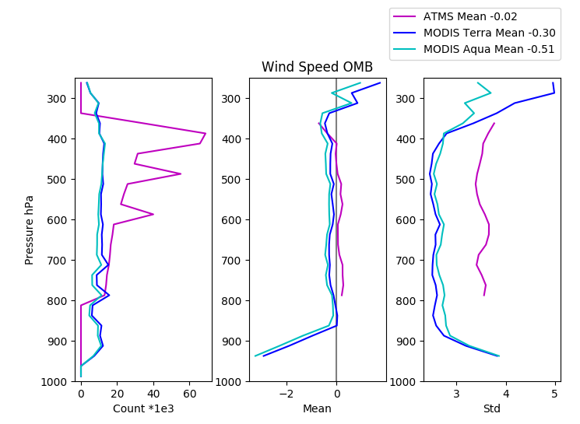
Figure 19: Speed OMB for MIRS (magenta) and MODIS IR AMVs (Terra: blue; Aqua: green) for 9 to 28 April 2020 from the GDAS/GFS.

GEOS-5 Nature Run simulated winds

A system was developed at CIMSS to generate simulated Atmospheric Motion Vectors (AMVs) by tracking moisture features from a time sequence of model output grids. The AMV simulator is based on the heritage winds algorithm developed and maintained at CIMSS over more than two decades This has been applied to regional and global models, including the GEOS-5 Nature Run (G5NR). These simulated AMVs provide a 3D distribution of winds on pressure surfaces which can be used in Observing System Simulation Experiments (OSSEs), for example, to evaluate the impact of passive winds derived from future hyperspectral infrared instruments.

This algorithm was used to generate AMVs by tracking specific humidity features on eight tropospheric pressure levels (200, 250, 300, 400, 500, 600, 700, 850 hPa) from the 7 km G5NR. In order to simulate AMVs from a hyperspectral IR sounder, two additional steps were required:
- Winds were only retained in clear sky and above cloud by using a cloud-top pressure grid.
- Subsequently, those winds retained were sampled based on a low earth orbiting (LEO) satellite and a prescribed swath width; in this case, Starlink satellites in a 60º inclined orbit with a swath width typical of a hyperspectral IR instrument (e.g., CrIS scans +/- 50º resulting in a 2200 km swath).

The resulting AMVs for one time period (1-hour time window) are depicted as red wind barbs in Figure 20. From a single LEO satellite orbit, it requires an entire day of orbits to achieve global coverage of the winds.

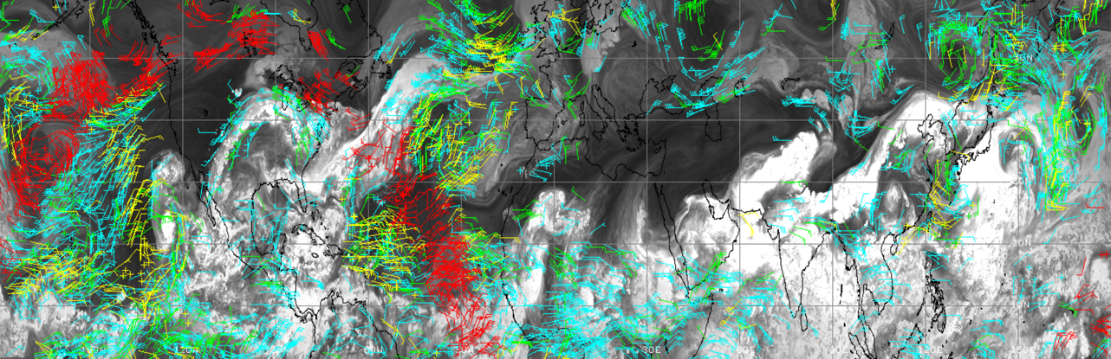
Figure 20: Winds derived from the G5NR moisture fields over the Northern Hemisphere on eight pressure levels, where yellow, green, cyan wind barbs are at low, middle, and high levels, respectively. The red wind barbs are those sampled by the Starlink orbit within a 1-hour time window.

ECO1280 Nature Run simulated winds

The system to generate 3D AMVs described in the previous section was modified to use grids from the ECO1280 to produce winds for use in OSSEs and to aid in making informed decisions for future satellite missions. To evaluate the impact of passive winds derived from future hyperspectral infrared instruments, this system was used to generate simulated AMVs for June and July 2016 with this scenario: Three low earth orbit (LEO) constellations of satellites with hyperspectral IR sensors, in orbits offset by four hours (Figure 21). The ECO1280 was used to produce the AMVs on eight pressure levels from 850 to 200 hPa. A gross error check is applied to the winds to remove those where the u- or v-component differs by more than 10 ms⁻¹ from the NR wind field. Additionally, an AMV spatial consistency check is applied.

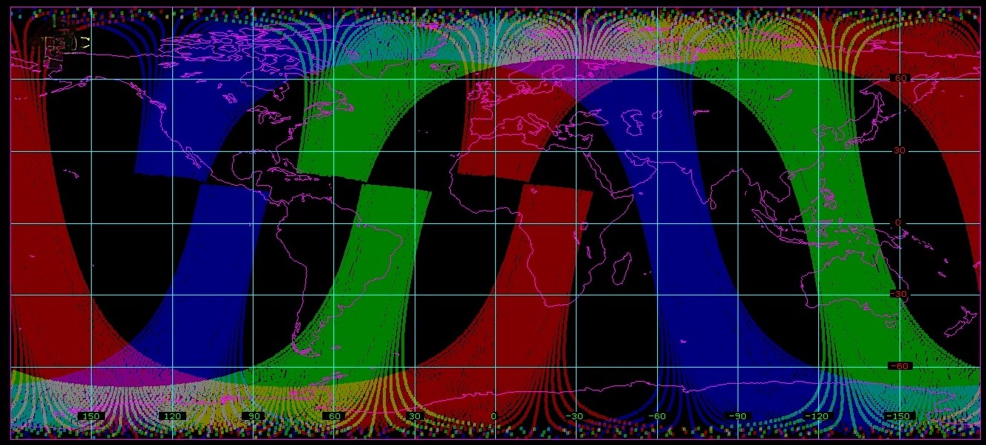
Figure 21: Polar-orbiting satellite swath coverage for a single orbit (100 minutes) from three satellite constellations at local equator crossing times of 0530 (red), 0930 (green), and 1330 (blue). The 1330 orbit is for NOAA-20 and the swath width is based on the CrIS instrument. The other two orbits were computed by modifying the right ascension of the ascending node of the NOAA-20 orbit.
To simulate winds derived from a hyperspectral IR sounder, the AMVs are filtered based on the NR cloud-top grid to retain only those in clear-sky and above-cloud. Furthermore, the winds were sampled to keep only those in view by satellites in three staggered polar orbits with a Cross-track Infrared Sounder (CrIS) instrument.

Initial statistics from this first case study are encouraging with the simulated AMVs having a u- and v-component wind bias of 0.1 to 0.3 m s⁻¹ and RMS difference of 2.0 to 2.5 m s⁻¹ when compared to the ECO1280 winds. An example of the northern hemisphere AMV coverage in a three-hour time window is depicted in Figure 22, which indicates that the above configuration using SmallSats with hyperspectral IR sounders will result in near continuous global 3D winds coverage for data assimilation applications.

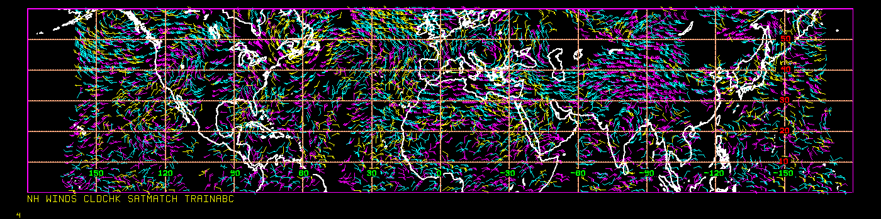
Figure 22: AMVs derived from the ECO1280 in a 3-hour time window covering latitudes from the equator to 60N. Yellow AMVs are below 700 hPa; cyan 400-700 hPa; and magenta above 400 hPa.

ERA5 reanalysis simulated winds

The same system used to generate simulated AMVs from the GEOS-5 and the ECO1280 NRs, was adapted to use the ERA5 reanalysis grids. The distribution of AMVs in the Arctic region is shown in Figure 23. Quantitative results are pending the completion of a WRF experiment.

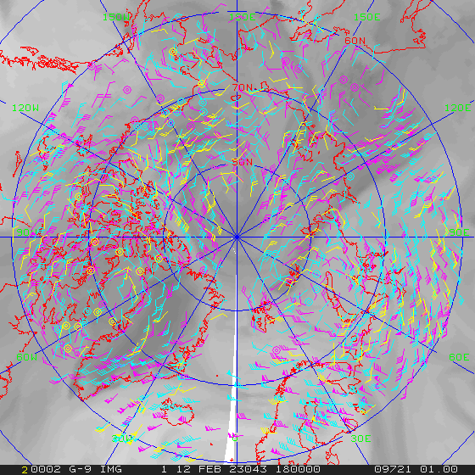
Figure 23: AMVs derived from the ERA5 reanalysis in a 6-hour time window centered at 1800 UTC on 12 February 2023 over the Arctic region. Yellow AMVs are below 700 hPa; cyan 400-700 hPa; and magenta above 400 hPa.

A machine learning optical flow system for generating AMVs

A publicly available machine learning system (WindFlow; Vandal 2022) for deriving AMVs is being investigated for use with both IR hyperspectral retrieved data and nature run grids. There are several advantages to this system over the heritage winds code:
- The heritage winds algorithm requires a triplet of images, while WindFlow operates with a pair of images. This extends the spatial coverage more equatorward for overlapping orbits of LEO satellites. In fact, for the JPSS satellite series the overlap would continuous over the entire orbit, resulting in daily global coverage.
- The optical flow algorithm results in a much higher density of winds, which can be used to simulate thinning strategies for nature run-based AMVs to account for instrument resolution, correlated errors, etc.
The WindFlow package includes test data (GOES ABI and GEOS-5 NR) and was pre-trained with the GEOS-5 NR. Modifications were made to the code to import grids from the ECO1280 and initial results are shown in the following figures.

The WindFlow algorithm was applied to a pair of ECO1280 grids from 01 June 2016 at 00 and 03 UTC on the 500 hPa surface. The result is depicted in Figure 24 as displacement vectors over the humidity field used to calculate the vectors. To validate the reasonableness of these vectors, the wind field from the nature is shown in Figure 25. Comparing the vectors from these two figures in regions of higher humidity features and fast wind speeds (over the central US, and south Pacific and Atlantic Oceans), shows a good qualitative agreement. Note: The WindFlow vectors in Figure 24 are pixel displacement and the ECO1280 vectors in Figure 25 are wind speed, so the vector lengths cannot be directly compared.

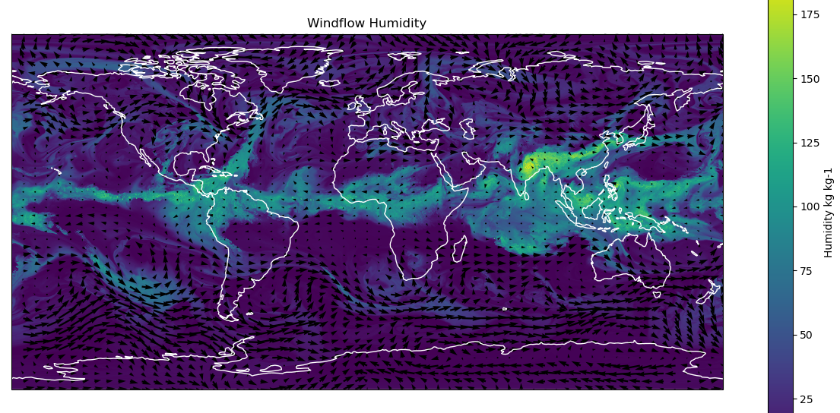
Figure 24: Derived AMVs using WindFlow applied to a pair of ECO1280 grids from 01 June 2016 at 00 and 03 UTC on the 500 hPa surface. Color shading is humidity and vector length is based on pixel displacement of the feature motion.
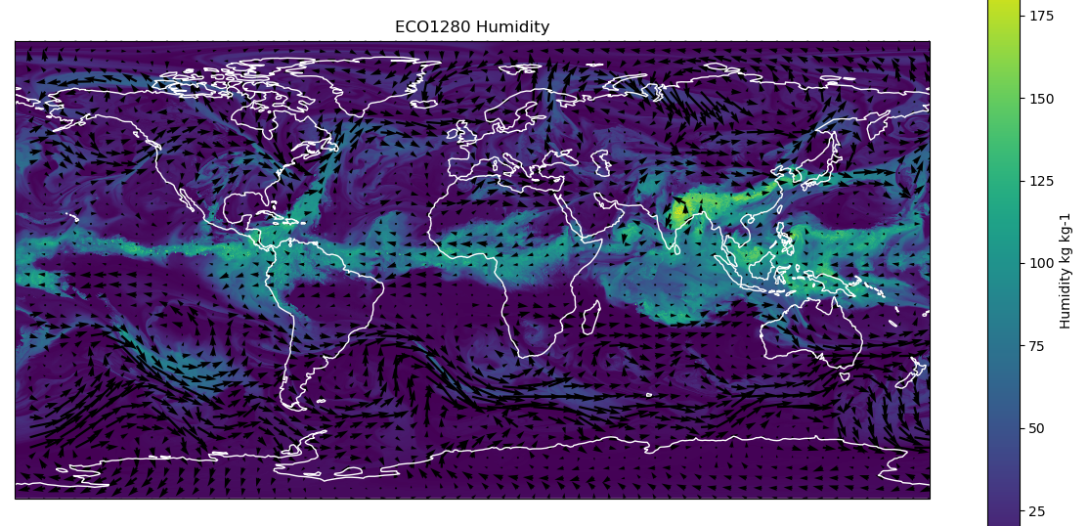
Figure 25: ECO1280 wind from 01 June 2016 at 00 UTC on the 500 hPa surface. Color shading is humidity and vector length is based on u- and v-component of the nature run wind.

References
Santek, D., S. Nebuda, D. Stettner, 2019: Demonstration and Evaluation of 3D Winds Generated by Tracking Features in Moisture and Ozone Fields Derived from AIRS Sounding Retrievals. Remote Sens., 11, 2597.
Vandal, T., K. Duffy, W. McCarty, A. Sewnath, and R. Nemani. 2022. Dense Feature Tracking of Atmospheric Winds with Deep Optical Flow. In Proceedings of the 28th ACM SIGKDD Conference on Knowledge Discovery and Data Mining (KDD ’22), August 14–18, 2022, Washington, DC, USA. ACM, New York, NY, USA, 9 pages.
https://doi.org/10.1145/ 3534678.3539345

The Quality Indicator (QI) ranges from 0.0 (low) to 1.0 (high) that provides a measure of the quality of each AMV.

