Task 2.1: CIMSS Support to JPSS VIIRS Derived Winds Validation and Science for 2023

Project Lead: David Santek

Budget: $133,000
CIMSS Support Scientists: Richard Dworak, Dave Stettner, Sharon Nebuda
NOAA Collaborators: Jeff Key, Jaime Daniels

2.1.1) Project Description

The Suomi National Polar-orbiting Partnership (S-NPP) and NOAA-20 Visible Infrared Imaging Radiometer Suite (VIIRS) polar winds product provides wind speed, direction, and pressure of cloud-tracked features at high latitudes. The VIIRS winds have been produced operationally by NESDIS since May 2014 and are also being distributed via the European Organisation for the Exploitation of Meteorological Satellites (EUMETSAT) EUMETCast broadcast. The VIIRS winds are being assimilated in the Naval Research Lab's (NRL) Atmospheric Variational Data Assimilation System - Accelerated Representer (NAVDAS-AR) and in NCEP’s parallel run of the Global Data Assimilation System/Global Forecast System GDAS/GFS. They are also used by additional numerical weather prediction centers abroad.

The objective of this project is to continue to monitor and assess the quality of the operational VIIRS winds from both S-NPP and NOAA-20, and begin the evaluation of the VIIRS winds from NOAA-21. Deficiencies will be identified and solutions proposed. Improvements will be explored, though the project is not intended to support extensive, basic research.

Scientists from the Cooperative Institute for Meteorological Satellite Studies (CIMSS) will work with NOAA scientists in Madison and Washington, D.C. to jointly address validation methodologies, develop monitoring tools, and explore algorithm improvements.

2.1.2) Proposed Activities for 2023

There are three task categories this fiscal year, some of which will continue into FY24 and beyond:

- Task 1 – Science and Product Services: This ongoing task involves addressing science and user questions and issues with the operational product, including addressing the needs of the NWP community.

- Task 2 – Algorithm Maintenance, Integration, and Enhancement: This task involves the integration of algorithm updates and improvements into the Enterprise framework. Problems that arise will be investigated and solutions will be proposed. Additionally, we will:

  - Evaluate the NOAA-21 VIIRS winds, both the single-satellite and tandem pairs and triplets.
  - Continue to monitor the S-NPP and NOAA-20 VIIRS IR winds generated at CIMSS, NESDIS, and from Fairbanks and Sodankylä direct broadcast (DB) data.
  - Continue the discussions and effort to transition from the heritage to the Enterprise winds algorithm for additional VIIRS channels, shortwave IR (SWIR), and Day/Night Band (DNB), as evaluations of winds derived from those channels are encouraging when compared to rawinsondes and assimilated in NRL’s NAVGEM model.
  - Evaluate the Enterprise Cloud Mask (ECM) regarding wind retrieval accuracy.
  - Explore options to retrieve DB data from remote sites to run the Enterprise code locally at CIMSS, rather than installing the wind retrieval code at DB sites which is difficult to install and maintain. The heritage winds code is currently used at DB sites in the Antarctic (McMurdo and Rothera).

- Task 3 – Validation: This task involves the validation of the VIIRS polar winds product. The validation strategy is:
- Derive winds with full product precedence in place. Cloud Products (cloud-top temperature, pressure, phase, type) are generated as part of the product precedence chain.
- Co-locate (in space and time) derived satellite winds with reference (“truth”) winds, including radiosonde, aircraft, and model reanalysis winds.
- Generate comparative statistics, primarily accuracy, and precision.
- Continue to monitor production and assess winds derived from additional VIIRS spectral channels, such as the shortwave IR (SWIR; e.g., M10: 1.6µm, M11: 2.25 µm) and the Day/Night bands (Figure 2.1.1).

Additionally, we will prepare and present validation information at maturity reviews.

- Task 4 – Long-term Monitoring and Anomaly Resolution: With the goal of long-term monitoring throughout the JPSS era, monitoring tools are developed and improved, and algorithms are adapted to problems that arise such as sensor degradation and channel loss. This includes developing a web page for interactive access to the product quick-looks and statistics and expanding the monitoring tools to use a notification system (e.g., the infrastructure and application monitoring tool, Checkmk) to send alerts when significant changes are detected in the product (e.g., data missing, low volume of winds, system status).

2.1.3) FY2023 Milestones

May 2023: Begin evaluation of the NOAA-21 VIIRS single-satellite winds product.
Jul 2023: Implement the VIIRS tandem pair and triplet wind generation using combinations of S-NPP, NOAA-20, and NOAA-21.
Sep 2023: Complete the migration of the SWIR winds from heritage to Enterprise algorithm.
Nov 2023: Revisit the generation of VIIRS tandem pair winds and develop a plan for moving from the heritage to the Enterprise algorithm.
Jan 2024: Complete an evaluation of NCC winds and recommend a strategy to transition from the heritage to the Enterprise algorithm .
Feb 2024: Improve monitoring tools to include notifications for the real-time winds product.

In addition to the milestones above, there are ongoing activities that don’t have a specific timeline associated with them, including:

- Adapt winds algorithm updates to STAR ASSISTT, as necessary
- Refine validation scripts, figures, and statistics
- Continue updates to the web page for viewing quick-looks and statistics

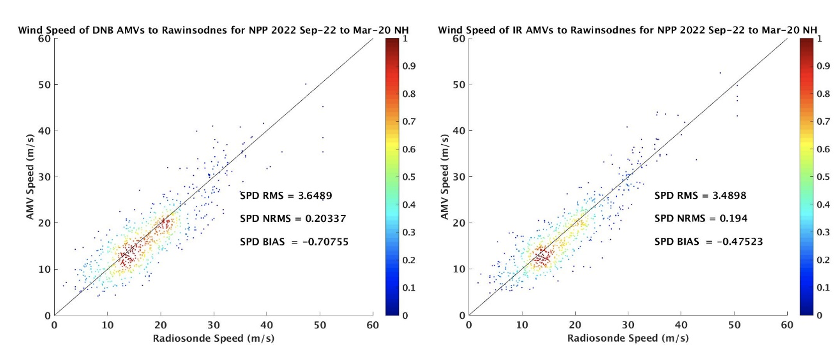

Figure 2.1.1: Collocated AMVs from VIIRS DNB (left) and IR (right) as compared to rawinsondes for September through December 2022. When compared to rawinsondes, the DNB wind speeds have a similar bias and RMS (-0.71 ms⁻¹, 3.65 ms⁻¹) to the IR winds (-0.48 ms⁻¹, 3.49 ms⁻¹).

