PASTE and ADDE Development Plan and Requirements

The ADDE server system will be updated in a series of development cycles. The purpose of this development will be to address the issues detail in the ADDE server upgrade overview. Each cycle will have its own requirements and goals. The requirements and goals will be reevaluated and updated before advancing from one cycle to the next.

The software developed will whenever possible leverage existing software packages and off the shelf technologies. The software will be compatible with ADDE; it may augment or replace parts of current implementation of ADDE.

The PASTE (Premier Atmosphere Science Translation Engineer) software package will be developed. This layer will provide dataset translation. PASTE 0.1 will be implemented as the first development cycle. This piece will fit into the existing PEATE and Leocat systems.

A Subsection and Transport layer have also been identified.

The diagram below represents a possible implementation at the end of this development.

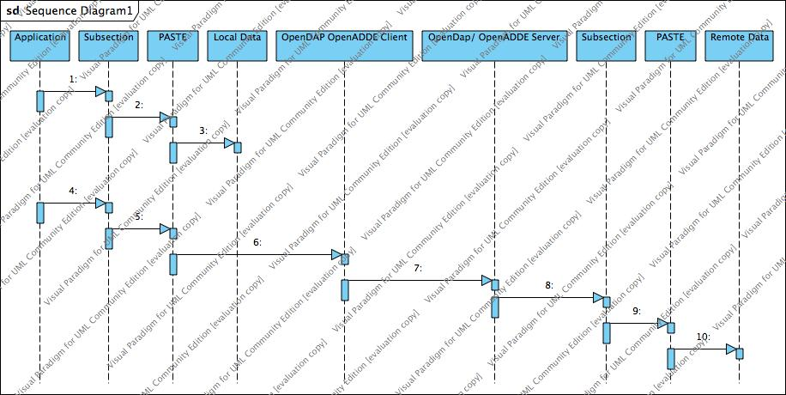

General Guidelines

Whenever possible software shall be written in JAVA

The software shall be kept in a subversion repository.
The software shall be defect tracked using Bugzilla.
All transformations shall be bidirectional/reversible.
Software shall provide ADDE access compatible with McIDAS X

File translation (PASTE)

Requirements

(PASTE-101) Software shall accept file specifications as URLs
(PASTE-102) Software shall be able to move a dataset between files
(PASTE-103) Software shall add a dataset if it does not exist
(PASTE-104) Software shall replace dataset if dimension sizes are the same.
(PASTE-105) Software shall support rearranging of dimension order.
(PASTE-106) Software shall report an error if dimension sizes do not match.
(PASTE-107) Software shall not change the type of the dataset.
(PASTE-108) Software shall transfer attributes of the dataset.
(PASTE-109) Software shall allow the dataset to be renamed.
(PASTE-110) Software operations shall be data driven
(PASTE-111) Software shall support command line control specification of data files.
(PASTE-112) Software shall support bitwise data operations during transfer.
(PASTE-113) Creation of transformation shall be accomplished by the creation of XML based transfer specification.
(PASTE-114) Software shall support HDF
(PASTE-115) Software shall support data transfers in either direction.
(PASTE-116) Software shall support command line help

Milestones

Software will be able to be used in PEATE processing chain to move dataset from Leocat output HDF to MODIS HDF (McIDAS X compatible)

PASTE (0.1) will be able to transfer dataset between HDF files. The transfer specification will be written in XML. HDF dataset and attribute listing utilizes will be developed.

Bugzilla will have the PASTE project defined. Unit tests will be implemented.

This development starts to address the issue of getting new data types into McIDAS. The infrastructure for supporting remapping is put into place and tested for HDF.

Subsection

Requirements

Software shall support ADDE (Area data Format)
Software shall be able to sub sect by row and column (2 Dimensional datasets)
Software shall be able to sub sect by geographic location.

Milestones

This will continue addressing the issue of getting new data types into McIDAS. HDF files will be able to be mapped directly into Area format. Area files will be able to be mapped and translated to HDF. Profiles for recognized area types will be provided assisting in McIDAS data integration.

Expansion

Requirements

Software shall support HDF 5
Software shall support NetCDF

Milestones

Transport

Requirements

Evaluate addition of OPeNDAP
Java based ADDE equivalent server.
Addition of data advertising and discovery.

Milestones

