A Guide to the Learning and Action Guide

What's it all about?
The Learning and Action Guide is designed to make your training event more effective. It assists the participants in taking responsibility for their own learning and helps them to structure their approach.

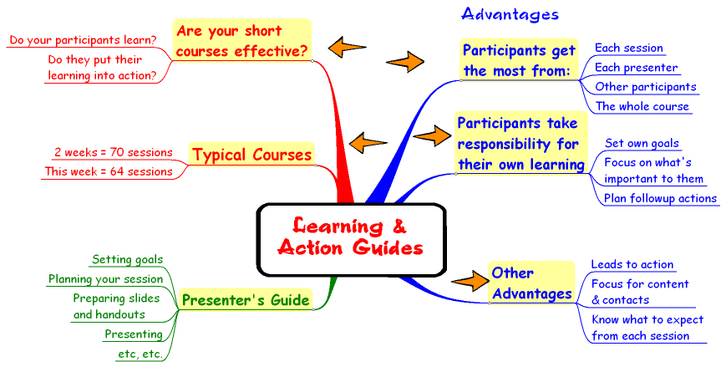
The Learning and Action Guide was developed by Ian Bell (iandbell@fastmail.fm). It was initially used for short courses run in the Australian Bureau of Meteorology where it was very well received by both participants and presenters. Some advantages are shown below:

The best way to assess its usefulness is to have a look through the Guide, think of a training event you have conducted, and consider whether it may have been more effective if you had used the Guide or implemented some of the ideas in it. If you are unsure, give it a try.
Adapting the Guide for your training event
Not all sections will apply to any particular training event. Adapt the Guide to suit your needs and to make it feel like your own rather than a transplant.
- Expand, reduce or rewrite sections as appropriate.
- Choose from the "options" section
- Develop and add new sections as you need them.
- See the “Examples” folder for further ideas.
- Learn as you go. What worked well last time? What could be improved in your situation?
This document explains what each section of the Guide is for and how to adapt it.
Use of Styles and Formatting
The Guide is set up using Word's "styles and formatting" feature from the "format" menu. If you want to change fonts, sizes or colours don't do it for individual headings or paragraphs. Do it from the "styles and formatting" menu. It will then change all instances within the document.
Logistics – fonts, printing, binders, paper
I have embedded the fonts with each document. This means that you should be able to use the same fonts, even if they are not on your system. Otherwise choose a font that contrasts with the main body of text.
There are several options for printing:
- Print the documents directly on a coloured printer
- Print a set of backgrounds commercially. To do this: copy a document; delete all but one page and the text from that page; you will now have just the header and footer; get a printer to print it in a single colour. Now delete the headers and footers from the remaining files. You may like to print extra copies for other courses. In this case don't include the course name.
- If you have printed templates commercially you can now print directly onto these printed sheets or print single copies of each page and photocopy them onto the templates.
The Guide can be used in several ways. It can be separately bound, either permanently or in a way that allows rearrangement of pages or the insertion of extra pages. Alternatively it can be inserted in a large binder so that participants can insert notes or handouts for each session. Each way has its advantages.
Using quality paper will make the Guide a pleasure to use. It should be heavier than standard photocopying paper and preferably non-white (but not too strong a colour – maybe bone or cream). Making the "Sessions" section a different colour will help participants to locate relevant sections easily.

1. Cover
The cover creates the first impression of your course and of the Learning and Action Guide. So use it to make a positive impression. Insert your own image relevant to the course and print it on nice light card.

2. General Section
Welcome to … Course/Workshop/Conference
Use this page to welcome participants to your training event.
Your comments could include:
- Welcoming comments
- Who has organised it and why
- What it will achieve
- The idea that the program is designed for their benefit
- A challenge to participants to get the most from the event and to apply it on their return to improve their work/work of their office
- Wishes that they will enjoy their time at the event.
Get it signed by organisers and somebody with authority (as senior in the organisation as possible).

Why are you here?
Goal setting. It is important that participants take responsibility for their own learning. This is the start of that process.
- Ask them to reflect on what they want from the event, both in terms of their work and on a personal level.
- Get them to set specific goals.
- Ask them to reflect on previous training events they have attended. What worked well? What didn’t? What was their role in each case?
- How can they contribute to this being the best training event they have attended?
- Stress the need for them to take an active role.

Getting the Most from … Course/Workshop/ Conference
- Adapt the sample page
- Delete or modify the last paragraph (language) as necessary

Using this Learning and Action Guide
You will need to reinforce its purpose and to encourage participants to use the Learning and Action Guide.
- Check that they are using it at the end of each session and end of each day for the first few days.
- Build in 10 minutes at the end of each day for participants to review the day, note any follow-up action required and identify possible Action Plan items.

Getting the Most from Presentations
Emphasise that each presenter, like each participant, is unique and that not all combinations will be optimal. However, all have been chosen because we, the organisers, believe they have much to offer.
If the presentation style does not suit the participant’s natural style it doesn’t mean that they cannot learn. This section gives suggestions they can adopt.

Taking Notes
As an organiser you don't want to see valuable time wasted by note copying. Remember the old definition of a lecture: "A period of time when the notes of the lecturer are transferred to the notebooks of the students without going through the brain of either!" Don't let that happen on your course.
- Note taking is often done inefficiently.
- Encourage presenters to provide hardcopy versions of their presentations or supporting material including notes and journal articles. Ensure they are distributed before the session.
- Set up a Web site for all presentations and, if large, provide a consolidated set to participants on CD-ROM or DVD.
- The Session Notes section of the Learning and Action Guide deliberately small to encourage writing only the salient points and for the participant to focus on what they will do with what they have learnt.
- Concept mapping is often more effective than taking linear notes.

Getting the Most from Workshops
- Delete this section if you do not have workshops
- Ensure workshops complement the theory and have clear goals.
- Encourage participants to take an active role and to be responsible for their own learning and goals within the context of the workshop.

Getting the Most from Resources
- Many resources are handed out and never looked at. Adapt this to correspond to the resource types you will be using.
- Each major resource should come with a proforma to help to focus on the important points and what to subsequently do with the resource.

This Guide will last forever …
A light-hearted look at the training folder. Check copyright (www.dilbert.com) if you want to use it.

Housekeeping

This section should cover the main things participants need to know to make their training run smoothly:
- Contact information
- Training room information, laboratories, etc.
- Computing support
- Food and refreshment information
- Security
- Administrative support
- Location of library
There will be particular issues related to your location and organisation.
Welcome Pack – this is handy if participants come from interstate or other countries. It can be sent to participants or made available on arrival at their hotel. It can include:
- a map of the city and how to get from the hotel to the training venue
- welcoming letter
- Lists/maps of nearest banks, restaurants, food supplies, religious venues, doctor, dentist, pharmacy, etc, etc.
- How to use public transport
- Recreation venues
- Contact numbers
This can be built up and added to over time so that little work is required with any individual course.

2. People Section
This section is very important in helping your event run smoothly and engendering interaction among participants and with presenters, both at the start and later for follow-up.
Ask all involved – organisers, presenters and participants – to provide their details:
- A photograph – this should be 94x122 pixels and should just be of their head. Most people will have larger photographs that include their whole body (and maybe a bunch of friends!) Either ask them to send a photo and then crop and resize it using a graphics program or be very specific about your requirements. Otherwise their face will be too small to recognise.
- Contact information – address, phone, email. If the email address is too long just move it down below "Things to follow-up with this person".
- A brief biography relevant to the training event – about 60 words (but some languages average longer words.) If it does not fit into the space you will need to edit it or send it back for them to do so.
Privacy. As this information is going to be published it is courteous (and indeed may be a legal requirement) to inform everyone and to seek informal or formal permission to publish their details.
These pages contain tables with fixed row and column sizes. Be wary of changing them. For extra pages just insert a page break and copy a blank table.

3. "Sessions" section
The previous sections have been setting the scene for learning. This section will contain a separate page to act as a focus for learning in each session. The "How to use the sessions section" page in the Learning and Action Guide explains the purpose. Encourage and remind participants to use them.
Your role is to work with the presenters to:
- Ensure that they are clear about what you want them to do.
- Help them to set clear, active session goals (see below)
- Assist them with their teaching and learning strategies and resources if needed.
- Ensure learning resources are made available to participants (handouts, presentations on a Web site or CD-ROM)
- Ensure they are familiar with the technology and are set-up/have tested it well ahead of time.
Layout
These pages contain tables with fixed row sizes. Be wary of changing them. If the goals are too long for the space either reduce them or put them on the back with a note to that effect on the front. Do likewise for the resources or provide a link via a Web site, provide a list as a separate handout or include them on the CD-ROM with the presentations.
Each session should be on a separate sheet so that participants can write on the back and insert handouts behind the page. For extra pages just insert a page break and copy a blank table.
Use paper that is heavier than normal and different to the rest of the Guide.
Setting session goals
This is crucial to the success of your training. Traditionally session goals, or learning outcomes, have been based on the teacher-centred paradigm where information is transferred from the teacher to the student. This would lead to goals such as "learn", "know about", "understand", etc.
Bad words: learn, know, understand, be aware of, be familiar with, appreciate, recognise, remember, appreciate, comprehend, conclude, decide, deduce, infer, understand, list, acquire, aware of, awareness of, familiar with, know, realise
Think about why you want someone to learn something rather than what it is you want them to learn. This will help to focus on their behaviour rather than their knowledge. Just knowing something won't help someone perform their job. They must be able to identify situations where they need to use the knowledge and then be able to apply it.
Each session goal should be demonstrable and assessable. They should relate to competencies required to do their job. Start each goal with an active verb.
Good words: identify, locate, apply, estimate, recognise and predict, interpret, discriminate, use … to …, compute, transform, solve, analyse, forecast, construct, measure, organise, verify, solve
Example: "Be able to apply the basic mid-latitude cyclogenesis model to satellite imagery to determine the stage in the cyclone's life cycle and whether conditions are favourable for development, thus predicting its future."

4. Action Plans
Many training events do not reach their full potential because participants attend them and then return to their workplace without any change taking place. This is where the Action Plan can make your training more effective. It is explained in the Guide.
You can help to make it more effective by:
- Introducing it to participants at the earliest possible time. Ideally this will be before they apply or are nominated for the training. Then they will be clear that this is expected of them. It will give them the opportunity to discuss needs and priorities with their supervisor and work colleagues.
- Informing supervisors that this will be expected as part of the training event and gaining their support. This may be better coming from the sponsor of the training event.
- Discussing Action Plans during the introduction and reminding participants from time to time to be looking for and developing ideas.
- Timetabling time on the last day for participants to complete their plans.
- Asking participants to lodge a copy of their Plan before they leave.
- Link people who are doing similar things.
- Following up with participants and their supervisors at pre-set times after the training. This should not appear as "enforcement" but encouragement and checking to see if there are impediments to its implementation and if there is any way you can assist.
Action Plans can vary from simple things that require no resources and are quickly accomplished to major projects. Provide about four pages as they may do more than one thing or develop an idea but not use it.

5. Options
Getting the Most from Image and Chart Discussions
These discussions have often been conducted in the same way for many years - people go through the process without clear goals or assessment of what works well and what doesn’t. Don't let yours continue the trend!

Options Workshop

Because participants have different priorities and needs, as well as different learning styles, it is not effective to try to teach them the same things in the same way for the whole time. It may be advantageous to have one or more sessions that are decided on by the participants. This would come towards the end when they have completed most of the training. Some may wish to extend their knowledge or skills in particular topics; others may want to spend more time with one of the presenters or someone who did not present but is available. They may work individually or in small groups. It is up to them.

Case Studies
Case studies and other workshops, like the Session presentations, should have clearly articulated goals. They will also require clear instructions and details of where any data is and how it can be accessed and displayed.

Evaluation
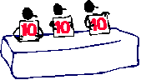
Your training cannot improve unless you evaluate it. The Evaluation.DOC document is one example that has been found to work well. There are many other styles that may work just as well or better for you. If you use it adapt it to meet your needs.
If you are running a two week course it is important to evaluate after the first week as well as at the end. This will enable you to make any adjustments as you go rather than find out at the end that there was something you could have done to improve the course.

Timetable
A sample timetable template is included. Adapt it to suit your needs or develop your own style.
Print the timetable on coloured paper so that it is easy to locate and include it in the Guide.

