Angels We Have Heard on High

Overhead we’ve heard is high.
50.5 for all things.
PIs whine and in reply.
3rd floor winces from the sting

Oooooooooooooooooooooo, overhead
Where does all the money go?
Oooooooooooooooooooooo, overhead
Seems like there is excess dough.

Come to 3rd and you will see
Upgrades in three fifty one
Come adore on bended knee
Watch movies when all are gone.

Oooooooooooooooooooooo, overhead
Why can’t I get furniture?
Oooooooooooooooooooooo, overhead
Maybe carpet for the floor.

How much is a newbie paid?
It’s been three years and no raise!
John and Hank please lend your aid
Overhead we then would praise!

Oooooooooooooooooooooo, overhead
Where does all the money go?
Oooooooooooooooooooooo, overhead
Seems like there is excess dough.

No Rest for you Steve Ackerman

No rest for you Steve Ackerman,
Your schedule’s full today,
As head of CIMSS you may be lord
Of all that you survey,
But first you have to do your show
On WHA
O-oh, what are the duties you enjoy?
That you enjoy?
O-oh, what are the duties you enjoy?

No rest for you Steve Ackerman,
Your students form a queue.
Their little minds need molding by
A weather god like you.
But first you have to meet with all
The big boys on your crew.
O-oh, what are the duties you enjoy?

No rest for you Steve Ackerman,
Your phone rings constantly.
It’s speed dial for half the phones
Across the whole country.
But you can screen incoming calls.
God bless Caller ID! O-oh, what are the duties you enjoy?

No rest for you Steve Ackerman
You need to write today.
So stay at home where interruptions
Won’t get in your way.
You need three crafty assistants
To keep the mob at bay. O-oh, what are the duties you enjoy?

No rest for you Steve Ackerman
Your bags are packed to go.
You have to fly to Washington
To give the suits a show.
But first you have to move your car
Before it gets a tow. O-oh, what are the duties you enjoy?
That you enjoy?
O-oh, what are the duties you enjoy?

Parking Lot Schlock

Parking lot, parking lot, parking lot schlock
Where did they go, we really don’t know
Spaces forsaken in Lot 51
O the parking crunch has begun

Parking lot, parking lot, parking lot schlock
2-hour time, chalk marks before nine
Tickets and towing in twenty blocks square
It just isn’t fair.

What a crime time, it’s the right time
To move my car away
Parking schlock time is a hell time
To find parking for my Chevrolet.

Giddyup parking man, out of your jeep
And jingle around my car
Affix my ticket to the one last week
That’s the parking lot
That’s the parking lot
That’s the parking lot schlock.

.

Rudolph the Red-Nosed Reindeer
There's Viagra, Cialis, enhancers, reducers;
Software, and watches, and patches, and boosters.
But, wait, there are more. That all add to our email décor!

They have approved your mortgage
And a free on-line degree
Spam mail's disguised in pictures
Click it and you'll be sorry

Now its employee spam mail
All of it is sent in vain
E-spanked for children selling
Fruit to fund their soccer games!

Checked my email late one eve,
Need Cash? mailed to say
Dear sir with all your free time
Won't you do survey's on-line?

Now all the spammers love me
A thousand messages per week
TC, oh can't you save us
From this spam mail misery

O Holy Night
Worked through the night
While filling out my timesheet
I tracked my hours
And… entered in the codes

Did I work then?
I guess I should be honest
Where should I charge
All my ‘Net surfing time?

I pressed Submit
Then went to get the printout
And saw these words
Inspiring me to sing

"I.... certify.... [hand motion]
The leave I have reported
Is accurate...Is accurate
I understand misrepresentation can lead

To disciplin...ary action"
Signed...this space left Blank

It’s the Most Wonderful Time of the Year
It's the most infectious time of the year
We have H1 and N1 or seasonal bugs
When the loved ones are near
It's the most infectious time of the year

It's the hack-hackiest season of all
There's no holiday greetings or long boring meetings
No one's here at all!
It's the hack-hackiest season of all

There's no parties for hosting
When bodies are roasting
Don't you go out there in the snow
There'll be scary germ stories
And tales somewhat gory of
Hands unwashed long, long ago.

It's the most infectious time of the year
There'll be much labored breathing
And guts will be retching
To toilets below
It's the most infectious time of the year.

Some parties are posted
To get flu in-host-ed
Instead, let's get the vaccine
Oh, those scary germ stories
Are prime allegories
Of pandemics long, long ago

It's the most infectious time of the year
To the clinic we're going
Chest X-rays are glowing
Rodger’s bone break you fear!!
It's the most infectious time
It's the most infectious time
It's the most infectious time - of the year!

Mele Kalikimaka
I know that William Straka is the first to show,
On a Hail and farewell day.
That's the ‘Sconnie greeting given to new folks,
In the land where cheeseheads play.

If Jordan says the day will be warm and bright
We’ll head to the roof, where plates fly out of sight
Hails and Farewells are the Space Science way
To say hi or goodbye to you.

Moola from your pocket is the way we fund,
Our Hail and farewell day.
That's the monthly shakedown, when we come to you
And, try to make you pay.

When it's chicken wings or brats, I'll say that's all right
For just chips and dip, then I will hide from sight
Hails and Farewells are the Space Science way
To say hi or goodbye to you.

Why can’t Jerry Robaidek bring some wine today
For our hail and farewell day?
It would be nice to drink something than Spotted Cow
To go with our Sundae!

He claims the wine is safe and we won’t lose our sight.
It couldn’t be any worse than …say... Miller Light
Hails and Farewells are the Space Science way
To say hi or goodbye…to say hi or goodbye….to say hi or goodbye to you!

Do you see what I see
Said the parking man to his mighty Jeep
Do you see what I see?
Not much parking 'round ol' SSEC
Do you see what I see?

Ack’s car, Ack’s car
2 hours it's been so far
Oh my heavens, this will not do
Here's a ticket made just for you.

Said the state-employed to their salted heaps
Do you know what I know?
Chalked tires were much easier to beat
Do you know what I know?

Red lights, red lights
It's got you in its sights
Devil car with cameras alight
You might get a ticket tonight

Here Comes Ackerman

Here comes Ackerman
Here comes Ackerman
Right down the hallway
He's got loads of adoring grads
But can't afford a microwave

He's a Dean of, well, Something
What it is, we haven't found
The Head of CIMSS - it is not dim
'Cause Ackerman is around

There goes Ackerman
There goes Ackerman
Right down the hallway
Weather Guy with frozen nose
But who knows where he GOES?

Busy guy - he has no time
To spell-check his e-mails
Raises money from near and far
Oh Ack should have been in sales.

God Rest Ye Merry, Gentlemen
I have proposals to submit the deadline is today
Procrastinated 'til right now, please work on them I say
Reviews internal are not needed, Grad school can okay
Submission rules are not there for me, not there for me
Submission rules just are not there for me

The RFP came out last May, it matched well with my work
I had six months to write it, but I didn't, I'm a jerk
But I'm a famous scientist, you're really just a clerk
Submission rules are not there for me, not there for me
Submission rules just are not there for me

When is the last moment that I can turn this in today?
Three days advance? I’ll take the chance; there will be a delay
You’ve never missed a deadline yet, please don't miss one today!
Submission rules are not there for me, not there for me
Submission rules just are not there for me

Here’s chocolate, flowers, candy, I’m so sorry I was late!
I promise I’ll do right next time, you do seem quite irate!
We’ll both move on, forget this one, until the next due date!
Submission rules are not there for me, not there for me
Submission rules just are not there for me

Silver Bells
Days are shorter
Skies are cloudy
Some folks have S.A.D.
In the air, there's a feeling of winter

Shopping 's crazy
People shoving
Yelling obscenities
But on Main Street and Webster you'll see

Snuggle House, Snuggle House
Spooning and hugs in the city
(Touch) Therapy, yes it's real!
Cuddly or creepy? Who knows!

Go to Facebook
See the pictures
Of long curly-haired men
Who just happen to have open schedules

Why snuggle?
It's a breakthrough
In Touch Therapy
Certified cuddles from Snuggle U

Snuggle House, Snuggle House
There’re no more hugs in the city
Closing down, please don’t frown
Now go find hugs that are free!

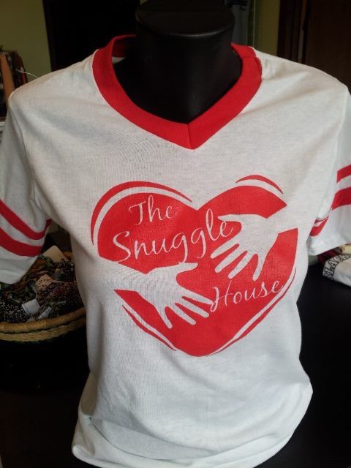

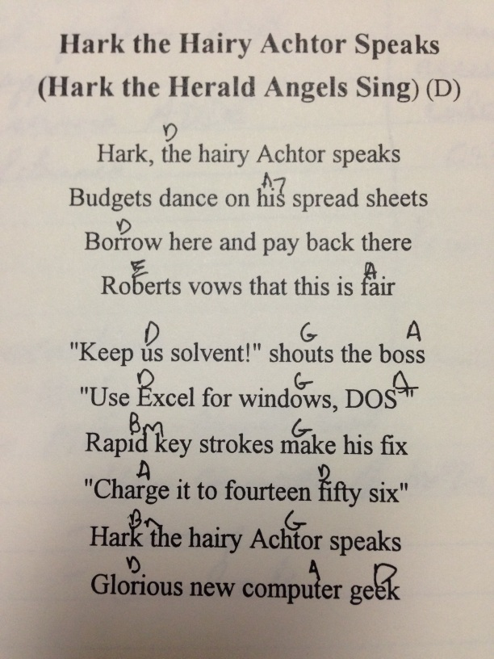

We Wish You a Merry Christmas

http://www.laurasmidiheaven.com/00-MIDI/2/001111982867/We%20Wish%20You%20A%20Merry%20Christmas!

We wish you a merry Christmas
We wish you a merry Christmas
We wish you a merry Christmas
And a happy new year!

Good tidings we bring to you and your kin
Good tidings for Christmas and a happy new year!
We wish you a merry Christmas
We wish you a snowy season
We wish you a shorter winter
And a happy new year!

Set List

