Determining Global 3D Winds by Tracking Features in Time Sequences of CrIS Humidity and Ozone Retrievals
David Santek ¹, Elisabeth Weisz¹, W. Paul Menzel¹, and David Stettner ¹
¹University of Wisconsin–Madison Cooperative Institute for Meteorological Satellite Studies/Space Science and Engineering Center.
Corresponding author: David Santek (dave.santek@ssec.wisc.edu)
†1225 W. Dayton St., Madison, WI 53706

Key Points:
- 3D winds are retrieved by tracking water vapor and ozone features on pressure surfaces from infrared sounders on three polar-orbiting satellites
- The current 3-satellite configuration provides insight into the potential of SmallSat wind missions.
- Insight is given into the capabilities when all geostationary satellites are equipped with IR sounders.

Abstract
The next-generation geostationary satellites are expected to have hyperspectral infrared (IR) sounders, providing hemispheric coverage of satellite-derived vertical profiles of temperature, moisture, and wind in clear skies and above clouds. Derivation of winds, or atmospheric motion vectors (AMVs), from IR hyperspectral sounders was first demonstrated using Aqua AIRS retrievals. The AMVs on discrete pressure levels (3D winds) provided, for the first time, vertical profiles of wind information in the polar regions. Since then, the capability has been extended to tracking features in global profile retrievals of humidity and ozone derived from CrIS and IASI radiances. And, it is now demonstrated for the first time globally using retrievals at single-field of view resolution from successive overpasses of three CrIS instruments on NOAA-21, NOAA-20, and SNPP flying in formation. 3D winds from polar-orbiting satellites can provide all-latitude (“global”) coverage giving insight to capabilities when all geostationary satellites are equipped with IR sounders.
Plain Language Summary
We developed an algorithm to derive 3D winds at 45 vertical levels from three polar-orbiting satellites flying in formation, carrying infrared sounding instruments. This mitigates the height assignment issues that have plagued atmospheric motion vectors (AMVs) derived from tracking features in successive satellite images. Moreover, the unique short temporal spacing between satellites (~25 minutes) results in global wind coverage. This 3D winds product provides a vertical distribution of AMVs throughout the troposphere and into the lower stratosphere, in clear sky and above cloud. This complements the traditional cloud-tracked AMVs. This uncommon operational satellite configuration is temporary, but provides insight into future SmallSat wind missions and a time when geostationary satellites are equipped with IR sounders.

1 Introduction
The derivation of atmospheric motion vectors (AMVs) from infrared (IR) high spectral resolution (or hyperspectral) sounders was first prototyped using Aqua Atmospheric Infrared Sounder (AIRS) retrievals at CIMSS/SSEC (Santek et al., 2019). The AMVs on discrete pressure levels (3D winds) provided for the first time vertical profiles of wind information in clear sky and above clouds in the polar regions. Since then, the capability has been extended to tracking features in global profile retrievals of humidity and ozone derived from the Cross-track Infrared Sounder (CrIS) mid-wave and short-wave radiances on NOAA-21, NOAA-20, and SNPP. Retrieval products have been generated using the Dual Regression (DR) method that derives atmospheric profiles, surface parameters, and cloud properties simultaneously under clear and cloudy conditions from any of the current hyperspectral infrared sounders at single field-of-view (SFOV) resolution. With three CrIS instruments flying in the afternoon orbit, time sequences of these global humidity and ozone profile fields enable feature tracking to determine atmospheric motion vectors (AMVs). Tracking features in retrieval fields rather than in the radiance images enables estimation of wind profiles at retrieval-determined pressure levels. This approach has been previously demonstrated from successive:
- AIRS overlapping successive passes from a single satellite in polar regions (Santek et al., 2019),
- CrIS overpasses from two satellites providing coverage from latitude 70° N to 70° S at grid spacing of one degree (Ouyed et al., 2023),
- IASI (Infrared Atmospheric Sounding Interferometer) overpasses from two satellites providing global coverage using an optic flow approach (Héas et al., 2023),
- Time-separated Earth scans with regional coverage from the Geostationary Interferometric Infrared Sounder (GIIRS) (Meng et al., 2024).
but is now demonstrated for the first time globally using SFOV (approx. 15 km) retrievals from successive overpasses of a triad CrIS instruments. In addition, the SFOV higher spatial resolution has the potential to derive more accurate wind information over the lower resolution standard retrieval product for CrIS and IASI, which generally operate on 3x3 FOVs. And, the DR can be tuned to generate moisture retrievals in cases of reduced spectral bands, for example, the failure of the long-wave band on SNPP CrIS or future small-sat missions which may only contain the short- and mid-wave bands.
This work gives an early look at the anticipated capabilities of the next-generation geostationary satellites (GeoXO, MTG) that are expected to have GEO hyperspectral infared sounder (GeoHIS) instruments providing hemispheric coverage of satellite-derived vertical profiles of temperature, moisture, and wind in clear sky and above clouds (Li et al., 2022). The typical temporal cadence of GIIRS and GeoHIS (30 minutes) is similar to the unique CrIS triad configuration (25 minutes). And, the spatial resolution of CrIS (15 km) is approximately the same as the current GIIRS (16 km), while the future GeoHIS expected to be much higher resolution of 4 km. There are some differences. An advantage of a geostationary orbit is the viewing angle is relatively constant over small regions for feature tracking, while the successive polar orbit passes have varied viewing angles of features requiring a parallax correction, especially at higher altitudes. But, until there is a global constellation of geostationary sounders, winds derived from IR retrievals (3D winds) from polar-orbiting satellites will be the only source of all-latitude (‘global’) height assigned 3D wind vectors.

2 Background
Santek et al. (2019) noted that “a recognized deficiency in the global observing system is an accurate depiction of the 3D structure of the global wind field. Knowledge of the wind field is essential to our understanding of general circulation and to accurately define the atmospheric state for initialization of numerical weather prediction models. However, the 3D structure of the global wind field is generally unobserved.” They showed that current tracking of atmospheric features in time sequence of multispectral images to produce AMVs (Atmospheric Motion Vectors) have data voids especially in the middle troposphere which is often related to inaccurate height assignment. Tracking features in atmospheric profile retrievals of humidity or water vapor (WV) and ozone (O₃) concentrations was suggested as a height-assigned alternative. It was noted that this would yield the total horizontal wind including the ageostrophic component that is key to understanding atmospheric dynamics. Ageostrophic circulations play a significant role in the dynamics of weather systems from the mid- and high-latitudes (e.g., synoptic scale baroclinic waves and into the tropics (e.g., low-level jets). Initial studies with repeat coverage in the polar regions by the Atmospheric Infrared Sounder (AIRS) onboard the Aqua satellite showed that (1) AIRS AMVs compare favorably to co-located imager AMVs for a six-week period, as evidenced by a zero-speed bias with a standard deviation of 3.5 ms⁻¹, (2) the impact per AIRS moisture AMV is very good, as they are ranked higher than all other satellite-derived wind datasets, and (3) the neutral, or slightly positive, forecast impact due to the addition of the AIRS retrieval AMVs is encouraging as these AMVs are only in the polar region, but they have an impact in the longer-range forecast over the northern hemisphere.
With the advent of several hyperspectral sounders in the afternoon orbit, three Cross-track Infrared Sounders (CrIS), it is now possible to track features globally twice per day from time sequences of profile retrievals generated from successive overpasses of the CrIS. With NOAA-21 fully commissioned and operational, equator crossing times occur at 130 pm, roughly 50 minutes (half an orbit) ahead of NOAA-20. Suomi-NPP orbits between the two, about 25 minutes away from each. From this triad of CrIS measurements, it is possible to generate global profile retrieval fields separated in time, and thus provide the opportunity to generate height assigned AMVs from the resulting humidity and ozone fields. An example of the coverage from the ascending and descending orbits of the retrieval from NOAA-20 CrIS data on 15 October 2022 of the 500 hPa relative humidity (RH) using the Dual-Regression (DR) retrieval algorithm is shown in Figure 1.
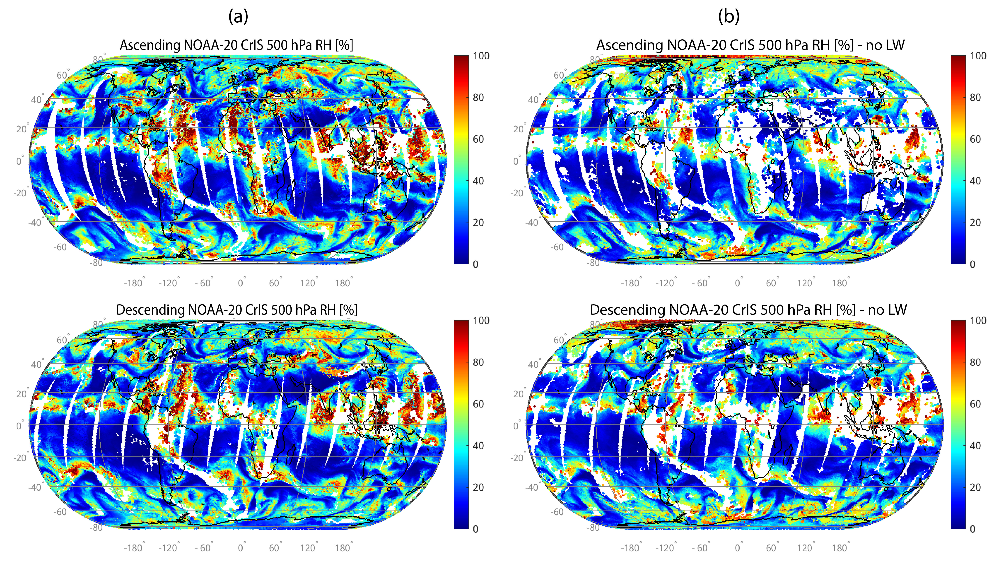

Figure 1. NOAA-20 CrIS 500 hPa RH retrievals from the ascending (upper) and descending (lower) orbits on 15 Oct 2022. Retrievals using all three bands (a) and without the longwave band (b).
The coverage has some holes from the cloud coverage but overall offers ample opportunity to track features and produce good mid-level tropospheric AMVs. A caveat to the CrIS triad is that SNPP CrIS IR spectral coverage lost its long-wave (LW) channels due to an instrument failure late in its life. On 15 Oct 2022 all three CrIS instruments were operating in all three spectral regions LW, MW, and SW; to demonstrate the impact of the loss of the LW band, we removed it from a second set of retrievals (shown in the right panels of Figure 1b). Dual Regression retrievals of humidity using just mid-wave (MW) and the short-wave (SW) bands differ from those using all three bands; inspection of humidity fields determined from three versus two bands (Figure 1a vs Figure 1b, respectively) indicate that the feature tracking in MW + SW retrievals will be somewhat reduced from that available in LW + MW + SW retrievals. Nonetheless, we show that the resulting 3-D winds from 2 band retrieval tracking are found to still provide new information about global atmospheric flow especially for mid-level winds found in the early stages of hurricane development.

3 Methodology
CrIS and AIRS retrieval products have been generated using the Dual-Regression (DR) method (Smith et al., 2012; Weisz et al., 2013) that derives atmospheric profiles, surface parameters, and cloud properties simultaneously under clear and cloudy conditions from any of the current hyperspectral IR sounders (i.e., AIRS, IASI and CrIS) at single field-of-view (SFOV) resolution. Since Dual-Regression is an IR-only algorithm the retrieval yield depends on the cloud coverage. Full temperature, humidity, and ozone profiles, i.e., from the surface to top-of-atmosphere (TOA), are provided only under clear-sky conditions both day and night. Under cloudy conditions the profiles are given from the cloud top to TOA, although under thin and/or broken clouds levels below the clouds are included as well. As will be elaborated further below, WV and ozone feature tracking to produce AMVs is done in clear regions and above clouds only; therefore, a sufficiently large number of successive overlapping overpasses is required to collect enough clear profile retrievals to reach the desired yield in AMVs.
The procedure to derive AMVs from retrieved humidity fields on pressure surfaces is described in Santek et al. (2019), and is updated here for the current satellite configuration. AMVs are extracted from a time sequence of three profile retrieval fields. The input data files are three time-ordered humidity or ozone concentration images, each separated by 25 minutes, on 45 pressure levels (103 to 778 hPa) and forecast model output. Three images are used because consistency between vectors derived from each pair provides a measure of quality in the winds. The model output is used to determine a first guess for target tracking. The 6-, 9- or 12-hour forecasts are linearly interpolated to the middle-image time. From the middle image of the triplet, potential targets are determined by locating rectangular regions where the bi-directional gradient in the humidity or ozone exceeds a user-specified threshold. The target size is determined based on the spatial resolution of the images and the time interval between images. After evaluations of different target sizes, a 5 × 5 box was chosen as it resulted in the best coverage of AMVs. The search box, wherein the best match of the chosen target box is sought, in the first and third images is 16 × 16 pixels. Unlike tracking cloud or water vapor features in typical infrared images, tracking features in images from AIRS retrievals of humidity or ozone are in clear areas and above clouds. This results in coverage of regions that are typically not possible from traditional cloud-tracked AMVs. If even one cloud pixel is in the target or search box, the cross-correlation cannot be computed, and that potential feature to track is discarded.
The initial target locations are investigated one-by-one to compute a displacement speed with the same feature at a time before and after the target image time. A first guess wind is interpolated from the model forecast at the location and pressure surface on which the features are being tracked. This guess is used to calculate a position in the first and third images of the sequence where the feature should be. The image data within the target and larger search box regions are read. A cross-correlation is computed between the target and sub-regions throughout the search box for the first pair of images. The highest correlated point between the target array within the search box is found and the vector displacement between these two points is calculated. This process is then repeated for the second image pair. Once the intermediate wind vectors are determined, acceleration checks are performed. The intermediate vectors are compared to each other. If the difference in the u- or v-component is greater than 10 ms⁻¹, this vector is flagged as poor quality. The intermediate vectors are then compared to an interpolated model forecast wind vector. Departures greater than 10 ms⁻¹ from the guess u- and v-components are flagged for each wind vector, although these are still considered good wind vectors. Slow vectors, speeds less than 3 ms⁻¹, are flagged as unusable. There are two independent routines used for automatic quality control (QC) of the AMVs. The first utilizes the statistical properties of a computed quality indicator for each wind vector using several consistency tests. The Quality Indicator (QI) for each AMV is calculated by estimating consistency in the intermediate wind vector pairs, spatial coherence, and (optionally) the deviation from the model grid. A QI larger than 60 is considered a wind of good quality. The second quality measure is a two-stage, three-dimensional objective analysis, based upon a recursive filter analysis, which utilizes weighted numerical model information as a background field.

4 Initial Results
CrIS data from 8 to 28 September 2023 (available in MW and SW bands for all three CrIS), was collected that covers different stages of development for several tropical cyclones and hurricanes in the Atlantic: Hurricanes Lee, Margot, and Nigel; Tropical Storms Ophelia and Philippe. The traditional cross-correlation (CC) pattern matching was used for feature-tracking (e.g., clouds) to produce satellite-derived atmospheric motion vectors (AMVs). For this 21-day period, nearly 4 million globally distributed winds were generated at 45 vertical levels (from 103 to 778 hPa). These are clear-sky and above-cloud winds. Initial evaluation of one day (13 September 2023) which had two hurricanes in the Atlantic is presented here. Figure 2 shows the locations of the AMVs for a single day at 200 hPa and shows very good global coverage, as these AMVs are above most clouds. Mid-troposphere levels typically lack satellite-derived winds, because there are few clouds at these levels that enable cloud tracking. However, tracking water vapor features from the CrIS retrievals has the potential to fill that gap, which is evident in the 500 hPa coverage shown in Figure 2, including in low latitudes. Figure 3 is an orbit segment passing near Hurricane Lee during its phase of weakening with AMVs derived in clear and above low cloud regions to the northwest of Lee. Nearby yellow and cyan AMVs in the low- to mid-troposphere capture the cyclonic circulation, while upper level AMVs (magenta) above Lee exhibit the anticyclonic outflow. Additional wind information in these regions could improve hurricane track and intensity forecasts. Figure 4 shows a vertical profile of the CrIS AMVs minus the ERA5 reanalysis winds, and shows a very good agreement, with a bias of -0.5 ms⁻¹ below 550 hPa and the vector standard deviation ranging from 2 to 3 ms⁻¹ through the depth of the mid-troposphere. At this time, a parallax correction is not being applied which may explain the increasing degradation of the bias from 550 to 400 hPa. The ERA5 is used as a proxy for rawinsondes when most observations are in data-void regions or when a short time interval is used (e.g., one day).
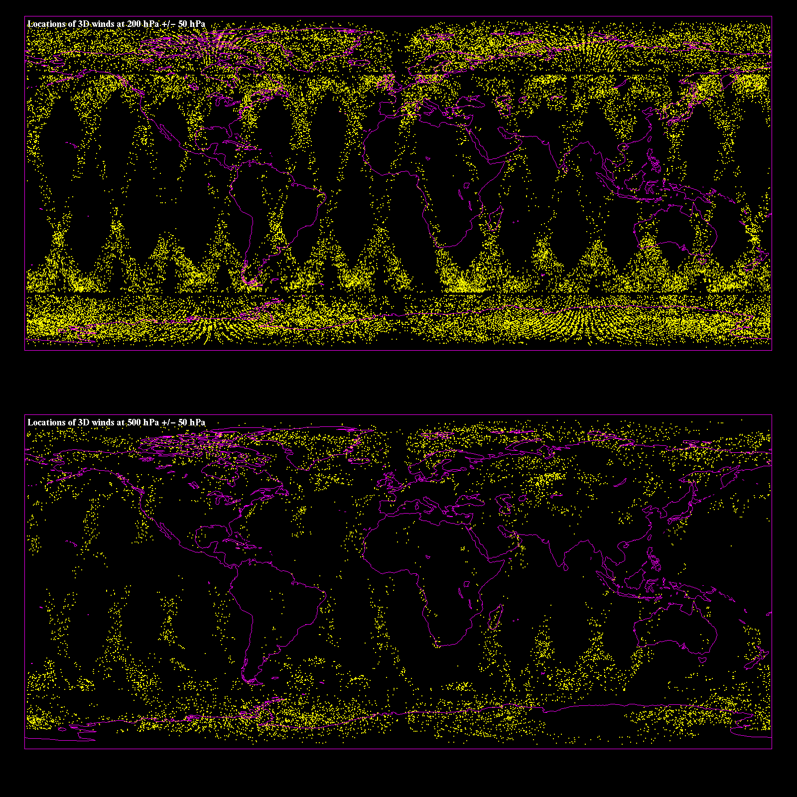

Figure 2. Locations of 200 hPa winds (upper) on 13 September 2023. There is very good global latitudinal coverage as this pressure level is above most clouds, except in some tropical regions. In the lower panel are the locations of the winds in the mid-troposphere (500 hPa). Additional gaps in coverage, as compared to the upper panel, are due to clouds that exist at or extend above 500 hPa.

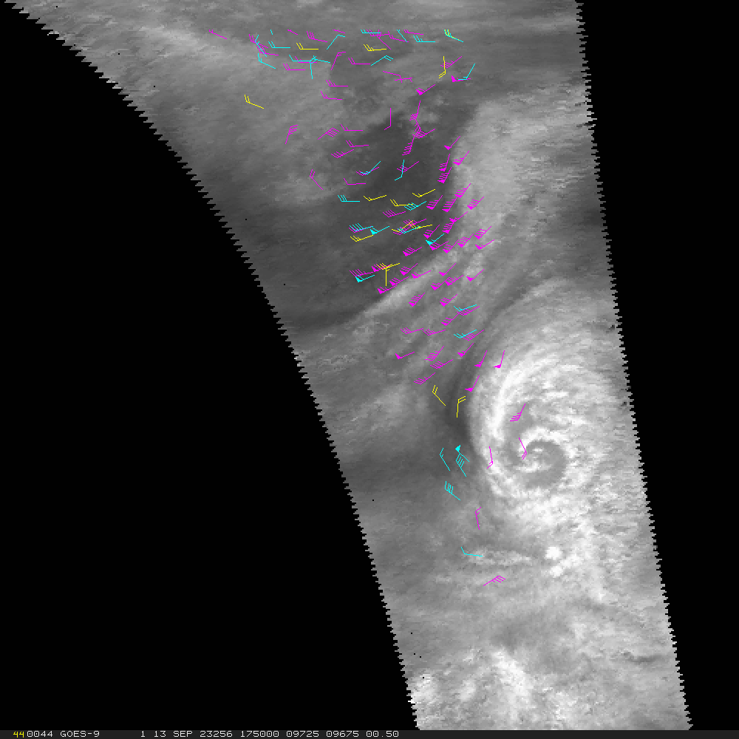

Figure 3. 500 hPa winds, plotted as wind barbs, for 13 September 2023 at 1750 UTC overlaid on a 500 hPa surface of retrieved humidity from NOAA-21. The wind barbs are color coded by pressure: 100 to 400 hPa (magenta), 400 to 700 hPa (cyan), below 700 hPa (yellow). Note the locations of AMVs in the clear and low cloud regions to the northwest of Hurricane Lee; its intensity at this time was about 95 kts.
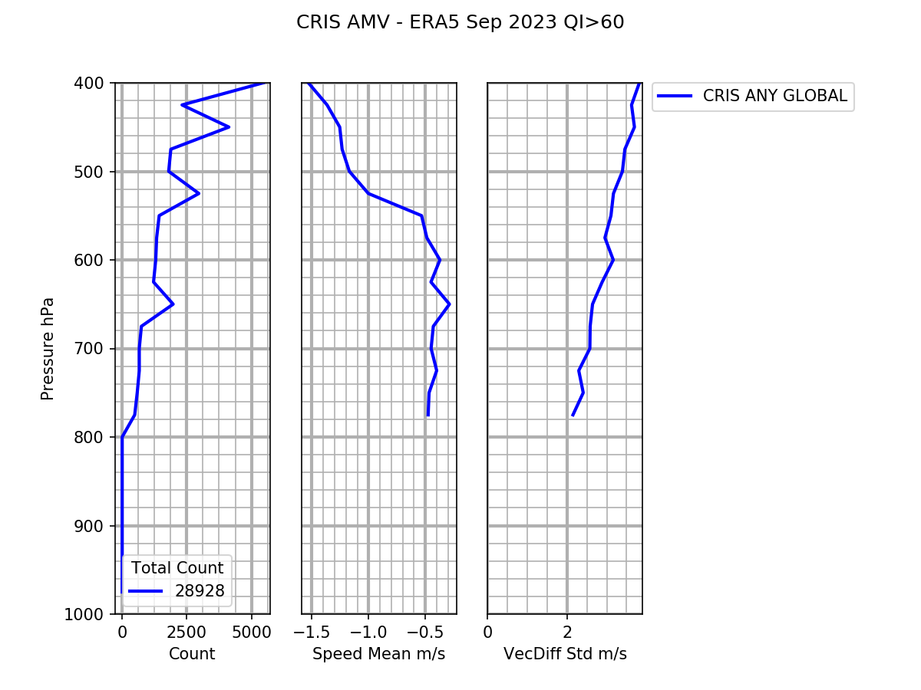

Figure 4. Vertical profile of the CrIS 3D winds minus the ERA5 reanalysis: AMV count (left), speed bias (middle), standard deviation of vector difference (right). This covers the time period 8 to 28 September 2023 of winds with a QI > 60.

5 Conclusions
In summary, this initial inspection of the horizontal and vertical coverage of the three CrIS 3D AMVs finds that there is
- reasonable completeness of global coverage (no large gaps were created by IR retrieval difficulties in clouds),
- representativeness of the wind profiles to atmospheric flow at different levels (especially at mid-levels in the troposphere),
- similarity with ERA5 wind determinations,
- information regarding the mid-level flow of hurricanes that can have a significant positive impact on the track and intensity forecasts.
More complete analysis will be undertaken to assess the impact on numerical model forecasts. It must ascertain whether the radiances assimilated already provide adequate information on the atmospheric motions or whether the retrieval-derived AMVs add additional useful flow fields to the model.
We were able to take advantage of this unique NOAA operational satellite configuration as it provides insight into the expected 3D wind coverage from future SmallSat wind missions and the quality and usability of 3D winds when all geostationary satellites are equipped with IR sounders.

Acknowledgments
The authors gratefully acknowledge the NOAA funding provided by Dr. Satya Kaluri through the Cooperative Institute for Meteorological Satellite Studies (CIMSS) via NOAA grant NA20NES432003.

Open Research – Data Availability
CrIS Level 1 data and Global Forecast System (GFS) grids, used as the inputs to the algorithm in this study, can be accessed through NOAA CLASS (NOAA 2024) and NOMADS (2024), respectively. The algorithms used in this study are based on the CrIS humidity and ozone retrievals as described by Smith et al. (2012) and Weisz et al. (2013) and the 3D winds feature tracking algorithm from Santek et al. (2019). The DR retrieval approach is the core of the HSRTV (hyperspectral retrieval) software package, which is freely available through https://cimss.ssec.wisc.edu/cspp/.

References
Héas, P., O Hautecoeur, and R. Borde, 2023: 3D wind field profiles from hyperspectral sounders: revisiting optic-flow from a meteorological perspective. Phys. Scr., 98, 115208 https://doi.org/10.1088/1402-4896/acf3a8
Li, J., W. P. Menzel, T. J. Schmit, and J. Schmetz, 2022: Applications of Geostationary Hyperspectral Infrared Sounder Observations: Progress, Challenges, and Future Perspectives. Bull. Amer. Meteor. Soc., 103, E2733–E2755, https://doi.org/10.1175/BAMS-D-21-0328.1.
Meng D., Z-M. Tan, J. Li, Z. Ma and Y. Chen, 2024: Added value of three-dimensional horizontal winds from geostationary interferometric infrared sounder for typhoon forecast in a regional NWP Model. J. Geophy. Res.: Atmospheres, 129, e2024JD040736.
NOAA Operational Model Archive and Distribution System (NOMADS). (2024). Global Forecast System (GFS). National Centers for Environmental Prediction. https://nomads.ncep.noaa.gov
National Oceanic and Atmospheric Administration (NOAA). (2024). Cross-track Infrared Sounder (CrIS) data. NOAA Comprehensive Large Array-Data Stewardship System (CLASS). https://www.aev.class.noaa.gov/saa/products/search?datatype_family=CRIS_SDR
Ouyed, A., Smith, N., Zeng, X., Galarneau, T., Jr., Su, H., & Dixon, R. D., 2023: Global three-dimensional water vapor feature-tracking for horizontal winds using hyperspectral infrared sounder data from overlapped tracks of two satellites. Geophysical Research Letters, 50(7), e2022GL101830.
Santek, D, S. Nebuda, and D. Stettner, 2019: Demonstration and Evaluation of 3D Winds Generated by Tracking Features in Moisture and Ozone Fields Derived from AIRS Sounding Retrieval. Remote Sens., 11, 2597, https://doi.org/10.3390/rs11222597
Smith, W.L., E. Weisz, S. Kirev, D.K. Zhou, Z. Li, E.E. Borbas, 2012: Dual-Regression Retrieval Algorithm for Real-Time Processing of Satellite Ultraspectral Radiances. J. Appl. Meteorol. Clim., 51, 1455–1476, https://doi.org/10.1175/JAMC-D-11-0173.1
Weisz, E., W.L. Smith, N. Smith, 2013: Advances in simultaneous atmospheric profile 3and cloud parameter regression-based retrieval from high-spectral resolution radiance measurements. J. Geophys. Res. Atmos., 118, 6433–6443, https://doi.org/10.1002/jgrd.50521

