24.3 Development of MetOp-SG Wind Properties
CIMSS Task Leader(s): David Santek
CIMSS Support Scientist(s): Jessica Maier, Dave Stettner, Tom Rink
NOAA Collaborator(s): Jaime Daniels
Budget: $53,000

Objective

Adapt the current polar winds algorithm for use with the EPS-SG METimage data using proxy data in preparation for an operational EPS-SG satellite in 2025.

Project Overview

The goal of this project is to adapt the existing polar winds algorithm for the Visible and Infrared Imaging Radiometer Suite (VIIRS) to the EPS-SG METimage instrument. The current VIIRS polar winds product uses the 10.76 µm (M-15 band) which has a nearly equivalent wavelength to the METimage 10.69 µm (VII-37 band). In addition, the METimage 6.72 µm (VII-33 band) has the same central wavelength as the Moderate Resolution Imaging Spectroradiometer (MODIS) band 27 water vapor band, which will enable the production of clear-sky winds which was not possible from VIIRS. Winds can now also be generated for the 7.33 µm (METimage VII-34) water vapor band, the 2.25 µm (VII-25) short wave IR band, and the 0.67 µm (VII-12) visible band.

The METimage polar winds product will provide wind speed, direction, and pressure of cloud-tracked and clear-sky water vapor features at high latitudes. This will complement the current polar winds products from MODIS and VIIRS. These polar winds are being operationally assimilated or monitored in many numerical weather prediction global models, including at NCEP, the Naval Research Lab (NRL), and the NASA Global Modeling and Assimilation Office (GMAO).

Milestones with Summary of Accomplishments and Findings

In preparation for EPS-SG, proxy datasets were produced and made available by the STAR calibration team, which have better coverage of the polar regions than the original proxy data from EUMETSAT, with additional orbits as well.

The third proxy dataset was made available in December 2022 and is comprised of global 1-minute granules for one day, 03 January 2000. This is the largest proxy dataset thus far, both temporally and spatially, and will result in the ability to compare and validate the winds with additional ground-truth datasets. For example, comparisons to rawinsondes will now be possible, which is one of the standard methods to evaluate Atmospheric Motion Vectors (AMVs).

A complete day of AMVs was generated from the IR window (VII-37; 10.7 µm), water vapor (VII-33; 6.7 µm), visible (VII-12; 0.67 µm), shortwave IR (VII-23; 1.4 µm), and a second water vapor band (VII-34; 7.3 µm). These winds were compared to the wind field from the ERA5 reanalysis. Figure 1 is an example vertical profile of the AMV counts, speed bias, and vector difference standard deviation of the MODIS and METimage IR winds compared to the ERA5. The shapes of the curves are similar, however, the MODIS winds over the Arctic (blue dashed) have a significantly higher count, slightly degraded bias, and improved vector difference standard deviation versus the METimage winds when compared to the ERA5.

Publications and Conference Reports
None at this time.
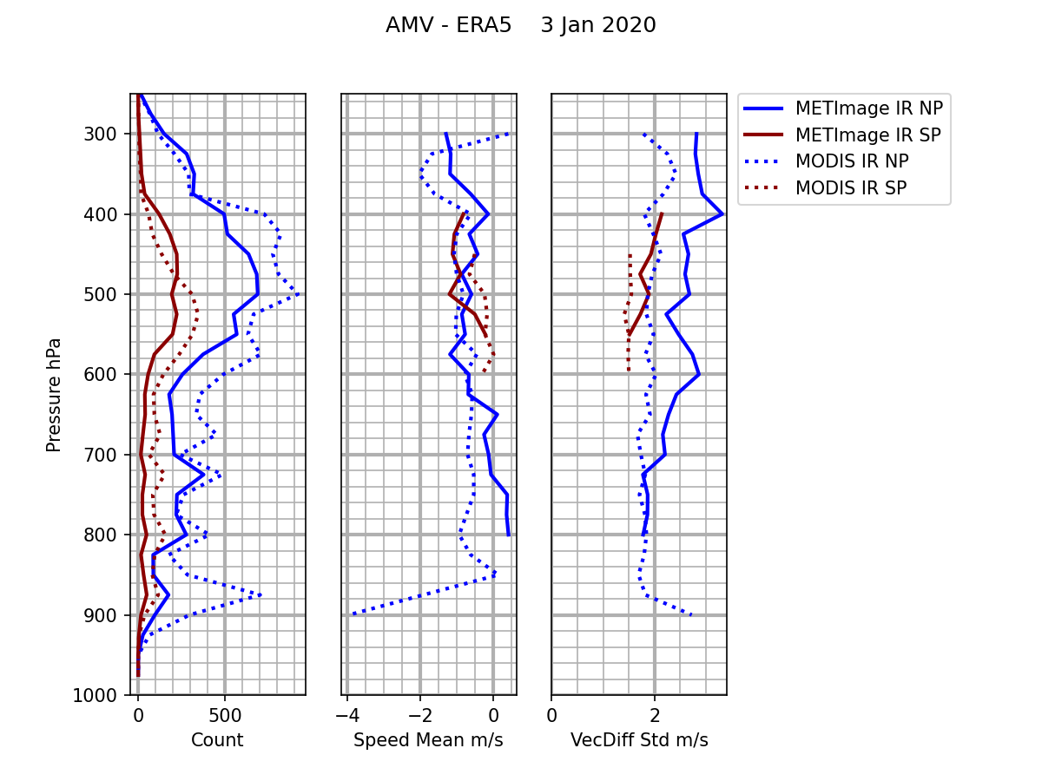

Figure 1: Comparison of MODIS and METimage IR AMV speed to the ERA5 reanalysis wind speed for 3 January 2020. Blue is Arctic; Red is Antarctic. The METimage data are solid lines; MODIS data in dashed.

