Task 2.1: Development of MetOp-SG Wind Properties

Project Lead: David Santek

Budget: $67,442

CIMSS Support Scientist(s): Dave Stettner, Tim Olander, Sharon Nebuda

NOAA/STAR Collaborator(s): Jaime Daniels

2.1.1) Project Description
The overall goal of this project is to evaluate the existing polar winds algorithm for the Visible and Infrared Imaging Radiometer Suite (VIIRS) to data from the EUMETSAT Polar System – Second Generation (EPS-SG) METimage instrument. The current VIIRS polar winds product uses the 10.76 µm (M-15) band, which has an equivalent wavelength to the infrared (IR) METimage 10.69 µm (VII-37) band. In addition, the METimage 6.72 µm (VII-33) band has the same central wavelength as the Moderate Resolution Imaging Spectroradiometer (MODIS) band 27 water vapor (WV) band, which will enable the production of clear-sky winds which was not possible from VIIRS.

The METimage polar winds product will provide wind speed, direction, and pressure of cloud-tracked and clear-sky water vapor features at high latitudes. The VIIRS winds have been produced operationally by NESDIS since May 2014 and are also being distributed via the EUMETCast broadcast. The VIIRS winds are being assimilated in NCEP’s operational version of the Global Data Assimilation System/Global Forecast System GDAS/GFS and the Naval Research Lab's (NRL) Atmospheric Variational Data Assimilation System - Accelerated Representer (NAVDAS-AR). They are also used by some numerical weather prediction centers abroad.

2.1.2) Benefit to the Public and Non-NOAA Users
- The METimage winds product parallels that of VIIRS, however, the Metop-SG satellites will be in a complementary orbit: NOAA-20/NOAA-21 are in the afternoon orbit; Metop-SG is in the morning orbit. Through the activities of this project, the outcome will be research results and prototyped implementation of deriving polar winds from METimage data. In turn, this new product is expected to be adopted by NESDIS operations and assimilated into numerical weather prediction (NWP) models, benefiting the general public through improved weather forecasts disseminated by NOAA. Moreover, the METimage winds will also used by other federal agencies that have similar weather models, such as the Navy (Fleet Numerical Meteorology and Oceanography Center (FNMOC)) and NASA (Global Modeling and Assimilation Office (GMAO)).
- Private sector companies developing NWP models with specialized forecasts serving various industries, such as aviation (e.g., Delta and Southwest Airlines, which have a staff of meteorologists), would also benefit from the METimage winds product.

2.1.3) Background and Previous Work
In preparation for EPS-SG, proxy datasets were produced and made available by the STAR calibration team, which has better coverage of the polar regions than the original proxy data from EUMETSAT, as well as additional orbits. The first STAR proxy dataset was constructed from Terra MODIS data; the second and third proxy datasets used the Community Radiative Transfer Model (CRTM) to generate the water vapor bands, with Terra MODIS and ECMWF data as input.

Since the Enterprise winds algorithm is not yet METimage-capable, winds (also known as atmospheric motion vectors (AMVs)) were derived using the heritage winds algorithm with the first proxy dataset to perform an initial evaluation and comparison to other wind datasets. However, this proxy dataset was not close in time for comparing to rawinsondes, so procedures were developed to compare the EPS-SG winds to the ERA5 reanalysis. A second proxy dataset was made available in early 2022 but lacked sufficient temporal and spatial coverage to generate enough winds for a complete assessment.

A third proxy dataset was made available in December 2022 and is comprised of global 1-minute granules for one day, 03 January 2000. This is the largest proxy dataset thus far, both temporally and spatially, and will result in the ability to compare and validate the winds with additional ground-truth datasets (e.g., rawinsondes). However, an inspection of the water vapor images revealed a lack of definition and contrast in clear sky regions, as compared to the first dataset. It is suspected that the use of the CRTM is the cause, as Terra MODIS was used in the first dataset, which preserved good definition in the METimage water vapor bands.

A complete day of AMVs was generated from the IR window (VII-37; 10.7 µm), water vapor (VII-33; 6.7 µm), visible (VII-12; 0.67 µm), shortwave IR (VII-23; 1.4 µm), and a second water vapor band (VII-34; 7.3 µm). These winds were compared to the wind field from the ERA5 reanalysis. Fig. 2.1.1 is an example vertical profile of the AMV counts, speed bias, and vector difference standard deviation of the MODIS and METimage IR winds compared to the ERA5. The shapes of the curves are similar, however, the MODIS winds over the Arctic (blue dashed) have a significantly higher count, slightly degraded bias, and improved vector difference standard deviation as compared to the METimage winds to the ERA5. Fig. 2.1.2 is a similar comparison to the ERA5, except for satellite-derived water vapor winds. The speed bias and vector difference standard deviation are similar to the IR winds; however, the count difference is much different with MODIS WV winds being twice that of the METimage WV winds. The reduced AMV count is due to the lower contrast in the images, which is likely the result of using the CRTM to create the simulated METimage images.

This has resulted in a baseline METimage wind product for comparison to those to be generated with the Enterprise algorithm.

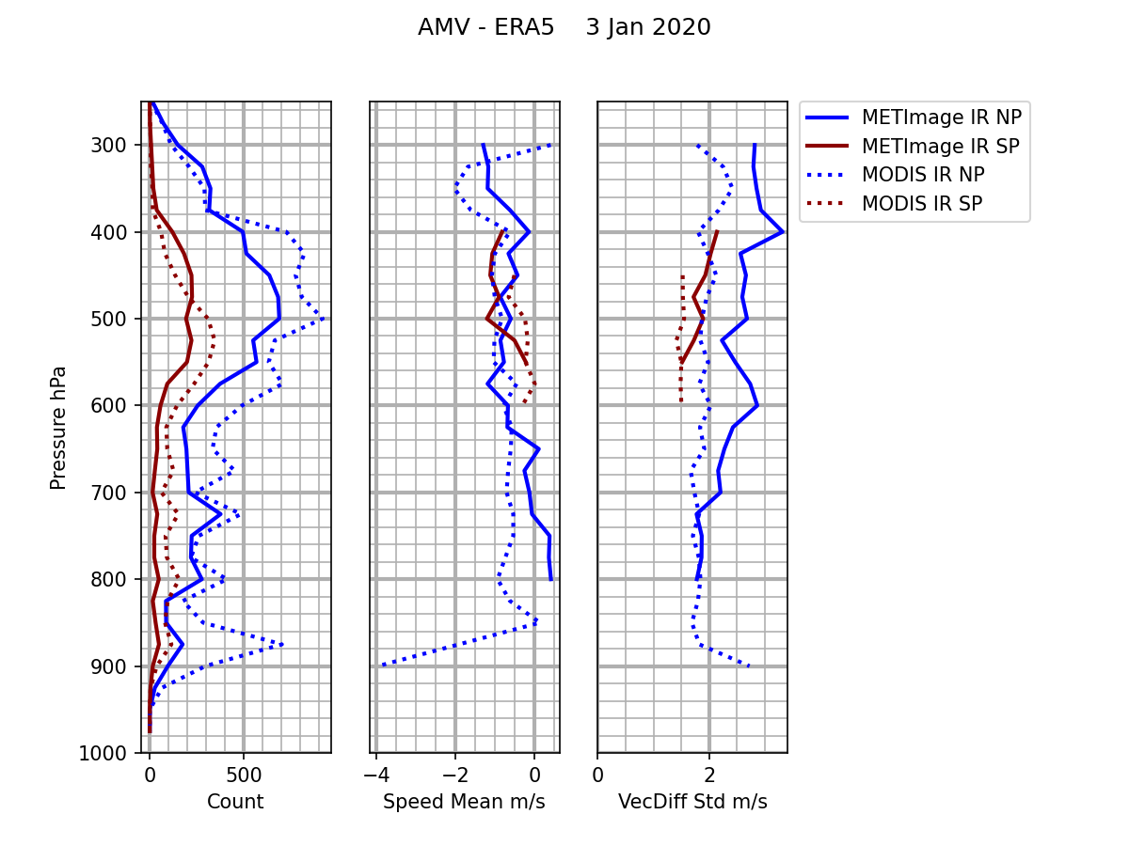
Figure 2.1.1: Comparison of MODIS and METimage IR AMV speed to the ERA5 reanalysis wind speed for 3 January 2020. Blue is Arctic; Red is Antarctic. The METimage data are solid lines; MODIS data in dashed.
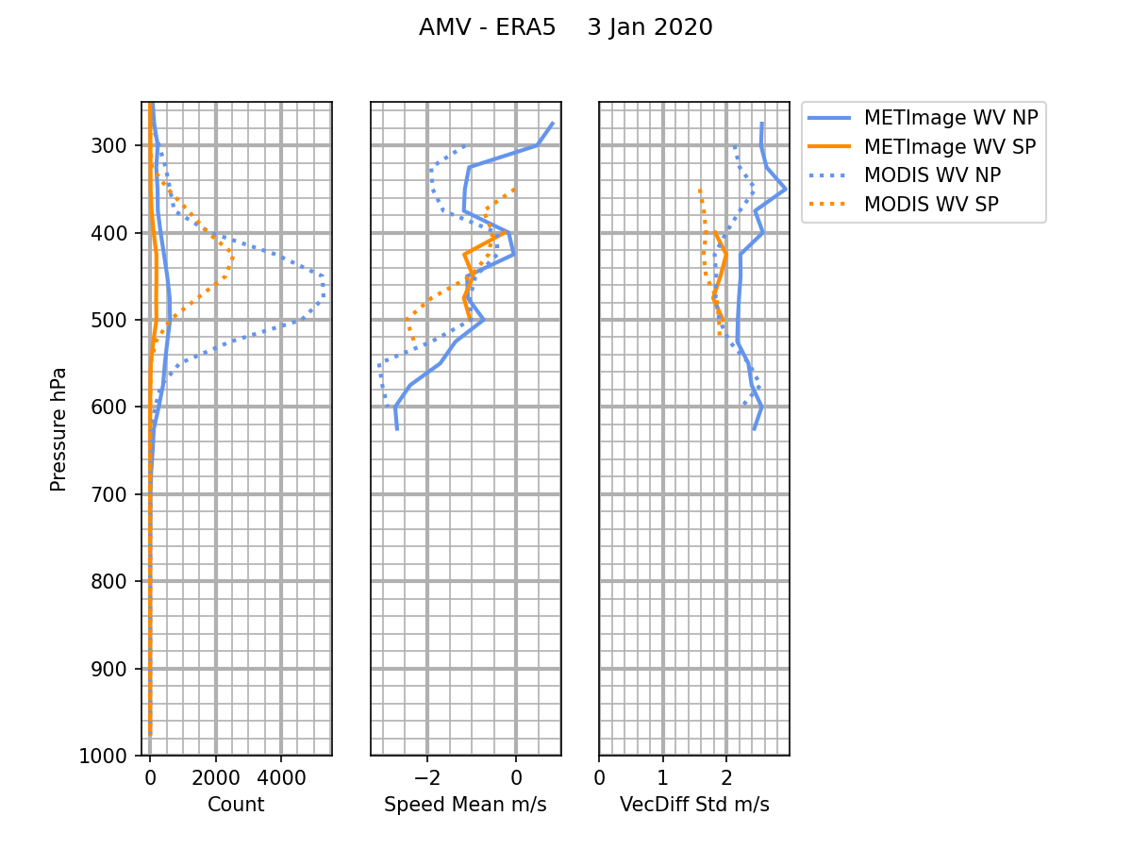
Figure 2.1.2: Comparison of MODIS and METimage WV AMV speed to the ERA5 reanalysis wind speed for 3 January 2020. Blue is Arctic; orange is Antarctic. The METimage data are solid lines; the MODIS data in dashed.
2.1.4) Proposed Activities for 2025-2026
Over the next year, the emphasis of this project will transition from using proxy data generated by NOAA and used with the heritage winds algorithm, to proxy and real-time data from EUMETSAT in the mission standard format to be used to derive AMVs in the CIMSS version of Enterprise framework. The launch of Metop-SG-A1 is expected in August 2025, with real-time data available about 6 months later.

- Since the Enterprise framework is currently not able to read the METimage data, a script will be written to reformat the METimage Level 1B to a VIIRS-like format, both of which are in netCDF format. Not only will this provide a means to test METimage data in the Enterprise framework winds algorithm, but it will also give insight into an approach to make the framework METimage-capable.
- Independently, the operational framework code will be updated to read the METimage netCDF files. Until that time, we will continue to use the CIMSS version of the framework and the converted files to generate AMVs using the proxy and possibly the real-time data when it’s available.
- Quantitatively compare the METimage wind products to their Metop-B/C and VIIRS counterparts, for both the proxy and real-time data (when available). If needed, the heritage winds code can be used to generate AMV datasets for specific case studies.
- Additionally, compare the METimage winds to rawinsondes and the ERA5 reanalysis.

2.1.5) Milestones
- Reformat proxy METimage Level 1B files into VIIRS-like netCDF files. (Quarter 1)
- Test the CIMSS version of the Enterprise framework winds code with the VIIRS-like netCDF files as input and evaluate as compared to Metop-B/C, VIIRS, rawinsondes, and the ERA5 reanalysis. These evaluations will use the scripts and procedures developed in previous years of the Metop-SG projects. (Quarter 2)
- Begin testing the winds generation of the real-time data, which is expected to begin in early 2026. Perform preliminary evaluations as described above. (Quarter 3)
- Automate the scripting for importing METimage files and processing AMVs at CIMSS, for routine generation of the winds. Continue with evaluations and comparisons. (Quarter 4)

UW-Madison CIMSS Data Sharing Plans

Task 2.1: Development of MetOp-SG Wind Properties
- Task Leader contact and descriptions of types of environmental data and information to be created or collected during the project

a. David Santek, Task Leader, Cooperative Institute for Meteorological Satellite Studies (CIMSS), University of Wisconsin-Madison, dave.santek@ssec.wisc.edu, 608-263-7410.

b. Various tools will be employed to share data amongst team members. Data will eventually be provided via a webpage, and as applicable, additional tools will become available for distributing any relevant data sets. We anticipate that this information will benefit both operational weather forecasters and numerical modelers.
- Type of collection method
Metop-SG METimage data granules will be obtained from EUMETSAT (proxy data, pre-launch) and from sites TBD once the satellite is operational. The data sets will be processed to derive satellite winds in the north and south polar regions. The product will be available via ftp and a visual summary at: http://stratus.ssec.wisc.edu/products/rtpolarwinds/.
- Tentative date by which data will be shared

As soon as possible.

- Standards to be used for data/metadata format and content

We will share the data/products with appropriate readme files in standard formats already accepted and widely used in the community.

- Policies addressing data stewardship and preservation

The satellite winds product will be available via ftp in real-time for 30 days. Thereafter, the product will be available on request from our archive.

- Procedures for providing access, sharing, and security, and prior experience in publishing such data
All data created by the project will be made available for download via FTP and/or HTTP within 24 hours of creation. We have been distributing such products in this manner for more than 15 years. The primary end user will be the CIMSS and NOAA researchers, and global NWP centers.

