## Task 2.3: CIMSS Support for Generation of 3D Atmospheric Motion Vectors from the ECO1280 Nature Run

### Project Lead: David Santek

### Budget: $120,656

**CIMSS Support Scientists: Tim Olander, Dave Stettner, Tom Rink**

### NOAA Collaborator: Lidia Cucurull (NOAA/OAR/ORTA)

**2.3.1) Project Description**

A system was developed at CIMSS to generate simulated Atmospheric Motion Vectors (AMVs) by tracking features from a time sequence of model humidity grids. This has been applied to regional and global models, including the GEOS-5 Nature Run (G5NR) and the ECMWF Cubic Octahedral (ECO1280) Nature Run. In addition, cloud top information and satellite orbit configurations are used to retain only those AMVs that are in clear sky, above cloud, and viewable from a predefined satellite orbit. These simulated AMVs provide a 3D distribution of winds on pressure surfaces which can be used in Observing System Simulation Experiments (OSSEs), for example, to evaluate the impact of passive winds derived from future hyperspectral infrared instruments.

**2.3.2) Background/Accomplishments**

The AMV simulator is based on the heritage winds algorithm developed and maintained at CIMSS for over two decades. There are three components to the heritage algorithm: target selection, feature tracking, and quality control:

1. From a time-sequence of three grids, potential targets are determined in the middle time grid by locating rectangular regions (patches) where the bi-directional gradient in the humidity field exceeds a user-specified threshold.
2. The initial target locations are investigated individually to compute a displacement speed of the same feature at a time before and after the target grid time. A cross-correlation is computed between the target and sub-regions throughout the search box for the first pair of grids. The highest correlated point between the target array within the search box is found and the vector displacement between these two points is calculated. This process is then repeated for the second grid pair.
3. There are two independent routines used for the automatic quality control (QC) of the AMVs. The first is a gross error check, which discards winds where the acceleration between the vector pairs is large. The second utilizes the statistical properties of a computed Quality Indicator (QI) for each wind vector by estimating consistency in the intermediate wind vector pairs and a 3D spatial coherence.

This algorithm was used to generate AMVs by tracking specific humidity features on eight tropospheric pressure levels (200, 250, 300, 400, 500, 600, 700, 850 hPa) from the ECO1280. To simulate AMVs from a hyperspectral IR sounder, two additional steps were required:

1. Winds were only retained in clear sky and above cloud by using a cloud-top pressure grid.
2. Subsequently, those winds retained in #4 were sampled based on a low earth orbiting (LEO) satellite and a prescribed instrument swath width.

The AMV simulator described above was applied to 2 months (June and July 2016) of ECO1280 grids, resulting in a global dataset of simulated clear sky and above cloud AMVs as viewed from nine LEO satellites flying in three time-separated triplets, in three orbits at local equator crossing times of 1330, 0930 0530. An example of the ECO1280 AMVs derived in a 3-hour window for the northern hemisphere, color-coded by pressure, is shown in Figure 2.3.1.

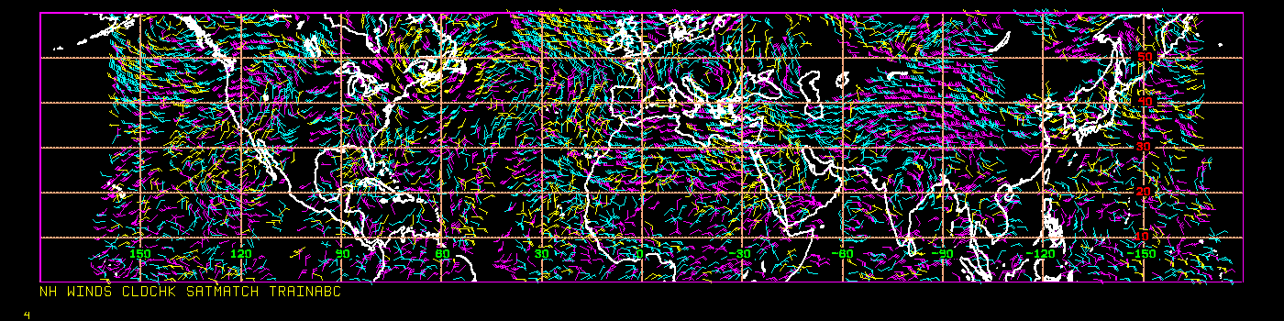

Figure 2.3.1: AMVs derived from the ECO1280 in a 3-hour time window covering latitudes from the equator to 60N. Yellow AMVs are below 700 hPa; cyan 400-700 hPa; and magenta above 400 hPa.

Initial statistics from this first case study are encouraging with the simulated AMVs having a u- and v-component wind bias of 0.1 to 0.3 m s-1 and RMS difference of 2.0 to 2.5 m s-1 compared to the ECO1280 model wind field.

The final output is a dataset of AMVs stored in BUFR format, binned by model assimilation cycle, for use in OSSEs.

**2.3.3) Proposed Work and Technical Approach:**

There are two main research efforts planned for this year: (1) Continue to refine the AMV simulator and (2) improve the tools to evaluate the quality and representativeness of the simulated AMV datasets.

(1) Refine AMV simulator: As described in section 2.3.2, the current AMV simulator is based on a CIMSS heritage *cloud* tracking algorithm which uses cross-correlation of image data patches to track features. For image data without cloud-like features (e.g., humidity fields), the use of optical flow for tracking may be a better option. We are in the process of evaluating WindFlow (Vandal et al. 2022), a machine learning-based system that uses optical flow for determining motion in time-separated gridded fields. There are several advantages to this system over the heritage winds code:

* The heritage winds algorithm requires a triplet of images, while WindFlow operates with a pair of images. This improves the temporal sampling of the winds generation.
* The optical flow algorithm results in a much higher density of winds, which can be used to simulate thinning strategies for nature run-based AMVs to account for instrument resolution and correlated errors.

In addition, WindFlow was trained using the GEOS-5 NR, so the existing system can be directly applied to the ECO1280, without re-training.

For an initial test, the WindFlow algorithm was applied to a pair of ECO1280 grids from 01 June 2016 at 00 and 03 UTC on the 500 hPa surface. The result is depicted in Fig. 2.3.2 as displacement vectors over the humidity field used to calculate the vectors. To validate the reasonableness of these vectors, the wind field from the nature run is shown in Fig. 2.3.3. Comparing the vectors from these two figures in regions of higher humidity features and fast wind speeds (over the central US, and south Pacific and Atlantic Oceans), shows a good qualitative agreement. Note: The WindFlow vectors in Fig. 2.3.2 are *pixel displacement* and the ECO1280 vectors in Fig. 2.3.3 are *wind speed*, so the vector lengths cannot be directly compared.

**Figure 2.3.2: Derived AMVs using WindFlow applied to a pair of ECO1280 grids from 01 June 2016 at 00 and 03 UTC on the 500 hPa surface. Color shading is humidity and vector length is based on pixel displacement of the feature motion.**

**Figure 2.3.3: ECO1280 wind from 01 June 2016 at 00 UTC on the 500 hPa surface. Color shading is humidity and vector length is based on the u- and v-component of the nature run wind.**

(2) Improve tools to evaluate the 3D winds: Since optical flow tracks individual pixels, the density of winds will increase significantly over the heritage winds algorithm. This will be beneficial when generating simulated AMVs for future missions with high-resolution instruments. However, it also results in new challenges in thinning strategies, assigning errors to the winds, and mitigating spatially correlated errors, all of which are important for data assimilation applications. Also, by using image pairs instead of triplets, the QI metric (described in Sec. 2.3.2) will require reworking. By using the ECO1280 grids (truth) for deriving AMVs using two independent methods, we anticipate being able to address the error characteristics and develop innovative techniques for quality control and QI determination.

**2.3.4) References**

Vandal, T., K. Duffy, W. McCarty, A. Sewnath, and R. Nemani. 2022. Dense Feature Tracking of Atmospheric Winds with Deep Optical Flow. In Proceedings of the *28th ACM SIGKDD Conference on Knowledge Discovery and Data Mining (KDD ’22)*, August 14–18, 2022, Washington, DC, USA. ACM, New York, NY, USA, 9 pages.   
https://doi.org/10.1145/3534678.3539345