14. CIMSS Research Towards Polar Orbiting Environmental Data Record (EDR) VIIRS Algorithms

14.1 CIMSS Research Towards Polar Orbiting Imager Derived Winds Science FY24
CIMSS Task Leader(s): David Santek
CIMSS Support Scientist(s): Rich Dworak, Tim Olander, Dave Stettner, Tom Rink
NOAA Collaborator(s): Jaime Daniels
Budget: $154,000

Objective
The objective of this project is to continue monitoring and assessing the quality of operational VIIRS winds from S-NPP, NOAA-20, and NOAA-21. Also, improvements to the current products and the possible addition of new products are explored.

Project Overview

The Suomi National Polar-orbiting Partnership (S-NPP), NOAA-20, and NOAA-21 Visible Infrared Imaging Radiometer Suite (VIIRS) polar winds product provides wind speed, direction, and pressure of cloud-tracked features at high latitudes. The VIIRS winds (also known as atmospheric motion vectors (AMVs)) have been produced operationally by NESDIS since May 2014. The VIIRS winds are being assimilated in NCEP’s Global Data Assimilation System/Global Forecast System GDAS/GFS and the Naval Research Lab's (NRL) Atmospheric Variational Data Assimilation System - Accelerated Representer (NAVDAS-AR). They are also used by additional numerical weather prediction centers abroad.

Scientists from the Cooperative Institute for Meteorological Satellite Studies (CIMSS) work with NOAA scientists in Madison and Washington, D.C., to jointly address validation methodologies, develop comparison and monitoring tools, and explore algorithm improvements.

Milestones with Summary of Accomplishments and Findings
Over the past year, we have:
- Evaluated the NOAA-20/NOAA-21 VIIRS tandem triplet AMVs, which showed an improvement over the single satellite winds. Figure 1 is a vertical profile of the mean vector difference (MVD) between rawinsondes and many different single-satellite winds (e.g., S-NPP, NOAA-20) and the NOAA-20/NOAA-21 tandem winds (magenta). The MVD of tandem winds is generally 0.5 to 1.0 ms⁻¹ improved over the single satellite winds.
- Completed the implementation and evaluation of the VIIRS shortwave IR (SWIR) winds in the CIMSS version of the Enterprise framework. These winds compare well with rawinsondes, have a positive impact when assimilated into NRL’s NAVGEM model, and are planned to be a NESDIS operational product.
- Begun an evaluation of the effect of viewing angle differences from successive polar passes on the quality of the AMVs. The initial results show a tendency for the parallax-corrected winds to be slower. This is likely due to the distance being shortened between the feature being tracked in time-separated images, as the location of the feature is pulled more toward nadir. When the feature is on the same side of nadir in both images (the predominant case), a slower speed results.
- Monitored the S-NPP, NOAA-20, and NOAA-21 VIIRS IR winds generated at CIMSS, NESDIS, and from Fairbanks and Sodankylä direct broadcast (DB) data. This has resulted in the Fairbanks VIIRS DB winds being imported into AWIPS to be displayed at NWS Alaska regional offices.

Publications and Conference Reports

Dworak, R., D. Santek, D. Stettner, and J. Daniels, 2025: Innovative Atmospheric Motion Vector Products from VIIRS. Proc. 17th International Winds Workshop, Newport News, Virginia, USA.

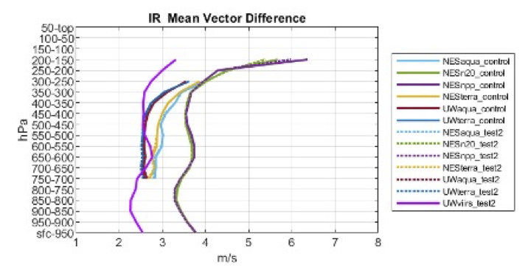
Figure 1: Vertical profile of the mean vector difference of VIIRS IR AMVs derived from alternating NOAA-20/NOAA-21 passes as compared to rawinsondes in magenta for April 2021. Other colors represent comparisons to additional polar orbiting satellite-derived winds.

