Deriving 3D Winds using Retrieved Moisture Fields from Microwave Sounders
PI: David Santek CoI: Brett Hoover
Collaborator: Mark Kulie (NOAA)

Contributors: Tim Olander, Chia Moeller, Elisabeth Weisz, Hong Zhang, Sharon Nebuda

SSEC2022 Proj. 4117 Final Report

01 February 2021

Summary
The Objectives and Expected Outcomes from the proposal are listed in the shaded box below. They were accomplished within budget; however, a time extension was needed to run the model experiment (which is still running at the time of this report).

Objectives
The scope of the project is as follows:
- Adapt existing processing scripts for the AIRS retrieval winds, for use with microwave retrievals to produce the product in near real-time,
- Evaluate the quality of the microwave-derived AMVs as compared to other 3D winds,
- Compute initial statistics (departures from the background) as compared to a numerical model,
- Seek proposal opportunities

Expected outcomes
We expect preliminary results will be included in future proposals to NOAA and NASA ROSES, which have funded related research using IR sounder retrievals. In addition, we are actively pursuing an opportunity led by Bill Blackwell (MIT), that would be a 3D winds mission based on microwave sounders on small satellites for the Air Force. Funding provided by SSEC2022 will help to keep SSEC at the forefront of 3D winds research and partnering opportunities in the future.

Briefly, the following were completed:
- We were able to produce the winds from the MiRS product in near real-time for several months. However, the file format was significantly changed in October 2020, so our processing has been suspended.
- The MiRS winds compare favorably to co-located AIRS retrieval winds, rawinsondes, and ERA5 reanalysis grids.
- A spectral analysis was performed on the ATMS instrument specifications to determine the degrees of freedom and information content in the retrievals of temperature and humidity. This gives an indication of the number of independent vertical levels that can be expected in the retrieved quantities.
- A 6-week GFS model experiment was begun on S4 to determine the impact of assimilating the MiRS winds. The experiment is not complete, however, preliminary observation minus background (OMB) statistics are reasonable.
- Results from this project were included in:
  - NOAA BAA Leo Sounder presentations and final report
  - Presentation to the NOAA SAT
  - Proposal to the JPSS PGRR FY21 (declined)
  - Proposal to NASA ROSES 2020 (in preparation)
  - The potential opportunity with Bill Blackwell did not happen

Details and figures on the above are presented in the following five sections.

- Near real-time generation of MiRS 3D winds
Satellite Data Services is currently receiving the Microwave Integrated Retrieval System (MiRS) product in near real-time from NOAA. The MiRS product consists of vertical profiles of retrieved temperature and humidity from the ATMS instrument onboard S-NPP and NOAA-20.

The MiRS data is then used as input to the Atmospheric Motion Vector (AMV) algorithm, which ran routinely from December 2019 to October 2020. Figure 1 depicts a single moisture retrieval level with winds from all pressure levels plotted.

Figure 1: Humidity image from 12 December 2019 at 500 hPa as derived by the MiRS algorithm. The wind vectors are from 17 pressure levels, ranging from 360 to 660 hPa, as derived by the winds algorithm that was developed for the AIRS retrieval winds.

- Evaluation of MiRS 3D winds

One month (March 2020) of MiRS AMVs were compared to the AIRS AMVs, rawinsondes, and ERA5 reanalyses using these co-location criteria: Distance threshold = 150 km; time threshold = 1 hour.

MiRS AMVs vs AIRS AMVs

Scatter plots of MiRS vs AIRS AMV speed for S-NPP and NOAA-20 (JPSS-1) are shown in Figure 2. The mean difference in speed is near zero ms⁻¹, with a reasonable RMS difference of 5.5 ms⁻¹. Figure 3 depicts the histogram of the speed differences, again separated by S-NPP and NOAA-20. These statistics and plots compare favorably with what was found for AIRS vs CrIS AMVs.

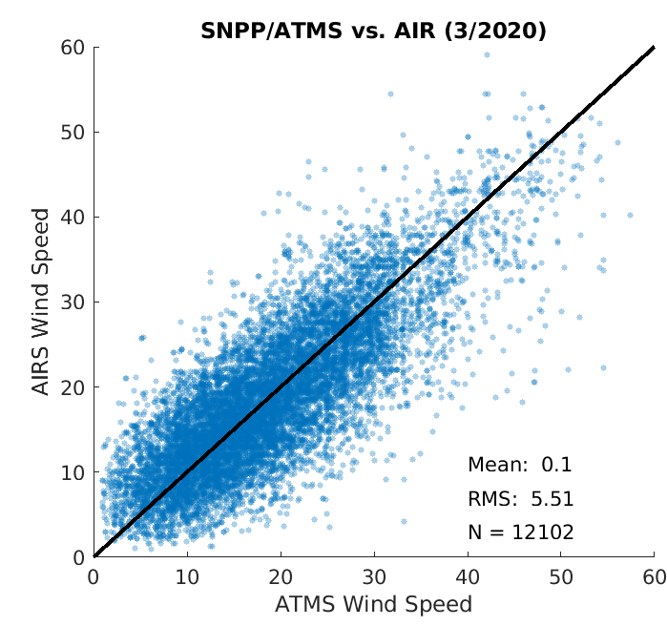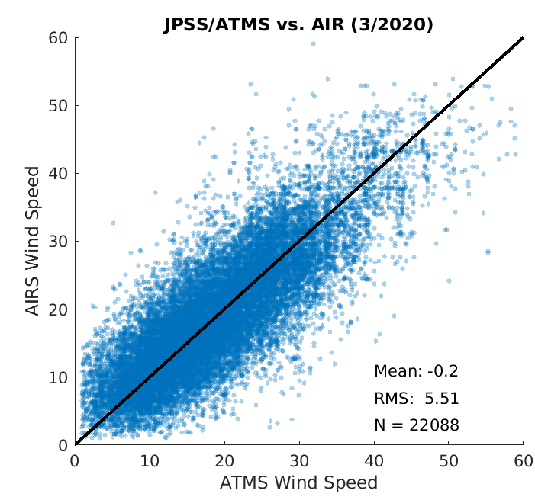
Figure 2: A scatter plot of AIRS vs MiRS AMV speed for March 2020 for S-NPP (left) and NOAA-20 (right). The wind vectors are from 17 pressure levels, ranging from 360 to 660 hPa, as derived by the winds algorithm that was developed for the AIRS retrieval winds.

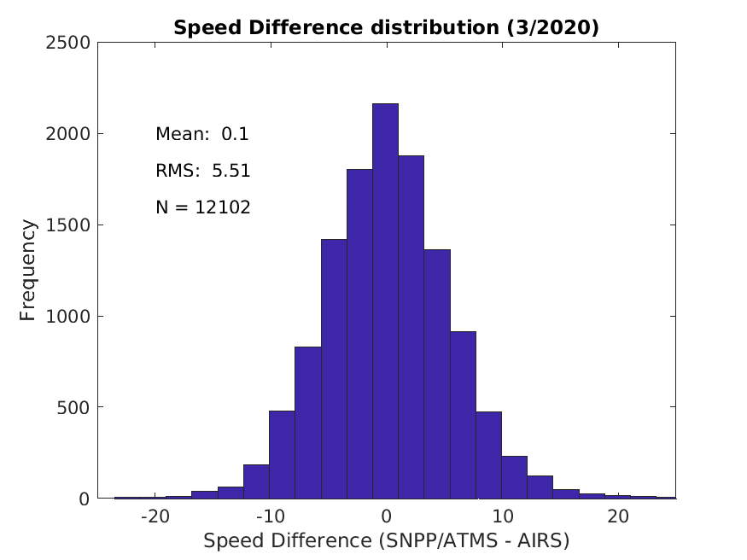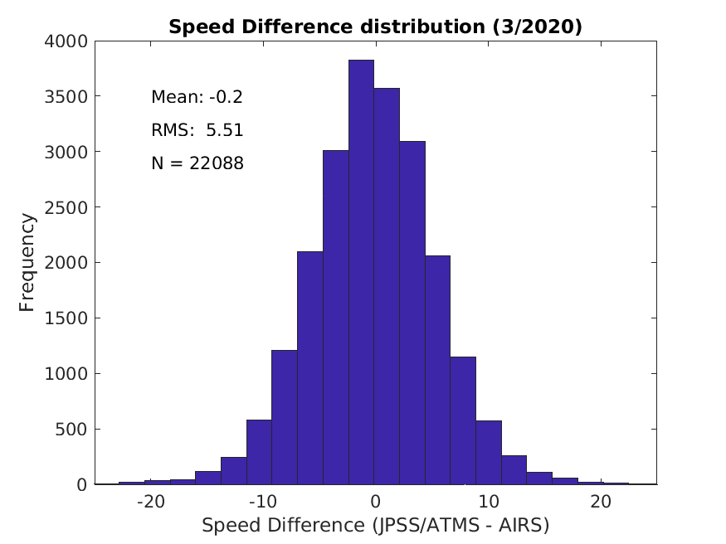
Figure 3: Same data as Figure 2, except as a histogram of speed differences between MiRS and AIRS.

MiRS AMVs vs rawinsondes

A frequency plot of wind speed differences between MiRS AMVs and co-located rawinsondes is shown in Figure 3 for NOAA-20. The mean difference is near zero ms⁻¹, with an RMS difference of 4.9 ms⁻¹. These statistics are nearly the same as a comparison of AIRS AMVs to rawinsonde winds for a two-month period in August and September 2019.

Figure 4: A scatter plot of MiRS AMV speed vs rawinsonde wind speed for March 2020 for NOAA-20. There are less than 2400 matches due to the scarcity of rawinsondes poleward of 70° latitude.

MiRS AMVs vs ERA5 reanalysis
Four days were selected (March 1, 11, 21, 31 of 2020) to compare the MiRS AMVs to the ERA5 reanalysis winds. In addition, winds from the AIRS and CrIS retrievals were included in the comparison plots. Figure 5 shows vertical profiles of the speed bias and RMSD between the retrieval winds and the ERA5. The bias and RMSD is very similar for the three sources of 3D winds, except the bias in the lower troposphere for the ATMS AMVs is the opposite sign as compared to winds from AIRS and CrIS.

One major difference in the retrievals from hyperspectral IR and microwave, is the ability of the microwave to sound through clouds. This is apparent in Figure 6 where the distribution of winds from MiRS (right) in the lower troposphere is not reduced nearly as much as from CrIS (left).

Figure 5: A vertical profile of the speed difference bias (dashed) and RMSD (solid) between MiRS (ATMS), AIRS, CrIS and the ERA5 reanalysis for March 1, 11, 21, 31 in 2020.

Figure 6: A vertical profile of the observation count by pressure level for CrIS (left) and ATMS (right) for March 1, 11, 21, 31 in 2020; from co-location to the ERA5.

The above comparisons to AIRS winds, rawinsondes, and ERA5 indicate that the 3D AMVs derived from the MiRS product have a similar quality to the AIRS and CrIS AMVs, which are being derived for a NASA ROSES project. And, the MiRS winds are complementary as they are derived in all-weather conditions, not only in clear air regimes.

- Spectral analysis of ATMS

Even though the retrieved quantities of water vapor and ozone are on 101 pressure surfaces for the MiRS and hyperspectral IR products, there are not 101 levels of independent information, as there is overlap due to the width of the weighting functions of the individual channels. To quantify the number of independent pressure levels from the retrieval algorithm, a spectral analysis is performed. This assessment involves the investigation of weighting functions, averaging kernels and retrieval error estimates following the retrieval characterization and error analysis for remotely sensed measurements by Rodgers (1990, 2000).

To perform a meaningful evaluation of the satellite data - with the goal of obtaining realistic error estimates, information content and resolution measures - a radiative transfer (or forward) model is used to compute radiances as well as the weighting functions at the instrument’s spectral channels from a known temperature and humidity profile. The RTTOV (Radiative Transfer for TOVS) radiative transfer model is used to compute the radiance spectrum and associated temperature and water vapor weighting functions from the 1976 US. Standard Atmosphere profile for all channels at 101 pressure levels. Given an atmospheric profile of temperature, water vapor and, optionally, trace gases, aerosols and hydrometeors, together with surface parameters and a viewing geometry, RTTOV computes the top of atmosphere radiances in each of the channels of the sensor being simulated.

From this analysis, two primary metrics result: Information Content (IC) and Degrees of Freedom (DOF). The DOF gives the number of independent pieces of information that can be measured and indicates the improvement over the background profile; the IC describes the information gained by making a measurement (relative to the a priori). This was done for both CrIS and ATMS.

The water vapor Information Content for CrIS, expressed in ‘bits’, is enumerated in the second row in Table 1 for three pressure layers and the total IC. These values can be directly compared with the IC from a different instrument, for example ATMS which is discussed below.

The Degrees of Freedom for CrIS (last row in Table 1) provide a measure of the number of independent pieces of information in the vertical retrieval of water vapor in the three pressure layers. The DOF ranges from 2 to 2.4 in each layer. So, even though the retrieval algorithm provides water vapor on more than 50 pressure levels from 100 to 1000 hPa, there are only about 7 levels of independent information.

Table 1: CrIS water vapor retrieval Information Content (IC) and Degrees of Freedom (DOF) in three pressure layers and total of the three layers for a US Standard Atmosphere.
Standard Atmosphere | WV  100-400 hPa | WV  400-700 hPa | WV  700-1000 hPa | WV  Total
Information Content | 12.99 | 17.92 | 13.17 | 44.08
Degrees of Freedom | 2.45 | 2.42 | 2.07 | 6.94

The water vapor Information Content for ATMS is enumerated in the second row in Table 2 for three pressure layers and the total IC. These are approximately a factor of 5 reduced as the IC from CrIS retrievals of water vapor (see CrIS IC in Table 1). This is not unexpected as CrIS has two orders of magnitude more channels and narrower weighting functions as compared to ATMS, resulting in the ability of CrIS to better resolve water vapor structure in the vertical.

The Degrees of Freedom for ATMS (last row in Table 2) provide a measure of the number of independent pieces of information in the vertical retrieval of water vapor in the three pressure layers. The DOF ranges from 0.5 to 1.0 in each layer. So, even though the retrieval algorithm provides water vapor on more than 50 pressure levels from 100 to 1000 hPa, there are only about 2.3 levels of independent information, which is a factor of 3 less than the DOF for the CrIS water vapor.

Table 2: ATMS water vapor retrieval IC and DOF in three pressure layers and total of the three layers for a US Standard Atmosphere.
Standard Atmosphere | WV  100-400 | WV  400-700 | WV  700-1000 | WV  Total
Information Content | 1.44 | 2.87 | 3.71 | 8.02
Degrees of Freedom | 0.54 | 0.71 | 1.07 | 2.32

- Assimilation of MiRS 3D winds

The final step of the project was to assimilate the winds into the GDAS/GFS. This is being done to quantify the NWP impact of the MiRS winds on the analysis and forecast. To this end, we have configured the FV3 GDAS on S4 and developed a GRIB encoder for the MiRS winds for importing into the GDAS. The time period is 9 April through 31 May 2020. The control has completed; we expect the experiment to complete within a couple weeks.

Preliminary OMB statistics from the first 20 days of the experiment are depicted in Figure 7. The mean speed bias is nearly zero for ATMS and the MODIS IR AMVs. However, the MiRS AMV standard deviation compared to the background is about a meter/second larger than the MODIS AMVs, which is expected as the MiRS winds are derived from much lower resolution data (14 km vs. 1 km from MODIS).

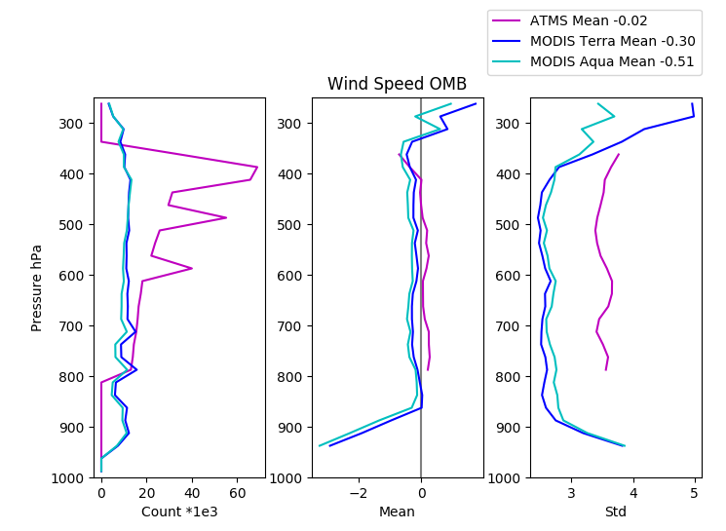
Figure 7: Speed OMB for ATMS (magenta) and MODIS IR AMVs (Terra: blue; Aqua: green) for 9 to 28 April 2020 from the GDAS/GFS.

- Proposal opportunities

Preliminary results of this project were used in two proposals and a report:
- In response to the JPSS PGRR FY21 announcement, a proposal was submitted entitled: "Demonstration and evaluation of a global, all-weather 3D winds product by blending winds derived from VIIRS, CrIS and ATMS." The goal was to create a winds product that is a blend of the 3D sounding retrieval winds from CrIS and ATMS (MiRS product), along with the feature tracked winds from VIIRS. This proposal was declined.
- A proposal is being prepared for NASA ROSES 2020 A.33 (The Science of Terra, Aqua, Suomi NPP, and JPSS), entitled: “Characterization and Applications of 3D Atmospheric Motion Vectors Derived at the Boundaries of the Free Troposphere: Into the Stratosphere and PBL.” Much of the proposal is based on the combined 3D winds product as detailed in the JPSS PGRR proposal, above. In addition, Andrea Lang (UAlbany) will be a Co-I as the science will be based on her stratosphere/troposphere interaction research.
- We contributed content to the NOAA Leo SounderSat BAA study of a combined hyperspectral IR and microwave Leo mission. One aspect of the study evaluated 3D winds derived from retrievals of humidity from both the IR and microwave sounders.

https://doi.org/10.1029/JD095iD05p05587
https://doi.org/10.1142/3171

