Algorithm Theoretical Basis Document (ATBD)

Satellite Image and Altitude-Resolved Water Vapor Wind Algorithms
Should there be another ATBD on using the ABI?

Christopher Velden

Cooperative Institute for Meteorological Satellite Studies (CIMSS)
Space Science and Engineering Center (SSEC)
University of Wisconsin-Madison

Madison, Wisconsin

February 2005

Table of Contents
1. PRODUCT DESCRIPTION 2
2. ALGORITHM THEORY AND BACKGROUND 2
3. ALGORITHM METHODOLOGY 2
3.1. The Context File 2
3.2. Image Registration 2
3.3. Targeting 2
3.4. Wind Vector Derivation 2
3.5. Automatic Editing and Quality Control Indices 2
4. EXPECTED ALGORITHM PERFORMANCE 2
4.1 Experiments to Date and Preliminary Results 2
5. ALGORITHM NUMERICAL PERFORMANCE CHARACTERISTICS 2
6. IMPLEMENTATION CONSIDERATIONS 2
7. SUMMARY 2
8. REFERENCES 2
9. APPENDIX A – Background information on the CIMSS winds algorithm 2
APPENDIX B − Vector Processing Error FLAG Values 2
APPENDIX B − Vector Processing Error FLAG Values 2
APPENDIX C − Wind Vector Output File format structure 2

Table of Figures
Figure 1. Flow diagram for the CIMSS automated satellite winds derivation algorithm. 2
Fig. 2. Flow diagram for HSR winds processing. 2
Figure 3: Flow diagram for the targeting algorithm. The blank box is normally where the target height is assigned. However, for HSR retrieval winds, this step is omitted since the height of the tracking surface is predefined by the retrieval analysis. 2
Figure 4: Flow diagram of the wind vector derivation routine. 2
Figure 5. Flow diagram for the Quality Indicator (QI) routine. 2
Figure 6: Flow diagram for the Recursive Filter (RF) automatic editing and quality control routine. The “adjusted height assignment” component would be deactivated when applied to the HSR retrieval winds. 2
Figure 7. Accuracy goals for HSR winds derivation. 2
Figure 9. Plots of the wind vectors derived from tracking 3 sequential 500mb moisture analyses derived from: MM5 Q field only (upper/left), MM5 with simulated GIFTS and no introduced noise (upper/right), MM5 with simulated GIFTS and “expected” (specification-level) noise (lower/left), and MM5 with simulated GIFTS and amplified noise (lower/right). 2
Figure 10. A racetrack aircraft flight pattern was flown over the region shown above. This provided multiple overpasses of the same region, and allowed sequential moisture fields to be derived for winds production. 2
Figure 11. Tracer winds produced by CIMSS algorithms from NASTI moisture analyses. 2
Figure 12. Comparison of winds produced by NASTI and the DWL. 2
Figure 13. Example of three constant-pressure moisture fields used to test the HSR winds algorithm. The fields are derived from single field of view (SFOV) AIRS retrievals. 2
Figure 14. Preliminary results of tracking AIRS retrieved moisture fields. 2
Figure 15. Illustration of the data density differences with current vs. future geo satellite sounders. 2

PRODUCT DESCRIPTION

In preparation for the launch of high spectral resolution (HSR) imagers/sounders in geosynchronous orbit over the next decade, the Cooperative Institute for Meteorological Satellite Studies (CIMSS) is proactively working on algorithm research and development. The activities involve the use of simulated data sets (based on the GIFTS (Geosynchronous Imaging Fourier Transform Spectrometer) instrument (Smith et al. 2000)), and aircraft high-spectral-resolution data sets (e.g., NAST-I (NPOESS Airborne Sounder Testbed-Interferometer)). The aircraft measurements along with radiative transfer calculations and numerical model data allow the construction of simulated data sets to support these activities. In addition, actual satellite-based HSR measurements from AIRS are being employed.
The data processing algorithms build upon CIMSS’s 20 years of experience working with high-spectral resolution measurements. The primary retrieval algorithms are 1) temperature and moisture, and 2) motion vectors, or winds. This ATBD deals with 2). Whereas contemporary satellite-derived motion vector algorithms utilize a sequence of single channel radiance images to identify individual elements to track and calculate displacements (Velden et al. 1997, 1998), the HSR winds system uses a sequence of the retrieved moisture fields on constant altitude surfaces to identify gradients for motion vector calculation. This represents a novel approach to wind tracking, since it eliminates the vector height assignment, often the largest source of error in the winds retrieval. This ATBD will describe both the ABI image and the altitude-resolved water vapor wind algorithms. The former is the traditional cloud and water vapor feature tracking method, while the latter produces, winds in non-cloud scenes derived from HSR retrieved moisture fields.
Are ther GOES-R requirements that need to be meet?

ALGORITHM THEORY AND BACKGROUND

The contemporary algorithm utilized to derive winds operationally at NESDIS from geostationary satellite images has been evolving since 1980 (Nieman et al. 1997), and now provides routine wind products for national and international users. This algorithm is fully automated and includes an elaborate quality control procedure as part of a post-processing step. CIMSS has played a major role in the development and advancement of this winds algorithm, which uses the approach of tracking features in clouds and water vapor gradients from selected channels (See Appendix A). The method employs sequential images of clouds and moisture derived from radiance fields to track the motion of selected targets (e.g., well-defined clouds, moisture gradients). This method has proven successful and effective in deriving wind fields, and numerous studies have indicated the usefulness of the satellite-derived wind data on weather analysis and forecasting (Velden et al. 1997, 1998, Key et al 2003).
Although the satellite derived cloud and water vapor radiance-tracked winds have been shown to improve numerical weather prediction forecasts on both regional and global scales (Soden et al. 2002; Goerss et al. 1998), a deficiency exists in the ambiguity of the vector height assignment. The current methods to assign an altitude to a derived vector rely on a combination of radiance information, semi-transparent cloud corrections, and an NWP model forecast temperature profile. Often, accurate wind tracers are assigned to the wrong altitude causing difficulties in assimilating the GOES winds (Nieman et al. 1993). Assumptions are made that the target motion represents a single level, and methods have been derived to best approximate this level. However, in reality, the radiance targets are three-dimensional and their motion in image sequences represents a moving volume. Therefore, the vector height assignments represent the greatest source of error in estimating tropospheric motions from geosynchronous satellites (how about a table of the various errors? I’ve seen a powerpoint from Dave Santek that showed errors, or expected errors for each source. I think he’s referring to the TELL or the 3D figure about registration, image accuracy, etc.). For more information on the current state-of-the-art in satellite-derived wind processing methods, accuracies and recent innovations, see Velden et al. 2005.
The HSR data will foster in a new approach for retrieving winds from geosynchronous satellites. In non-cloudy atmospheres, the current methods only provide upper-tropospheric winds from imager water vapor channels. The HSR measurement concept for altitude resolved "water vapor winds" should provide the needed vertical resolution to provide vertical profiles of wind velocity necessary to realize the full potential of satellite measurements toward improving weather forecasts. As part of the GOES-R Risk Reduction program, CIMSS is collaborating with NOAA to demonstrate the concept of this new approach to passive wind tracing. This concept can be tested using simulated and existing real data.
Specifically, an algorithm to derive clear-sky, altitude-resolved water vapor winds is being developed and evaluated. The method utilizes the same basic automated tracking code developed at CIMSS, however the input to the algorithm is in the form of constant-level moisture analyses derived from HSR sounding information. For example, in clear-sky regions, vertical profiles of moisture can be derived from simulated multiple GIFTS water vapor sensing channels (it has already been extensively demonstrated through GIFTS aircraft experiments how well these moisture features can be depicted). Data cubes are processed and merged into 3-dimensional analyses of moisture variables (such as mixing ratio). In this approach, sequences of retrieved water vapor fields (such as constant-pressure mixing ratio analyses) become the ‘imagery’ for tracking winds. Since the moisture fields will already be analyzed to constant pressure surfaces by the retrieval algorithm, the heights of tracked moisture gradients (water-vapor wind vectors) will be pre-determined. The height assignment error that contemporary satellite-derived winds suffer should be minimized, and improved water vapor tracked winds should result. Furthermore, the HSR information allows analyses of moisture at multiple vertical levels, which can then be used to create vertical profiles of wind.
To date, the new scheme has been trialed on simulated data from GIFTS, on airborne observations provided by the NAST-I instrument, and with AIRS moisture retrievals. From these first attempts, the "proof of concept" is successfully illustrated, and preliminary results are shown in section 4.

ALGORITHM METHODOLOGY

The vector derivation process involves the execution of a sequence of commands. Each command is presented in greater detail in the following sections. A general overview of the command sequence is presented in Figure 1. This flowchart highlights the principal derivation steps used in the current operational processing at NOAA/NESDIS (derived from CIMSS research code): image registration, identification of targets including target height assignment, target displacement in subsequent images (wind vector determination), and quality control. Additional routines compliment these applications, performing specific tasks related to select satellite wind data subsets. A complete description of the CIMSS processing strategies for geostationary satellite wind determination can be found in the User’s Guide (Olander, 2001).
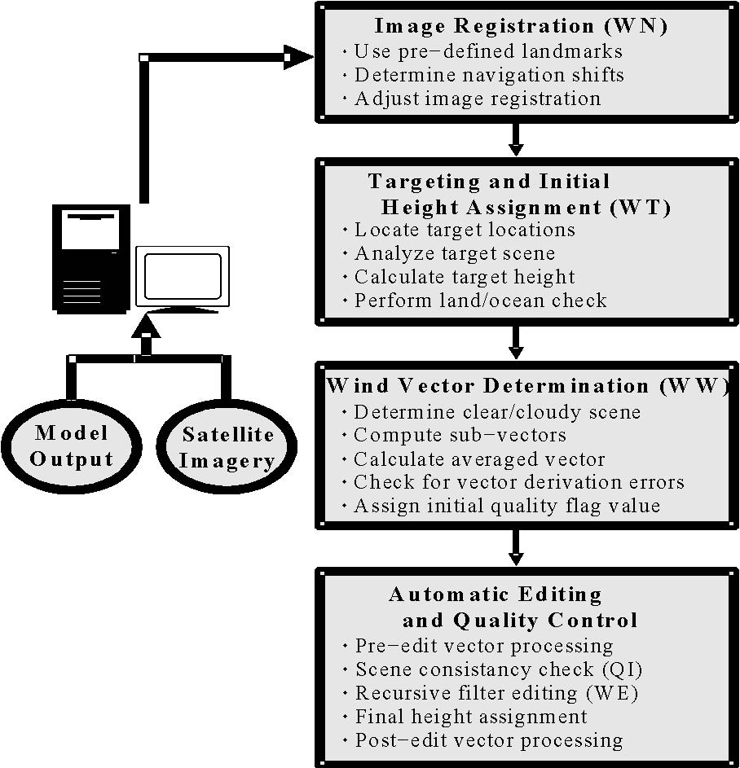
Figure 1. Flow diagram for the CIMSS automated satellite winds derivation algorithm for current GOES imager?.

A modification to the basic strategies listed above will be required for HSR data applications. Figure 2 is the flowchart of the processing to be used for HSR. The primary differences with the current GOES algorithm (?) are:
- The image registration step is removed. Accurate image registration will result from the geolocation and stitching of the retrieval data cubes.
- Height assignment for the vectors is provided from the retrieval step; the height of the isobaric moisture analyses, on which the winds are tracked.

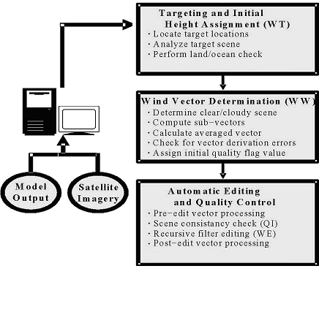
Figure 2. Flow diagram for HSR winds processing.

Prior to execution of the winds derivation process, two input data sets must be collected and staged. The first set is a sequence of three or more images (up to five) derived from the retrieval moisture analysis at specified atmospheric pressure levels. These images must be accurately geolocated, with precise time stamps for each pixel because of the unique sampling strategy and stitching methods used in the HSR data processing. The second data set is a numerical model forecast of temperature, moisture and wind, valid for the image times being processed (application discussed in later section). The model data must be in GRIB format.
Once the input data are properly staged, wind processing can begin. The first step is to determine potential wind vector targets. Targets are features in the moisture fields/images (specific humidity, mixing ratio, etc) identified using a maximum gradient searching routine coupled with a Coakley−Bretherton analysis scheme (Coakley and Bretherton, 1982). The search area size is user−defined and will be optimized for the HSR retrieval fields using simulated datasets. For this application, clouds are masked out in the retrieval moisture analysis and are not considered as targets (although they could be). The target heights are assigned to the pressure level of the moisture field being used. The assumption being that an accurate height is determined in the retrieval process. Also, each target is assigned a land or ocean flag value, depending upon the surface characteristic at the target location determined from a navigation file.
The next step is the determination of target motions in subsequent images. Calculations are performed at each target location. Targets (moisture features) are tracked between successive image triplets using a numerical model forecast wind field as a first guess for economizing the search area in subsequent images for maximum correlations. The search area size, like the target size, is user−defined and an optimal size will be determined for the HSR retrieval fields. The pattern matching between targets and tracking areas is done using one of three user-selected methods: cross-correlation, Euclidian norm, or L(p) norm (it would be good to summarize what these are. (Please see section 3.4 for more details) Specified matching thresholds must be met for a displacement to be calculated. The best method for use with HSR retrievals has yet to be determined. Guess departures and acceleration checks between successive image pair sub−vector values (two vectors are calculated for the image triplet: 1>2, 2>3) are computed and indicated using a series of additive error flag values (see Appendix B). The departures and accelerations must fall below specified thresholds, or error flags will indicate that the vectors are suspect. Also, in the tracking process, accurate image-to-image registration (geolocation) is important as any navigation shift between images may be erroneously interpreted as a wind vector acceleration.
Once the targets are tracked in subsequent images, vector values that possess non−critical error flag values (FLAG <=3, see Appendix B) are passed into two independent wind vector quality control routines. These routines check the overall coherence of the wind vector field (i.e., the fit of each individual vector to a background analysis and/or numerical model guess wind field). The first routine is the EUMETSAT Quality Indicator (QI). Based on a series of tests (when will reader be informed of what these tests are?) [Test description may be found in Section 3.5], the QI routine examines each wind vector for temporal consistency and its coherence with surrounding "buddy" vectors. An index value is computed and assigned to each vector record. The second routine is a three-dimensional Recursive Filter (RF) objective analysis routine. The RF analysis involves comparing each wind vector to an objective analysis of the whole vector field. The “fit” of each vector is calculated. Then each vector is subject to a height assignment re-evaluation based on the minimization of a penalty function (not applicable to HSR vectors). Quality flag values from the RF analysis are assigned to each vector examined. The combined RF and QI indices can be used in data assimilation as measurement confidences or analysis weights.

The Context File
Parameters used by the wind vector derivation routines are defined within a context file. This file allows the user to define runtime elements specific to the current wind set, such as input/output files, path names, and analysis control parameters which are used repeatedly instead of using command line keywords. Separate context files can be defined for specific wind derivation processing domains and/or instruments, which allow for simultaneous processing of wind sets or customization for particular data set analysis. Can you specify the context file, like you did file format in the Appendix? Please see Appendix D for a detailed description of the context file.

Image Registration
Accurate image geo-registration, both within an image, and image-to-image, is critical to accurately track feature motion. The winds navigation (WN) routine corrects registration errors in consecutive images utilizing cross correlation and minimum lag coefficient analysis at user selected landmark points. These correlation routines are the same ones employed in the wind vector derivation (see section 3.4), but applied to land features. This technique will not be appropriate for determining vectors from HSR retrievals, since we will be relying on accurate geolocation provided in the retrieval scheme. However it will still be used on ABI images.

Automatic image registration is performed using 11 µm (micron) infrared window imagery since landmarks can be identified at the surface using this channel. Adjustments to water vapor images are determined using the adjustments obtained separately from analysis of the infrared imagery. Registration modifications to 3.9 µm infrared imagery are also adjusted using analysis of 11 µm images.

The user predetermines landmark locations. Cloud-free landmarks are sought and identified within the first infrared image of the image set. The algorithm will automatically determine landmarks that are cloud contaminated past a user defined threshold by utilizing the Coakley-Bretherton spacial coherence analysis routine (Coakley and Bretherton, 1982). A user defined (default is 15) box of data centered on the landmark is filtered into 3x3 boxes with means and standard deviations of the warm and cold samples calculated. A plot of the standard deviations versus the means would exhibit an arch. The warm base of the arch represents cloud free regions, while the cold base represents completely cloudy regions. An estimate of cloud cover A_{c} can be determined from the clear sky radiance I_{s}, the cloudy radiance I_{c} and the mean radiance I_{m}. The mean radiance is given by:

I_{m} = (1 – A_{c})I_{s} + A_{c}I_{c}

The fractional cloud cover is:

A_{c} = (I_{m} – I_{s})/(I_{c} – I_{s})

A landmark is considered cloud free if two checks are met. The difference between the minimum and maximum averaged mean for all of the 3x3s must be less than a user-defined threshold (55 operationally). The difference between the warm averaged mean (clear) and the cold averaged mean (cloud) must be less than a user-defined threshold (55 operationally).

Once all cloud-free landmarks have been identified, matching landmarks are searched for in the remaining infrared images in the image set. Images with 10% or more bad/unusable data are skipped. Matching landmarks are found in successive images by computing the minimum correlation error (lag correlation) between the landmark point from the first image and all other points within the search area within the remaining images in the image set. The point, which obtains the minimum correlation error, is retained as the matching point, from which line/element differences are calculated. A larger search box allows for more extreme shifts in navigation to be corrected, but also increases the probability for incorrect correlation matches between two images.

If the line/element shifts for a particular landmark are less than user-defined threshold values, it is counted as an initial good landmark (NMARK). Average line/element shifts for all good landmarks for all images are then computed, with differences between each good landmark and the computed average shift calculated. If these differences are below a certain user-defined threshold distance, the point is then retained as a final good landmark (OMARK).

Four final quality checks are performed to determine if the line and element shifts should be applied to the images. If the number of OMARK landmarks is less than a user defined value (5) the shift is not applied. If the line/element standard deviation is greater than a user defined value (1.5), the shift is not applied. If the absolute value of the line/element mean is less than a user-defined (2) value, the shift is not applied. If the ratio of NMARK to OMARK is less than a user defined value (.4), the shift is not applied.

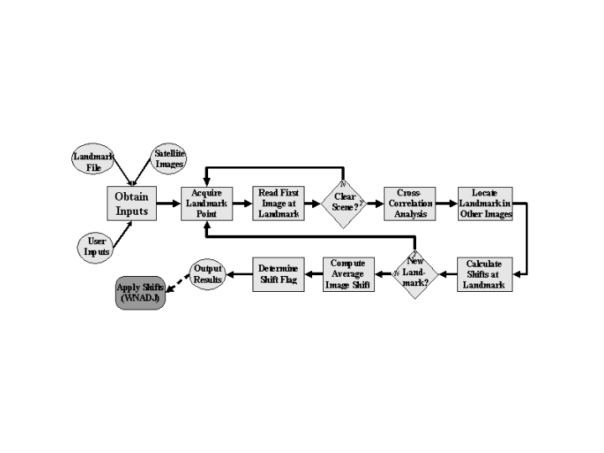
\ Figure 3. Flow diagram for ABI image registration.

Targeting
Target selection for potential wind vectors is performed using the WT program. Command line keyword entries allow the user to modify various aspects, including target box size and thresholds for target gradients. Of the three images used in the tracking sequence, the middle image is used as the targeting image. A flow diagram of the targeting routine is shown in Figure 4.

Figure 4: Flow diagram for the targeting algorithm. The blank box is normally where the target height is assigned. However, for HSR retrieval winds, this step is omitted since the height of the tracking surface is predefined by the retrieval analysis.

The target selection process is performed over the user-defined search region of the target image (using latitude/longitude boundaries). The size of each individual target selection box is defined by the user. The targeting program will loop through the targeting image, searching each target box for a potential target. Two loops will control the flow of this process, a "line" (north/south) loop and an "element " (east/west) loop. At the beginning of each line loop, starting at the northern latitude boundary, a block of data (target box) is read from the image. Starting at the western longitude boundary, the target box is examined for a potential wind target. The method used to locate a target within the target box depends on the targeting imagery type. For HSR retrieval winds, the target focus will be on maximum moisture gradient found within the target box that meets prescribed gradient thresholds. Once a target box has been examined, as described below, the next target box will be read and examined. After crossing the eastern boundary or image edge, the next block of lines are read and the process is repeated until the southern boundary or image bottom is reached.
Within each target box, a bidirectional gradient is computed. Parameters allow the user to explicitly define the sensitivity of the bidirectional analysis by setting a gradient threshold value. Optimal values have been determined for current geostationary satellite imager infrared (7), water vapor (1), and visible (50) image tracking (could these threshold values, or typical values be listed, or do they vary a lot/)/).[Should SWIR be mentioned at all?] These parameters will also be determined for HSR derived images. Targets that meet or exceed these criteria are candidates for deriving displacement vectors (winds) in the next processing step.
For the ABI images, an additional step is necessary during the targeting: determination of the vector height. There are four methods used, although all techniques are not applicable for any one target.
1. Infrared Window Channel (WIN) and Water Vapor Histogram Methods (HIST)
Height assignment using singler satellite bands can be made by comparing either infrared window (11 μm) or water vapor (6.7 μm) brightness temperature values with numerical model forecast temperature profiles. Cloud heights are determined by interpolating the cloud temperature, which is an averaged value over a set number of pixels, to the interpolated model guess field at the target location. This method works well with opaque clouds, however movement of opaque clouds usually does not accurately represent atmospheric motion at the assigned level (Nieman et al., 1993), resulting in a lower derived wind speed than observed. Semitransparent clouds or subpixel clouds give a more accurate representation of the actual movement of the atmosphere at a particular level. Estimation of this level is very difficult in these cases since determination of the cloud top brightness temperature is affected by an unknown cloud emissivity or the percentage of cloud versus clear sky, respectively. The brightness temperatures are warmer than observed in these cases, thus leading to estimated cloud heights that are too high in pressure (too low in altitude), typically resulting in an overestimation of the wind speed at the estimated cloud height.
2. Water Vapor/Infrared Window Intercept Method (H2O)

Height assignments derived with this method are based upon the fact that radiances from two different spectral bands are linearly related for different cloud amounts within the field of view at a specified height. Observed radiance measurements are a function of clear sky and opaque cloud radiances. Opaque cloud radiance can be calculated from:
$$R_{\text{bcd}}(N,P_{c})=R_{\text{cl}}(N)−\int{t(N,p)(\text{dB}[N,T(p)]/{\text{dp}})\text{dp}\text{.}}$$
where R_{bcd} is the opaque ("black") cloud radiance, R_{cl} is the clear−sky radiance, t(N,p) is the fractional transmittance of radiation of spectral band N emitted from the atmospheric pressure p arriving at the top of the atmosphere (p=0), P_{s} is the surface pressure, P_{c} is the cloud pressure, and B[N,T(p)] is the Planck radiance of the spectral band N for a temperature T(p). The second part of Equation AAA represents the radiance decrease from clear sky conditions introduced by an opaque cloud at a pressure level p. This calculation is dependent upon an "accurate" estimation of the current atmospheric temperature and moisture structure, which are provided by a guess (model forecast) profile. By comparing the observed radiances with the calculated radiances (for an observed atmosphere defined by the guess profiles), an estimation of the cloud height can be derived for a completely opaque cloud.

Figure BBB: Measured radiances (mW m⁻² sr⁻¹ cm) for fields of view partially filled with clouds.

In Figure BBB, observed WV and IR radiances at each field of view (FOV) are plotted with the calculated radiances at different heights for opaque clouds in the atmosphere (curved line). The straight line connects the center points of the warmest and coldest clusters, which approximate the observed surface and cloud conditions. By extrapolating this line to intersect the calculated radiance curve, where the cloud amount is one (representing an opaque cloud), the cloud top temperature/pressure can be determined.
The cluster determination algorithm used is a modified version of the bivariate asymmetric Gaussian histogram analysis (Rossow et al, 1985; Tomassini, 1981), and involves ten steps. These steps are outlined in detail in Nieman et al (1993). Calculated water vapor radiances can be in error due to incorrect guess (model forecast) profiles.
This error would lead to calculated radiances being systematically higher or lower than observed radiances. When the calculated radiances are systematically lower, an adjustment is applied to the radiances obtained via Equation AAA. When the calculated radiances are greater than observed radiances, no adjustment is applied since it is assumed that the lower measured radiance is due to cloud contamination.
The accuracy of this method can be affected by the amount of water vapor in the atmosphere (Spinoso, 1997). Dry atmospheric conditions lead to a steeper slope between the IR and WV radiances, leading to an overestimate in the target height (lower pressure value).
3. CO₂−Infrared Window Ratio Method (CO₂)
Unlike previous methods discussed above, the CO₂−Infrared Window Ratio technique, also called the CO₂ Slicing method, can work with semi−transparent clouds effectively. This is due to the fact that the emissivities of ice clouds and the cloud fractions for the Infrared Window and CO₂ channels are roughly the same (Nieman et. al., 1993).

Height assignment based upon this method are determined using the following equation:
$$\frac{R({\text{CO}}_{2})−R_{\text{cl}}({\text{CO}}_{2})}{R(\text{IRW})−R_{\text{cl}}(\text{IRW})}=\frac{\text{nE}({\text{CO}}_{2})[R_{\text{cbd}}({\text{CO}}_{2},P_{c})−R_{\text{cl}}({\text{CO}}_{2})]}{\text{nE}(\text{IRW})[R_{\text{cbd}}(\text{IRW},P_{c})−R_{\text{cl}}(\text{IRW})]}$$
where n is the fraction of the FOV covered by cloud and E is the cloud emissivity. The ratio of the measured radiance difference between cloudy and clear sky for the CO₂ and Infrared Window (IRW) channels is calculated (left side of Equation CCC). This ratio is compared to a series of possible solutions computed at incremental pressure values. The pressure value which produces a result most closely matching the ratio value on the left side is used as the pressure of the cloud. The radiance values on the right-hand side require a first guess field, as with the H₂O−Infrared Window Intercept method, in order to properly estimate the atmospheric profile at the target location.
Typically, the 11 μm infrared window channel and the 13 μm CO₂ channel are used with this method (Eyre and Menzel, 1989), however any two channels can be used provided their weighting functions (molecular absorption characteristics) are sufficiently dissimilar while the effective cloud amount is the same for the two channels (Spinoso, 1997).
This method can fail when the observed and clear radiance difference falls below the instrument noise for either channel used in Equation CCC, such as low broken cloud or very thin cirrus scenes. Also, when the scene contains two cloud layers, the CO₂ slicing method will produce a height somewhere between the two heights (Menzel et al, 1992). Finally, with very high opaque clouds, this method will fail since the clear−cloudy difference will be near zero. In such cases the window channel method will work sufficiently (Nieman et al, 1993).
4. Cloud Base Method (BASE)
Wind speeds for low level cumulus clouds (cloud top pressures greater than 600 hPa (altitudes lower than 600 hPa)) have been found to be best represented by the movement at the cloud base level instead of the mid or upper levels of the cloud (Hasler et al., 1979). A method was developed at the Australian Bureau of Meteorology (LeMarshall, 1993; Spinoso, 1997) to estimate this height using the Infrared Window channel.
This method first obtains a histogram of the brightness temperature values over a selected region surrounding the cloud target being examined. This histogram is then smoothed and Hermite polynomials are fitted to the histogram to separate the distribution into two components; a cloudy and clear sky region.

Assuming the distributions are normal, the cloud base height can be estimated. The mid-cloud temperature, also called the modal cloud temperature, is determined by examining the second-derivative histogram of the cloudy distribution, while the cloud top temperature is estimated to be located at the coldest 5% of the cloudy distribution. The cloud base temperature is estimated to be located the same distance from the modal cloud temperature as the cloud top temperature. The calculated cloud base temperature is converted to a pressure using a guess field interpolated to the target location.
As mentioned previously, this height assignment method is only applied to those targets which are calculated to have a cloud top pressure of greater than 600 hPa (altitude lower than 600 hPa). This "initial" target cloud top height is provided by one of the previous Infrared Window height assignment methods. The Cloud Base method is used to adjust only these winds, and is not utilized for water vapor winds or winds with pressures less than 600 hPa (altitudes higher than 600 hPa).
These height assignment techniques depend on numerical model forecast temperature, moisture, and/or pressure fields to convert satellite brightness temperature measurements into pressure height estimates. Model guess forecast fields must be valid for a time period within nine hours of the satellite imagery being used by the targeting routine.
Satellite brightness temperature values are calculated directly from the satellite imagery radiance measurements. These conversions are satellite−dependent, and rely on the specific radiative transfer coefficient files.
Each different height determination is saved for each target, along with a quality control value noting the quality of the height estimate value. The final "best height" for the target is determined by the wind vector derivation routine.

Wind Vector Derivation
Wind vector determination from a sequence of consecutive (normally three to five) satellite images is performed using the WW routine. Time differences between all images do not have to be constant, but they must be sequential. The initial targets are investigated one by one, with wind vector calculations attempted at each target position within the user−defined analysis region. Numerous command line keyword entries allow the user to modify various thresholds and control algorithm execution. Many command line keywords for the wind vector derivation routine are similar to those used in the targeting routine. A flow diagram of the target displacement (vector derivation) routine is shown in Figure 5.

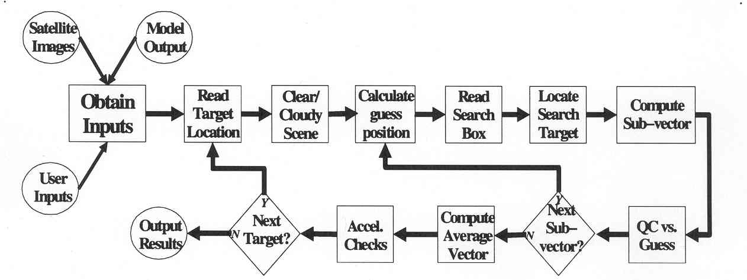

Figure 5: Flow diagram of the wind vector derivation routine.

For HSR images, the height is already determined, but for ABI images the "best" height assignment value for each target is selected from the four potential height values prior to wind vector determination. The height selection process is dependent upon the satellite channel being investigated. Infrared wind vector heights will be determined from one of four height values: IR Window (WIN), H₂O−Intercept (H₂O), CO₂ Slicing (CO₂), or Cloud Base (BASE). Visible wind vector heights will be chosen from the same set as the infrared winds, however the H₂O height will not be available. Water vapor wind vectors are chosen from either H₂O or Water Vapor Histogram (HIST) height values. The lowest pressure (highest altitude) value of all of the calculated height values is used as the final wind vector pressure height assignment value. If the final infrared or visible channel height is WIN and a valid Cloud Base (BASE) height is available, the BASE height will be used for the best height assignment value.
For each water vapor channel target, a cloud contamination flag value (MASK) is determined to identify clear or cloud contaminated WV signals. This process first checks to make sure the target has valid WIN and HIST height values. If true, the process will check for a valid H₂O height. If this height is valid, the HIST pressure height value is subtracted from the lower pressure (higher altitude) value between the H₂O and WIN height values, otherwise the HIST height is subtracted from the WIN value. If this difference is greater than the threshold value (default of 75 hPa), the scene is said to be "clear", otherwise the WV scene is said to be "cloud contaminated".
The process begins with the determination of a first guess wind vector (interpolated from the model forecast wind field at the location and height of the initial target). This guess is used to calculate the center location of the search area in the other images. The search area size is user−defined, and is normally much larger than the target box size. The image data within the target box (middle image) and search box regions (other two images) are read and a correlation is computed for each target box-sized region within the search box regions (can you give the correlation formula?). L(p) norm is the default correlation routine. It can be defined as

||x||_{p} = (|x₁|^{p} + … + |x_{n} |^{p})^{1/p}

If p = 2.

||x||₂ = √(|x₁|² + … + |x_{n} |²)

This can be referred to as the Euclidean norm if the following is used:

||x - y||₂

The winds software uses a value of p=2.

The software then generates a lag coefficient matrix from the sum of the squares of the differences between the target array and the search array. This is done for any correlation method chosen.

The other two correlation methods modify this coefficient matrix. These will be discussed a bit later.

The minimum value in the matrix is determined along with the position. A quadratic interpolation is computed to give a non-integer value to the minimum position.

A second choice for correlation is the cross correlation method. This is defined as (in 1 dimension)

(∑_{i} [(x(i) -mx) * (y(i)-my)])/(√∑_{i}(x(i)-mx)²*√∑_{i}(y(i)-my)²)

Where x is the search array and y is the target array. m represents the mean of x and the mean of y. This calculation modifies the coefficient matrix and follows the wind calculation as below.

A third choice for correlation is the radiance correction to the Euclidean norm. In one dimension it looks like

∑_{i}(x(i)-y(i))²-i*(mx-my)²

Where x is the search array, y is the target array, and m is the means. This calculation modifies the coefficient matrix and follows the wind calculation as below.

The highest correlated point between the initial target location (in the target box) and the search box region is determined for each of the non-target images. The vector displacement between these points is calculated and the two sub-vectors are determined. At this point, acceleration checks are invoked to assess the consistency between the two sub-vectors. If the checks meet pre-determined thresholds, a final vector speed and direction is determined by averaging the intermediate sub−vectors, and these values are considered as the final displacement (wind vector). This vector is then compared to an interpolated model forecast wind vector at the middle-image target location. Vectors with large departures (e.g ??) from the guess vector are flagged [u and v deviations of greater than 10m/s], and this information is stored along with the vector information (see Appendices B and C).

Automatic Editing and Quality Control Indices
Currently, two independent routines are used for automatic quality control (AQC) of the feature-tracked vectors. Each AQC routine possesses numerous command line keyword options. This allows considerable user control of each routine, permitting them to be tuned for specific needs, such as rapid scan cycles, different satellite channels, etc.
The first quality control routine, named QI, involves the utilization of vector statistical properties in the derivation of a quality indicator (QI). Each vector is put through various temporal and spatial consistency tests, and a QI value is then assigned. A flow diagram of the QI routine is shown in Figure 6.

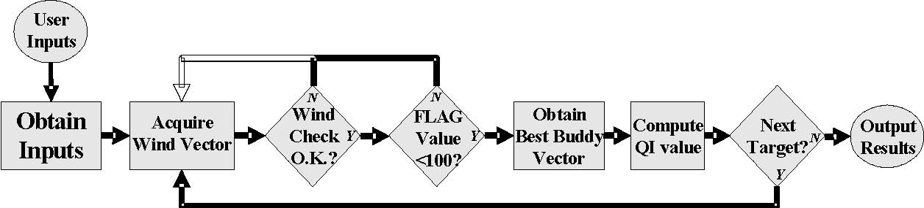
Figure 6. Flow diagram for the Quality Indicator (QI) routine.

The statistically-based QI routine, developed at EUMETSAT and the European Space Operations Center and based on the EUMETSAT approach for automatic quality control, estimates the reliability of each derived vector based on several quality control tests (Holmlund, 1998). These tests analyze the consistency in space and time of each wind’s vector components, the symmetry of vector pairs (achieved from tracking tracers between consecutive images), the differences with surrounding vectors, and the difference from a forecast wind (numerical model guess). Currently, seven “consistency” tests are included in the QI analysis scheme

Direction : |D2(x,y)−D1(x,y)|/(d1*exp−((V2(x,y)+V1(x,y))/20)+10)
Speed : |V2(x,y)−V1(x,y)|/(s1*(V2(x,y)+(V1(x,y))+s2)
Vector : |S2(x,y)−S1(x,y)|/(v1*(|S2(x,y)+(S1(x,y)|)+v2)
Spatial : |S(x,y)−S(x−i,y−j)|/(p1*(|S2(x,y)+(S1(x−i,y−j)|)+p2) (1)
Forecast : |S2(x,y)−F1(x,y)|/(f1*(|S2(x,y)+(F1(x,y)|)+f2)
U−component: |u2(x,y)−u1(x,y)|/(x1*(|u2(x,y)+(u1(x,y)|)+x2)
V−component: |v2(x,y)−v1(x,y)|/(y1*(|v2(x,y)+(v1(x,y)|)+y2)

where Di(x,y), Vi(x,y), Si(x,y), ui(x,y), and vi(x,y) are the direction, vector, speed, u−component, and v−component derived from the ith image pair of an image triplet at location (x,y), respectively. S(x,y) = S1(x,y) + S2(x,y); S(x−i,y−j) refers to the vectors in the surrounding locations in the EUMETSAT segment coordinates (Bulher and Holmlund, 1994). F(x,y) is the interpolated forecast vector.
In order to combine the results of the different test functions listed above, each result must be normalized into a specific range. This is done using a simple tanh−based function (see Holmlund, 1998 for greater detail):
Φi(x) = 1 − tanh{ [fi(x)] }^{ai}
The spatial test is only applied to vectors within a predefined pressure range centered at the height of the vector S(x,y) in question. Deviations obtained from these tests do not result in vector rejection, but instead only act to lower the value of the quality indicator associated with each vector in the wind output file. This quality indicator can then be used in conjunction with the WE editing routine (RF analysis value) to accept or reject a vector. Keywords can be used to adjust many of the parameters involved in the testing processes.
The second QC routine is based upon a three-dimensional, recursive filter (RF) analysis (Hayden and Pursor, 1988;1995). In this routine, each vectors “fit” to the objective analysis is calculated (basically an elaborate three-dimensional “buddy check”). Based on this fit, a value is appended to the data record that can be used as a quality indicator. A flow diagram of this routine is shown in Figure 7.

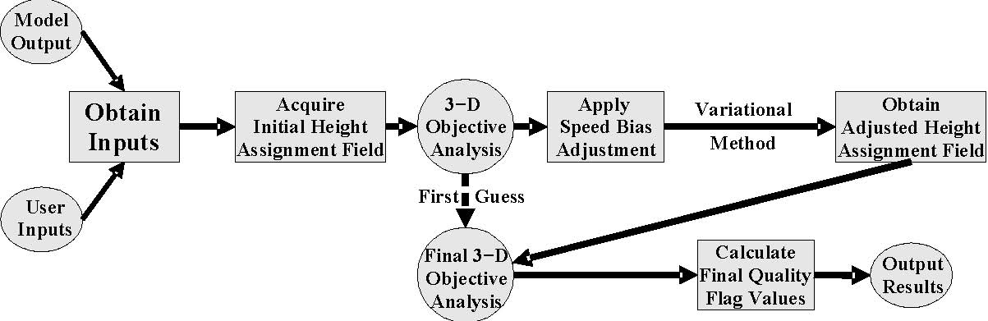

Figure 7: Flow diagram for the Recursive Filter (RF) automatic editing and quality control routine. The “adjusted height assignment” component would be deactivated when applied to the HSR retrieval winds.

For the ABI images, there is an additional step which reassigns the vector heights based on a penalty function. The first stage of the objective analysis provides a preliminary analysis using the satellite data at their initially assigned pressure height and pseudo data from the numerical model forecast (typically the 12− or 18−hour forecast field of temperature and wind). After applying a speed bias to certain winds (a slow−bias is observed with upper−tropospheric cloud drift winds), pressure altitudes of the wind vectors are adjusted by minimizing a variational penalty function evaluated using the initial wind vector analysis and the numerical model forecast field for various atmospheric parameters. The penalty function equation is :
where V=velocity, T=Temperature, P=pressure, dd=direction, s=speed, F=weighting factors, m=measurement, i,j=horizontal dimensions of model guess field, and k=vertical dimension of model guess field.
Before the penalty function is calculated, gross error checks are performed on the five parameters listed in Equation 3. If any of the error checks fail, the penalty function is not calculated for the wind vector in question. The values for the error checks are modified using various command line keywords such as FIT and VAR.
The M values listed in Equation 4 are the default gross error limit weighing factor values, which are assigned/modified by the FIT keyword. The F values represent the penalty function weighting factors, and are assigned/modified with the VAR keyword. Considerable care should be taken when modifying the various M or F values, since modifying one or both of the values will significantly change the gross error limit threshold values for the particular parameter being modified. For example, if the influence of the vector error in Equation 3 is reduced by increasing the weighting factor Fv, the gross error tolerance will be increased in Equation 4 unless the gross error limit weight factor Mv is reduced to compensate for this increase. The velocity Mv value performs an additional function of defining the maximum permitted value of the penalty function. This value is determined by the following equation:
An initial quality flag is assigned to the vector at the reassigned height at this stage of the processing. This value represents the quality of the reassigned wind vector in relation to the model forecast analysis field at the vector height and location. This quality flag value is stored in the RFI data value and is calculated with the following equation:
The second stage of the procedure applies the full RF analysis utilizing the initial objective analysis vectors as a first guess and the reassigned pressure altitude vectors from the penalty function evaluation.
The RF objective analysis provides a final quality estimate for each vector based on the local quality of the analysis and the fit of the observation to that analysis. Vectors that do not obtain a final quality value exceeding an empirically defined threshold are flagged and rejected. This final quality value is stored within the output wind file. The user-defined keyword settings can be used to tune various RF parameters if too many or too few vectors are rejected during the editing process.

EXPECTED ALGORITHM PERFORMANCE
We anticipate the new approach to tracking winds from HSR moisture fields will yield superior vector accuracies over what is currently achievable. The accuracy goals are shown in Figure 8, and are based on the GIFTS concept/specifications/requirements.

Figure 8. Accuracy goals for HSR winds derivation.

Experiments to Date and Preliminary Results
GIFTS data were simulated using the GIFTS forward model retrievals and mixing ratio (Q) fields from MM5 model output on 12 June 2002 over the southern Great Plains. While generally clear sky conditions were prevalent prior to convective initiation, a cloud mask was added to eliminate data below the level of any detectable cloud tops in all of the Q fields (therefore, no vectors are attempted beneath clouds). Three time steps at 30-minute intervals were used to track Q gradients on pressure-resolved horizontal planes at 50mb increments from 1000-350mb. A visualization of the resultant wind fields is given in Figure 9.
Figure 9. VisAD display of the simulated GIFTS winds illustrates the data density and vertical distribution.

The tracking results for 500mb are shown in Figure 10. Resultant winds are shown for three experiments designed to illustrate the upper and lower bounds that might be expected given “perfect” retrieval conditions (no sensor noise), versus retrievals performed with noise introduced into the simulated radiance fields. The winds derived straight from the MM5 fields (no GIFTS information) are also shown for comparison.
Figure 10. Plots of the wind vectors derived from tracking 3 sequential 500mb moisture analyses derived from: MM5 Q field only (upper/left), MM5 with simulated GIFTS and no introduced noise (upper/right), MM5 with simulated GIFTS and “expected” (specification-level) noise (lower/left), and MM5 with simulated GIFTS and amplified noise (lower/right).

As expected, the introduction of noise into the simulated GIFTS information degrades the vector output. The resultant wind field coverage (with expected noise) is degraded from the “perfect” (model-only) scenario, but not significantly. As can be seen in Figs. 8 and 9, the concept of tracking moisture analysis fields is achievable, and has the potential to be a significant improvement over what is currently achievable from geosynchronous satellites, especially given the profile-nature of the wind information.
In a first attempt to assess the vector quality that should be achievable from this new approach, we examined winds derived from hyperspectral observations taken from the airborne NASTI instrument flown during a mission that gathered observations off the coast of California on 11 Feb 2003. The flight tracks and coverage are shown in Figure 11. A Doppler Wind Lidar (DWL) was also flown, and was used to help validate the accuracy of the NASTI winds.

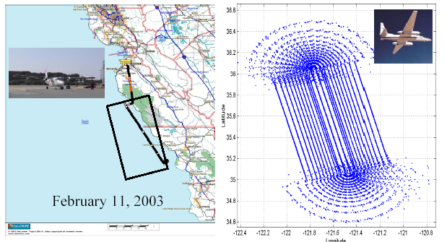
Figure 11. A racetrack aircraft flight pattern was flown over the region shown above. This provided multiple overpasses of the same region, and allowed sequential moisture fields to be derived for winds production.

Utilizing the approach and methodology discussed above, wind fields were derived from the NASTI moisture analyses. Since there were nine successive overpasses of the same domain, 3 sets of winds (each using 3 sequential analyses centered at 21, 22 and 23 GMT) were attempted. Examples of the resulting wind fields are shown in Figure 12 for several selected pressure levels. As can be seen, even though the domain is spatially limited by the overflight scan angles, coherent vectors are produced.

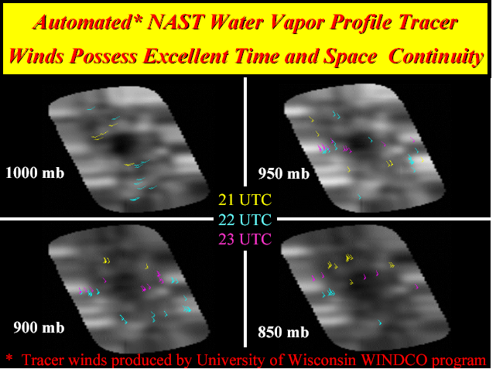
Figure 12 Tracer winds produced by CIMSS algorithms from NASTI moisture analyses.

In order to validate the quality of the winds shown in Fig. 12, wind profiles from the coincident DWL observations were used as a comparison. Figure 13 shows one such comparison. The profiles match nicely, with deviations in wind speed limited to less than 3 m/sec. For more information see Velden et al. 2004. (why not put the info here as well for completeness?)

Figure 13. Comparison of winds produced by NASTI and the DWL.

The next step in the process of evaluating the new HSR winds derivation concept involves the employment of newly available satellite HSR data. The AIRS instrument on the NASA Terra polar-orbiting satellite was used to derive moisture soundings from three successive passes (~100 minutes apart) over the northern polar region of the globe (providing overlapping passes for sequential sounding/imaging). The retrieval constant-pressure moisture analyses were converted to images and used as tracking surfaces for the HSR winds algorithm. An example is shown in Figure 14.
Figure 14. Example of three constant-pressure moisture fields used to test the HSR winds algorithm. The fields are derived from single field of view (SFOV) AIRS retrievals.

The sequential AIRS moisture fields were targeted and tracked using the same approach as with the simulated GIFTS and NASTI fields. The first results are shown in Figure 15. Despite the limitations imposed by the AIRS HSR observations (poor spatial and temporal sampling compared to what will be expected with geo HSR), a coherent vector field is achieved over regions with strong moisture gradients and motions. Qualitative examination of the image loops reveals the wind vectors are consistent with subjective analyses of the moisture field motions.
Figure 15. Preliminary results of tracking AIRS retrieved moisture fields.

ALGORITHM NUMERICAL PERFORMANCE CHARACTERISTICS
The current version of the baseline winds software runs on UNIX or Linux operating systems. The prototype code currently operates on medium-speed computers, approximately 1 Ghz processors. The CIMSS’s real-time computer is a Dell Precision Workstation 530. It has dual 2.4GHz Intel Xeon processors and 1Gb of RAM. The current development computer is a Dell Precision Workstation 620. It has dual 933MHz Intel Pentium 3 processors and 1Gb of RAM. Both systems run Red Hat Enterprise Linux WS. Experimental winds derivation tasks are normally completed in 15-30 minutes. A version of this software is currently in use at the NESDIS operational winds processing center, proving the robustness of the numerical performance and capability. This code will be well positioned for prototyping and conversion to implementation status when the time comes. A thorough documentation of the algorithm numerical performance and characteristics will require the evaluation of prototype code in a controlled testing environment. This will be done in the future (currently being done?).

IMPLEMENTATION CONSIDERATIONS
The current processing strategies used for the GOES satellites will need modifications due to the increased data coverage, especially in the vertical (Fig. 16). Consideration should be given to using commercially available mathematical library functions for computing 2D correlation, sorting, and interpolation used in the 3D recursive filter. This may improve the performance of the algorithm. If these algorithms are from Matlab and IDL I think the processing will slow down. Prototyping in Matlab and IDL is fine.
Figure 16. Illustration of the data density differences with current vs. future geo satellite sounders.

From a data processing standpoint, the algorithm will require access to several data sources. The winds processing cannot begin until the moisture retrievals at discrete pressure levels for a specific time are processed and stitched together to form a continuous scene over a relatively large region (for example, one-half of the CONUS region). A minimum of three time-sequential fields is needed. The fields then need to be converted to images (currently, McIDAS functions are employed). Finally, access to numerical model output is required to provide the first guess information for the winds algorithm.
Once the data are staged, the targeting and wind derivation steps can be run in parallel for different pressure levels of the moisture fields. However, the 3D recursive filter QC step cannot begin until all the levels have been completed for a specific time.
From a ground processing systems design standpoint, the prototype algorithm will need to conform to the design specifications as provided by the designer. This will be determined at a later date, and updated in future versions of this ATBD.

SUMMARY

CIMSS is developing the aforementioned new approaches to passive wind tracing that will be possible from HSR sounders to be flown on future geosynchronous satellites. These new concepts have been demonstrated by first examining simulated HSR data sets, on one case of real HSR data from airborne observations provided by the NAST-I instrument, and recently available satellite HSR retrievals from AIRS. The results from the simulated and AIRS experiments show a successful demonstration of the concept, as coherent vectors fields are achieved at multiple pressure levels that are consistent with subjectively-analyzed moisture advection. The NASTI case shows good agreement between HRS winds and those derived with a doppler wind lidar also flown on the aircraft. This new methodology to retrieve wind profiles in cloud-free areas from satellites with HSR sounders could become a new standard in regions where geosynchronous satellite HSR observations are available.

REFERENCES
Bosart, L. F, C. S. Velden, W. E. Bracken, J. Molinari, and P. G. Black, 1999: Environmental Influences on the Rapid Intensification of Hurricane Opal (1995) over the Gulf of Mexico. Mon. Wea. Rev., 128, 322−352.
Buehler, Y., and K. Holmlund, 1994: The CMW extraction algorithm for MTP/MPEF. Proc. Second Int. Wind Workshop, Tokyo, Japan, EUMETSAT, 37−43.
Coakley, J.A, and F.P. Bretherton, 1982: Cloud cover from high resolution scanner data: detecting and allowing for partially filled fields of view. J. Geophys. Res., 87, 4917− 4932.
Goerss, J., C. S. Velden and J. Hawkins, 1998: The impact of multispectral GOES-8 wind information on Atlantic tropical cyclone track forecasts in 1995. Part 2: NOGAPS forecasts. Mon. Wea. Rev., 126, 1219-1227.
Hayden, C., and R. J. Pursor, 1988: Three−dimensional recursive filter objective analysis of meteorological fields. Preprints, Eighth Conf. on Numerical Weather Prediction, Baltimore, MD, Amer. Meteor. Soc., 185−190.
Hayden, C., and T. R. Stewart, 1987: An update on cloud and water vapor tracers for providing wind estimates. Extended Abstracts, Sixth Symp. on Meteorological Observation and Instrumentation, New Orleans, LA, Amer. Meteor. Soc., 70−75.
Hayden, C., and C. S. Velden, 1991: Quality control and assimilation experiments with satellite derived wind estimates. Preprints, Ninth Conf. on Numerical Weather Prediction, Denver, CO, Amer. Meteor. Soc., 19−23.
Hayden, C., and R. J. Pursor, 1995: Recursive filter objective analysis of meteorological fields: Applications to NESDIS operational processing. J. Appl. Meteor., 34, 3−15.
Holmlund, K., 1998: The utilization of statistical properties of satellite−derived atmospheric motion vectors to derive quality indicators. Wea. Forecasting, 12, 1093−1103.
Key, J., D. Santek, C.S. Velden, N. Bormann, J.-N. Thepaut, L.P. Riishojgaard, Y. Zhu, and W.P. Menzel, 2003, Cloud-drift and Water Vapor Winds in the Polar Regions from MODIS. IEEE Trans. Geosci. Remote Sensing, 41(2), 482-492.

Merrill, R. T., 1989: Advances in the automated production of wind estimates from geostationary satellite imagery. Preprints, Fourth Conf. on Satellite Meteorology and Oceanography, San Diego, CA, Amer. Meteor. Soc., 246−249.
Merrill, R. T., W. P. Menzel, W. Baker, J. Lynch, and E. Legg, 1991: A report on the recent demonstration of NOAA’s upgraded capability to derive cloud motion satellite winds. Bull. Amer. Meteor. Soc., 72, 372−376.
Nieman, S., W. P. Menzel, C. M. Hayden, D. Gray, S. Wanzong, C. S. Velden and J. Daniels, 1997: Fully automated cloud-drift winds in NESDIS operations. Bull. Amer. Meteor. Soc., 78, 1121-1133.
Nieman, S., J. J. Schmetz, and W. P. Menzel, 1993: A comparison of several techniques to assign height to cloud tracers. J. Appl. Meteor., 32, 1559-1568.
Olander, T., UW-CIMSS Satellite-Derived Wind Algorithm User’s Guide, 2001. Manual. Available from CIMSS.
Soden, B. J., C. S. Velden, and R. E. Tuleya, 2001: The impact of satellite winds on experimental GFDL hurricane model forecasts. Mon. Wea. Rev., 129, 835-852.
Smith, W. L., F, W. Harrison, D. Hinton, V. Parsons, A. M. Larar, H. E. Revercomb, H. L. Huang, C. Velden, W. P. Menzel, R. Petersen, G. E. Bingham and R. Huppi, "GIFTS- A System for wind profiling from geostationary satellites", in Proceedings, the Fifth International Winds Workshop, Lorne Australia, 28 February - 3 March, 2000.
Velden, C. S., 1993: Investigation of water vapor motion winds from geostationary satellites. Second Workshop on Wind Extraction from Operational Satellite Data. Toyko, Japan, EUMETSAT, 99−104.
Velden, C. S., 1996: Winds derived from geostationary satellite moisture channel observations: Applications and impact on numerical weather prediction. Meteor. Atmos. Physics, 60, 37−46.
Velden, C. S., C. M. Hayden, W. P. Menzel, J. L. Franklin, and J. Lynch, 1992: The impact of satellite− derived winds on numerical hurricane track forecasting. Wea. Forecasting, 7,107−118.
Velden, C. S., C. M. Hayden, S. Nieman, W. P. Menzel, S. Wanzong and J. Goerss, 1997: Upper-tropospheric winds derived from geostationary satellite water vapor observations. Bull. Amer. Meteor. Soc., 78, 173-195.
Velden, C. S., T. L. Olander and S. Wanzong, 1998: The impact of multispectral GOES-8 wind information on Atlantic tropical cyclone track forecasts in 1995. Part 1: Dataset methodology, description and case analysis. Mon. Wea. Rev., 126, 1202-1218.
Velden, C. S., G. Dengel, R. Dengel, A. H.-L. Huang, D. Stettner, H. E. Revercomb, R. O. Knuteson, and W. Smith, Sr., 2004: Determination of wind vectors by tracking features on sequential moisture analyses derived from hyperspectral IR satellite soundings. AMS 20th IIPS, San Diego, CA. Amer. Met. Soc., P2.24.
Velden, C. S., and many other coauthors, 2005: Recent innovations in deriving tropospheric winds from meteorological satellites. Bull. Amer. Meteor. Soc., March issue.

APPENDIX A – Background information on the CIMSS winds algorithm
The satellite winds derivation algorithm has been under development at the University of Wisconsin−Madison/Cooperative Institute for Meteorological Satellite Studies (UW−CIMSS) and the National Oceanic and Atmospheric Administration/National Environmental Satellite, Data and Information Service (NOAA/NESDIS) for about 20 years. Initial efforts required human interaction to target and track cloud features in satellite imagery displayed with the Man computer Interactive Data Access System (McIDAS), developed by the Space Science and Engineering Center (SSEC) at the University of Wisconsin. These methods were very labor-intensive and subjective.

Since the late 1980s, automated tracking (Hayden and Stewart, 1987; Merrill, 1989; Merrill et. al., 1991; Velden, 1993) and quality control techniques (Hayden and Pursor, 1988; Hayden and Velden, 1991; Holmlund, 1998) were developed and advanced to the level where significant impact on global forecast models has been achieved (Velden et. al., 1992; Velden, 1996; Velden et. al., 1998; Goerss et. al., 1998; Soden et. al., 2001). Winds derived from this algorithm are now being assimilated into global models worldwide. Wind data are currently produced operationally at NOAA/NESDIS and pseudo−operationally at UW−CIMSS for a variety of users. Forecast and research meteorologists qualitatively use the data to aid in analysis of various weather systems (Velden et. al., 1997; Bosart et. al., 1999).

Many improvements have been implemented through collaborative research efforts at UW−CIMSS and NOAA/NESDIS, impacting processing strategies and algorithm functionality. Algorithms have been introduced by collaborating meteorological agencies over the years, providing important additions to the existing set of algorithms developed at UW−CIMSS and NOAA/NESDIS. Such efforts have improved two aspects continually being investigated to provide the highest quality and most accurate satellite−derived wind vectors: automated height assignment and quality control. Routines have been provided by the Australian Bureau of Meteorology (ABoM) and European Organization for the Exploitation of Meteorological Satellites (EUMETSAT), for use within the winds derivation algorithm and will be discussed in greater detail in this guide. These additions, coupled with the ongoing research efforts at NOAA/NESDIS and UW−CIMSS, have resulted in a "state of the art" satellite−derived winds algorithm that has impacted many different areas of forecast and research meteorology.

The winds algorithm historically has been operated within the McIDAS architecture, operating recently within an UNIX environment. In order to create an algorithm that could be more freely shared with other interested parties wishing to derive their own satellite wind vector data sets, a "McIDAS−independent" version of the winds algorithm has been initiated (Olander et. al., 2000). The algorithm will still utilize McIDAS data structure formats and McIDAS navigation/calibration routines, but does not require the McIDAS software package to be installed. The current version of the winds algorithm can analyze satellite imagery from the NOAA GOES satellites, MTSAT-1R, Meteosat−5, and Meteosat−7 geostationary satellites and MODIS and AVHRR polar orbiting satellites. Finally, the ability to use imagery from select prior geostationary satellites for retro−processing will also be incorporated in coming versions.
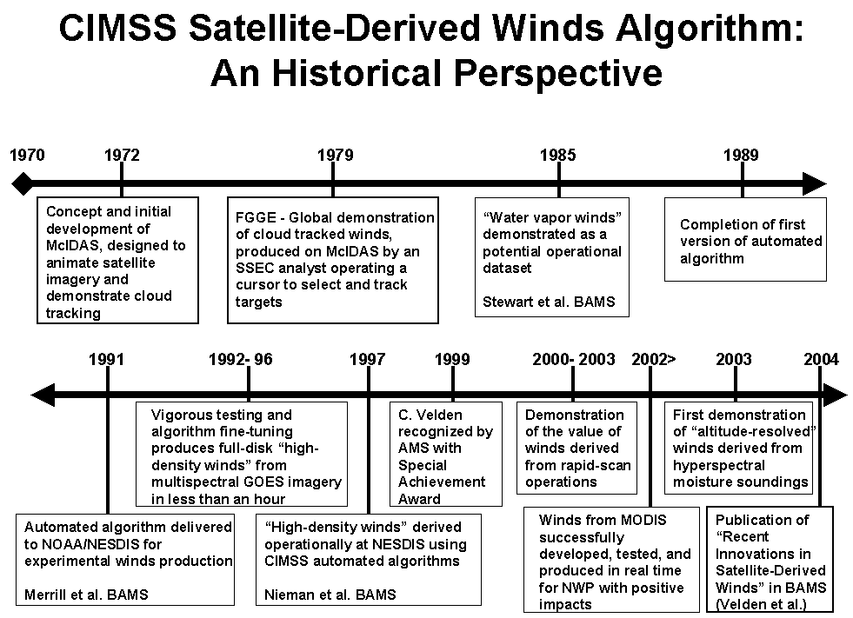

APPENDIX B − Vector Processing Error FLAG Values
FLAG Error description
Wind targeting and tracking errors (cumulative)
0 | No error
1 | U−component departure from guess
2 | V−component departure from guess
3 | U and V−component departure from guess
10 | U−component acceleration
20 | V−component acceleration
30 | U and V−component acceleration
40 | Possible land feature

Wind targeting and tracking errors (non−cumulative)
100 Band wind guess
200 Correlation error
300 Search box off top/bottom of image
400 Target box off edge of image
500 Pixel brightness out of bounds (noisy lines)
600 Bad image navigation
700 Target box off top/bottom of image
800 Search box off edge of image
1000 Target outside of latitude/longitude boundaries
1500 Zenith angle failure
2000 Target outside of pressure minimum/maximum

Wind editing and post−processing errors (non−cumulative)
3000 Resultant wind outside of lat/lon limits
4000 Slow vectors
5000 RF analysis flagged winds
6666 Postprocessing error
7777 QI value below threshold

APPENDIX C − Wind Vector Output File format structure
The GWIN format structure defines the storage layout of each wind vector contained within the wind vector file. The GWIN format structure contains 120 data elements. These values are stored in two distinct blocks. The first block contains the row header values. These seven values are shared among all wind vectors in a particular row. The second block contains the data records. There are 113 individual values stored for every wind vector derived. The first 61 elements are the vector information values, with the remaining 52 values representing four repeat groups. The repeat groups represent the values obtained when calculating wind vectors between image pairs (up to four different pairs can be stored).
All data values are stored in the format structure as an integer or long. Character values are converted to integer values when stored and back to character values when read from the wind vector file.
Units Legend :
CYD − yyyyddd (yyyy=year, ddd=Julian date)
HMS − hhmmss (hh=hour, mm=minutes, ss=seconds)
DEG − degrees (compass heading (north=0, west=270) or map coordinate location)
MPS − meters/second
MB − hPa or millibars
K − degrees Kelvin
(Scale) values are 10^{X}, and represent the floating point value stored as an integer. Scale values are contained within the GWIN format structure file.
Row Header These values repeat for each pair of images used to track wind sub−vectors. For a typical group of three images, there will be two repeat groups. First repeat group contains the sub−vector values determined with images one and two, while the second contains the sub−vector values for
Value | Format | Units (scale) | Description
DAY1 | Integer | CYD | Julian date
HMS1 | Integer | HMS | Time (UTC)
CMAX | Integer |  | Total number of vectors in row
SATD | Character |  | Satellite ID name
PROD | Character |  | Wind vector product (WV or CDFT)
SID | Integer |  | Satellite ID number
PDCR | Character |  | Wind set producer country
Data Record
Vector Information
Value | Format | Units (scale) | Description
MOD |  |  | not used
FLAG | Integer |  | Error flag
TYPE | Character |  | Wind type (sensor/band)
LAT | Long | DEG (4) | Latitude location
LON | Long | DEG (4) | Longitude location
DIR | Integer | DEG | Final wind direction
SPD | Integer | MPS | Final wind speed

PW | Integer | MB |  | Final height assignment
TC | Integer | K (2) |  | Cloud temperature at final height
CE |  |  |  | not used
CH | Character |  |  | Height assignment method
PW58 | Integer | MB |  | CO2 Slicing height assignment
TC58 | Integer | K (2) |  | CO2 Slicing temperature
CE58 |  |  |  | not used
QC58 | Integer |  |  | CO2 Slicing quality control
PW8A | Integer | MB |  | H2O Intercept height assignment
TC8A | Integer | K (2) |  | H2O Intercept temperature
CE8A |  |  |  | not used
QC8A | Integer |  |  | H2O Intercept quality control
PWHI | Integer | MB |  | WV histogram height assignment
TCHI | Integer | K (2) |  | WV histogram temperature
CEHI |  |  |  | not used
QCHI | Integer |  |  | WV histogram quality control
PWWI | Integer | MB |  | IR window height assignment
TCWI | Integer | K (2) |  | IR window temperature
CEWI |  |  |  | not used
QCWI | Integer |  |  | IR window quality control
TCOL |  |  |  | not used
WM | Integer |  |  | Cloud tracking metric
DIRG | Integer | DEG |  | Final guess wind direction (from WE)
SPDG | Integer | MPS (1) |  | Final guess wind speed (from WE)
GTYP |  |  |  | not used
DDIR | Integer | DEG |  | DIR−DIRG vector difference
DSPD | Integer | MPS (1) |  | SPD−SPDG vector difference
SGRD |  |  |  | not used
SGSP |  |  |  | not used
SDEL |  |  |  | not used
ODIR | Integer | DEG |  | Original wind direction (from WW)
OSPD | Integer | MPS (1) |  | Original wind speed (from WW)
OPW | Integer | MB |  | Original height assignment (from WT)
TSIZ | Integer |  |  | Target box size
TLAG | Integer |  |  | Search box size
RFI | Integer | (2) |  | Initial Recursive Filter quality flag
RFF | Integer | (2) |  | Final Recursive Filter quality flag
ODDG | Integer | DEG |  | Original guess vector (from WW)
OSPG | Integer | MPS (1) |  | Original guess vector (from WW)
STDV | Integer | (1) |  | Target box BT standard deviation
GRAD | Integer | (1) |  | Target box BT gradient
LINE | Integer | MB |  | Height assignment (from CKCIRRUS)
ELE | Integer |  |  | Target element (LINE was target line)
LAND | Integer |  |  | Land flag (1=land, 2=water)
MASK | Integer |  |  | Cloud flag (1=clear sky, 2=cloud view)
ZEN | Long | DEG (4) |  | Zenith angle from satellite subpoint
PWT |  |  |  | not used
PWB |  |  |  | not used
 |  |  | 82

TLT |  | not used
TLB |  | not used
TEM1 | Integer | Temporary − QI value
TEM2 | Integer | Temporary − Cloud Base height
TEM3 | Integer | Temporary − Cloud Base temperature
TEM4 |  | not used
Repeat Group

images two and three.
Value | Format | Units (scale) | Description
IDAY | Integer | SYD | Date of first image in pair
ITIM | Integer | HMS | Date of first image in pair
TLAT | Long | DEG (4) | Latitude of sub−vector
TLON | Long | DEG (4) | Longitude of sub−vector
TDIR | Integer | DEG | Direction of sub−vector
TSPD | Integer | MPS (1) | Speed of sub−vector
CORR | Integer | (2) | Target correlation of sub−vector
ERR | Integer |  | Acceleration error flag of sub−vector
TAVG | Integer | (1) | Sub−vector target box average
TRAN | Integer | (1) | Sub−vector target box range
TSTD | Integer | (1) | Sub−vector target box standard deviation
TGRA | Integer | (1) | Sub−vector target box gradient
COLD |  |  | not used

APPENDIX D − Context File

There are five main sections within each context file: PATHS, GRIBS, FILES, VALUES, and MISCELLANEOUS.

PATHS

The PATHS input values are the complete path names for the directories in which the different winds algorithm input/output files are stored. The first parameter on each line is the descriptor name, the second parameter is the absolute path to the directory containing the file(s), and the third is a short description/comment. The path names can be up to 80 characters long.

Descriptor Name Description/Comment
GRIBPATH Model guess files (GRIB format).
IMAGEPATH Satellite triplet set and height assignment images.
WINDPATH Wind vector output file.
GRIDPATH Wind vector output file in McIDAS GRID format.
SCHEMAPATH Wind vector format file “SCHEMA”.
RTCFPATH Radiative transfer coefficient files.
TOPOPATH High-resolution topography file “TOPOHRES”.

GRIBS

The files defined in the GRIBS section are the individual GRIB format files containing the numerical model output for each separate parameter and level. The GRIB file names can be up to 100 characters long and must be contained in the GRIBPATH directory defined in the context file. Lists of GRIB file descriptors are presented below. The first parameter is the data field type. The second parameter is the file name for the particular GRIB file described by the third parameter, which describes the grib file type and level.

Type Description
TEMP Air temperature at 13 levels
DEWP Dew point depression at 6 levels (1000 to 300 mb)
HEIGHT 1000 mb heights
MSLP Mean sea level pressure at surface
U Wind u-component at 10 levels (1000 to 100 mb)
V Wind v-component at 10 levels (1000 to 100 mb)

Currently, there are 13 numerical model levels expected (in mb) :

Level Number Pressure Levels (mb)
1 1050 (surface)
2 1000
3 850
4 700
5 500
6 400
7 300
8 250
9 200
10 150
11 100
12 70
13 50

Values are read and stored in arrays for each data field type. The temperature, dew point depression, and U and V component arrays can contain up to 13 levels of data, although dew point depressions usually are not defined above 300 mb. Two additional GRIB files containing 1000 mb heights and mean sea level pressure are also needed in order to estimate the surface parameter types for the radiative transfer calculations. Missing GRIB files will be filled with "missing data" values.

FILES

The FILES section contain the names of the input satellite data files, the output wind vector file, and the grid file output during execution of the Recursive Filter wind editing routine, if desired. For entries that are not available or used, the value “MISG” should be entered. These file names can also be overridden using command line keyword entries in various winds algorithm routines, however it is recommended that a context file is utilized to minimize errors and maximize continuity between the various routines.

Two height assignment images can be specified for derivation of the wind vector pressure heights. Up to five images may be used in the derivation of wind vectors.

Parameter Description
ARA1 First image in wind vector image set.
ARA2 Second image in wind vector image set.
ARA3 Third image in wind vector image set.
ARA4 Fourth image in wind vector image set (if desired).
ARA5 Fifth image in wind vector image set (if desired).
HARA1 First height assignment image (infrared image)
HARA2 Second height assignment area (water vapor image, if used).
MDF Wind vector output file.
GRID Grid output file from Recursive Filter editing command.

VALUES

The parameters in the VALUES section define run-time control variables utilized during the wind vector derivation process. They can be modified for specific satellites and channels in order to optimize various functions of the individual winds algorithm routines. All of these parameters can be overridden using command line keywords, but it is recommended that the context file values are used when calculating a set of wind vectors in order to retain continuity between the different winds algorithm routines.

Parameter Description
LLAG Line size for target tracking search area.
ELAG Element size for target tracking search area.
LSIZ Line size for target selector/analysis box.
ESIZ Element size for target selector/analysis box.
QCU U-component quality control criterion (m/s difference).
QCV V-component quality control criterion (m/s difference)
LATN Northern latitude extent of target/wind vector derivation.
LATS Southern latitude extent of target/wind vector derivation.
LONW Western longitude extent of target/wind vector derivation.
LONE Eastern longitude extent of target/wind vector derivation.
PMAX Maximum pressure of cloud height assignment.
PMIN Minimum pressure of cloud height assignment.
MAXB Maximum acceptable image brightness temperature.
MINB Minimum acceptable image brightness temperature.
ROW Input/output row number within wind vector file (MDF).

MISCELLANEOUS

The parameters in the Miscellaneous section control selected run-time input/output functions for various wind vector derivation routines. Many of these parameters can also be overridden using command line keyword entries.

Parameter Definition
ALL Obtain all possible targets within image.
OUT Output vector information at end of job to screen.
INIT Initialize output wind file/row (used for reanalysis).
WTRM Cloud tracking metric (LP, EN, CC, NM, MC).

EXAMPLE CONTEXT FILE

*** PATHS ***
GRIBPATH /home/guess/nogaps/12z/ path to input GRIB files
IMAGEPATH /home/stevew/mcidas/data/ path to input image files
WINDPATH /home/stevew/mcidas/data/ path to input/output wind file
GRIDPATH /home/stevew/mcidas/data/ path to output grid file
SCHEMAPATH /home/stevew/mcidas/data/ path to schema file "SCHEMA"
RTCFPATH /home/stevew/windco/data/ path to RTE Coefficient files "*RTCF"
TOPOPATH /home/stevew/windco/data/ path to topography file "TOPOHRES"

*** GRIBS ***
TEMP 00600_000020air_temp sfc temperature
TEMP 00600_010000air_temp 1000mb temperature
TEMP 00600_008500air_temp 850mb temperature
TEMP 00600_007000air_temp 700mb temperature
TEMP 00600_005000air_temp 500mb temperature
TEMP 00600_004000air_temp 400mb temperature
TEMP 00600_003000air_temp 300mb temperature
TEMP 00600_002500air_temp 250mb temperature
TEMP 00600_002000air_temp 200mb temperature
TEMP 00600_001500air_temp 150mb temperature
TEMP 00600_001000air_temp 100mb temperature
TEMP 00600_000700air_temp 70mb temperature
TEMP 00600_000500air_temp 50mb temperature
DEWP 00600_010000dwpt_dprs 1000mb dew point depression
DEWP 00600_008500dwpt_dprs 850mb dew point depression
DEWP 00600_007000dwpt_dprs 700mb dew point depression
DEWP 00600_005000dwpt_dprs 500mb dew point depression
DEWP 00600_004000dwpt_dprs 400mb dew point depression
DEWP 00600_003000dwpt_dprs 300mb dew point depression
HEIGHT 00600_010000geop_ht 1000mb heights
MSLP 00600_000000pres mean sea level pressure
U 00600_010000wnd_ucmp 1000mb u wind component
U 00600_008500wnd_ucmp 850mb u wind component
U 00600_007000wnd_ucmp 700mb u wind component
U 00600_005000wnd_ucmp 500mb u wind component
U 00600_004000wnd_ucmp 400mb u wind component
U 00600_003000wnd_ucmp 300mb u wind component
U 00600_002500wnd_ucmp 250mb u wind component
U 00600_002000wnd_ucmp 200mb u wind component
U 00600_001500wnd_ucmp 150mb u wind component
U 00600_001000wnd_ucmp 100mb u wind component
V 00600_010000wnd_vcmp 1000mb v wind component
V 00600_008500wnd_vcmp 850mb v wind component
V 00600_007000wnd_vcmp 700mb v wind component
V 00600_005000wnd_vcmp 500mb v wind component
V 00600_004000wnd_vcmp 400mb v wind component
V 00600_003000wnd_vcmp 300mb v wind component
V 00600_002500wnd_vcmp 250mb v wind component
V 00600_002000wnd_vcmp 200mb v wind component
V 00600_001500wnd_vcmp 150mb v wind component
V 00600_001000wnd_vcmp 100mb v wind component

*** FILES ***
ARA1 AREA4182 first satellite image
ARA2 AREA4181 second satellite image
ARA3 AREA4183 third satellite image
ARA4 MISG fourth satellite image
ARA5 MISG fifth satellite image
HARA1 AREA7199 first height assignment image
HARA2 AREA7199 second height assignment image
MDF MDXX4018 wind file
GRD GRID4018 output grid file

*** VALUES ***
LLAG 21 search box line size
ELAG 37 search box element size
LSIZ 15 target box line size
ESIZ 15 target box element size
QCU 10 quality control U criterion
QCV 10 quality control V criterion
LATN 60 north latitude coverage limit
LATS 0 south latitude coverage limit
LONW 120 west longitude coverage limit
LONE 20 east longitude coverage limit
PMAX 1000 maximum acceptable cloud pressure
PMIN 100 minimum acceptable cloud pressure
MAXB 250 maximum acceptable brightness value
MINB 20 minimum acceptable brightness value
ROW 1 input/output row number in wind file

*** MISCELLANEOUS ***
ALL YES obtain every possible target
OUT YES output vector information at end of job
INIT NO initialize output wind file
WTRM LP cloud tracking metric

