CIMSS Research Toward Determining Global Three-Dimensional Winds by Tracking Features In Temporal Sequences of Polar Weather Satellite Humidity and Ozone Retrievals FY23

A Proposal to

The National Oceanic and Atmospheric Administration
National Environmental Satellite Data and Information Service
Center for SaTellite Applications and Research (STAR)

Program: JPSS Proving Ground/Risk Reduction

For the Period
1 July 2023 – 30 June 2024

Support Requested: $150,000
Total Task I: $5,352
Total Task II: $144,648

Task |  | Project Total | Task 1 | Task 2
Task 2.1 |  | $150,000 | $144,648 | $5,352

Submitted by the
University of Wisconsin-Madison

On behalf of

The Cooperative Institute for Meteorological Satellite Studies (CIMSS)
Space Science and Engineering Center (SSEC)
at the University of Wisconsin-Madison
1225 West Dayton Street
Madison, Wisconsin 53706

Dr. David Santek Dr. Tristan L’Ecuyer
Principal Investigator Director, CIMSS

Brenda Egan, Managing Officer Pre-award
Research and Sponsored Programs

April 2023

NOAA’s Mission: Science, Service, and Stewardship
To understand and predict changes in climate, weather, oceans, and coasts,
To share that knowledge and information with others, and
To conserve and manage coastal and marine ecosystems

NOAA’s Long-Term Goals:
Weather-Ready Nation: Society is prepared for and responds to weather-related events

NOAA Strategic Plan-Mission Goals
- Serve society’s needs for weather and water
- Support the nation’s commerce with information for safe, efficient and environmentally sound transportation
- Provide critical support for the NOAA mission

Cross-Cutting Priorities
- Accurate and reliable data from sustained and integrated earth observing systems
- An engaged and educated public with an improved capacity to make scientifically informed environmental systems
- Diverse and constantly evolving capabilities in NOAA’s workforce

CIMSS Research Themes
Theme 1. Satellite Meteorology Research and Applications
Theme 2. Satellite Sensors and Techniques
Theme 4. Education and Outreach

CIMSS Tasks
Task I: Administrative Activities – CIMSS Management, Education, Outreach
Task II: Research involving direct collaboration with NOAA scientists, including research collaborations with ASPB scientists

NOAA Funding Source: Satya Kalluri /NOAA/NESDIS/JPSS
Contact Information : Satya.Kalluri@noaa.gov / 301-683-3510
Contact #2: Nazmi Chowdhury /NOAA/NESDIS/JPSS
Contact #2 Information: Nazmi.Chowdhury@noaa.gov / 301-713-7192

Brief Summary:
CIMSS proposes to track features in global profile retrievals of humidity and ozone derived from AIRS and CrIS radiances on Aqua, NOAA-20, and NOAA-21 (and possibly SNPP). Retrieval products will be generated using the Dual Regression (DR) method that derives atmospheric profiles, surface parameters, and cloud properties simultaneously under clear and cloudy conditions from any of the current hyperspectral infrared (IR) sounders at single field-of-view (SFOV) resolution. With three CrIS and one AIRS instrument flying in the afternoon orbit, time sequences of these global humidity and ozone profile fields enable feature tracking to determine atmospheric motion vectors (AMVs).

Table of Contents
Introduction 4
CIMSS CA Task I: CIMSS management support, including General Education and Outreach Activities 4
Project Lead: Wayne Feltz 4
Total Task I Budget: $5,352 4
CIMSS Support: 4
CIMSS CA Task II: Research involving direct collaboration with NOAA scientists, including ASPB scientists 4
Task 2.1: CIMSS Research Toward Determining Global Three-Dimensional Winds by Tracking Features In Temporal Sequences of Polar Weather Satellite Humidity and Ozone Retrievals FY23 4
Project Lead: Dr. David Santek 4
Budget $144,648 4
NOAA/ASPB Collaborators: Satya Kalluri (NOAA/NESDIS) 4
Management, Facilities and Reporting 10
Vitae 13
UW-Madison CIMSS Data Sharing Plans 18
Task 2.1: CIMSS Research Toward Determining Global Three Dimensional Winds by Tracking Features In Temporal Sequences of Polar Weather Satellite Humidity and Ozone Retrievals FY23 18

Introduction

CIMSS CA Task I: CIMSS management support, including General Education and Outreach Activities

Project Lead: Wayne Feltz

Total Task I Budget: $5,352

CIMSS Support:

Project Description
Task I activities are related to the overall management of CIMSS, as well as general education and outreach activities. These are activities that support the operation of CIMSS; provide outreach platforms to transmit CIMSS science to varied audiences; train and develop future scientists in the workforce, and provide capabilities requested under the Federal Funding Opportunity NOAA-NESDIS-NESDISPO-2023-2007660, but which are not tied to a specific project or projects. Task I funding includes partial funding/salary support for the CIMSS PI/Director, Tristan L’Ecuyer, and other CIMSS management support staff, travel, and visiting researcher support. Also, inclusive of Task I are educational and outreach activities including support of post-docs and graduate students within CIMSS not assigned to specific projects or research; support of undergraduate research interns; development of community outreach, education, and training programs; and support for CIMSS education and outreach staff. The inclusion of Task I for all CIMSS submissions are based on NOAA requirement as part of the FY23 Funding Guidance Memo directive, with a provided target value of ~3.7% of Task II and III activities.

CIMSS CA Task II: Research involving direct collaboration with NOAA scientists, including ASPB scientists

Task 2.1: CIMSS Research Toward Determining Global Three-Dimensional Winds by Tracking Features In Temporal Sequences of Polar Weather Satellite Humidity and Ozone Retrievals FY23

Project Lead: Dr. David Santek
CIMSS Support Scientists: Elisabeth Weisz, Paul Menzel, Tim Olander, Richard Dworak

Budget $144,648

NOAA/ASPB Collaborators: Satya Kalluri (NOAA/NESDIS)

2.1.1) Project description
CIMSS proposes to track features in global profile retrievals of humidity and ozone derived from AIRS and CrIS radiances on Aqua, NOAA-20, and NOAA-21 (and possibly SNPP). Retrieval products will be generated using the Dual Regression (DR) method that derives atmospheric profiles, surface parameters, and cloud properties simultaneously under clear and cloudy conditions from any of the current hyperspectral infrared (IR) sounders at single field-of-view (SFOV) resolution. With three CrIS and one AIRS instrument flying in the afternoon orbit, time sequences of these global humidity and ozone profile fields enable feature tracking to determine atmospheric motion vectors (AMVs). Tracking features in retrieval fields rather than in the radiance images enables the estimation of wind profiles at retrieval-determined heights. This approach has been demonstrated from the successive AIRS overpasses in polar regions, but now can be tested globally.

2.1.2) Background and Previous Work
Santek et al. (2019) note that “a recognized deficiency in the global observing system is an accurate depiction of the 3D structure of the global wind field. Knowledge of the wind field is essential to our understanding of general circulation and to accurately define the atmospheric state for the initialization of numerical weather prediction models. However, the 3D structure of the global wind field is generally unobserved.” They show that current tracking of atmospheric features in a time sequence of multispectral images to produce AMVs (Atmospheric Motion Vectors) have data voids, especially in the middle troposphere which is often related to inaccurate height assignment. Tracking features in atmospheric profile retrievals of humidity or water vapor (WV) and ozone concentrations has been suggested as a height-assigned alternative. This would yield the total horizontal wind including the ageostrophic component that is key to understanding atmospheric dynamics. Ageostrophic circulations play a significant role in the dynamics of weather systems from the mid- and high-latitudes (e.g., synoptic scale baroclinic waves) and into the tropics (e.g., low-level jets). Initial studies with repeat coverage in the polar regions by the Atmospheric Infrared Sounder (AIRS) have shown that (1) AIRS AMVs compare favorably to co-located imager AMVs for a six-week period, as evidenced by a zero-speed bias with a standard deviation of 3.5 ms⁻¹, (2) the impact per AIRS moisture AMV is very good, as they are ranked higher than all other satellite-derived wind datasets, and (3) the neutral, or slightly positive, forecast impact due to the addition of the AIRS retrieval AMVs is encouraging as these AMVs are only in the polar region, but they have an impact in the longer-range forecast over the northern hemisphere.

With the advent of several hyperspectral sounders in the afternoon orbit, three Cross-track Infrared Sounders (CrIS) and the long-lived AIRS, it is now possible to track features globally twice per day from time sequences of profile retrievals generated by successive overpasses of the CrIS and AIRS. When NOAA-21 is fully commissioned and operational, it will have an equator crossing time at 1330 local time, roughly 50 minutes (half an orbit) ahead of NOAA-20. Suomi-NPP will orbit between the two, about 25 minutes away from each. From AIRS and this triad of CrIS measurements, it will be possible to generate global profile retrieval fields separated in time and thus provide the opportunity to generate height-assigned AMVs from the resulting humidity and ozone fields. An example of the coverage from the ascending and descending orbits of the retrieval from NOAA-20 CrIS data on 15 October 2022 of the 500 hPa relative humidity (RH) using the Dual-Regression (DR) retrieval algorithm is shown in Figure 2.1.1.
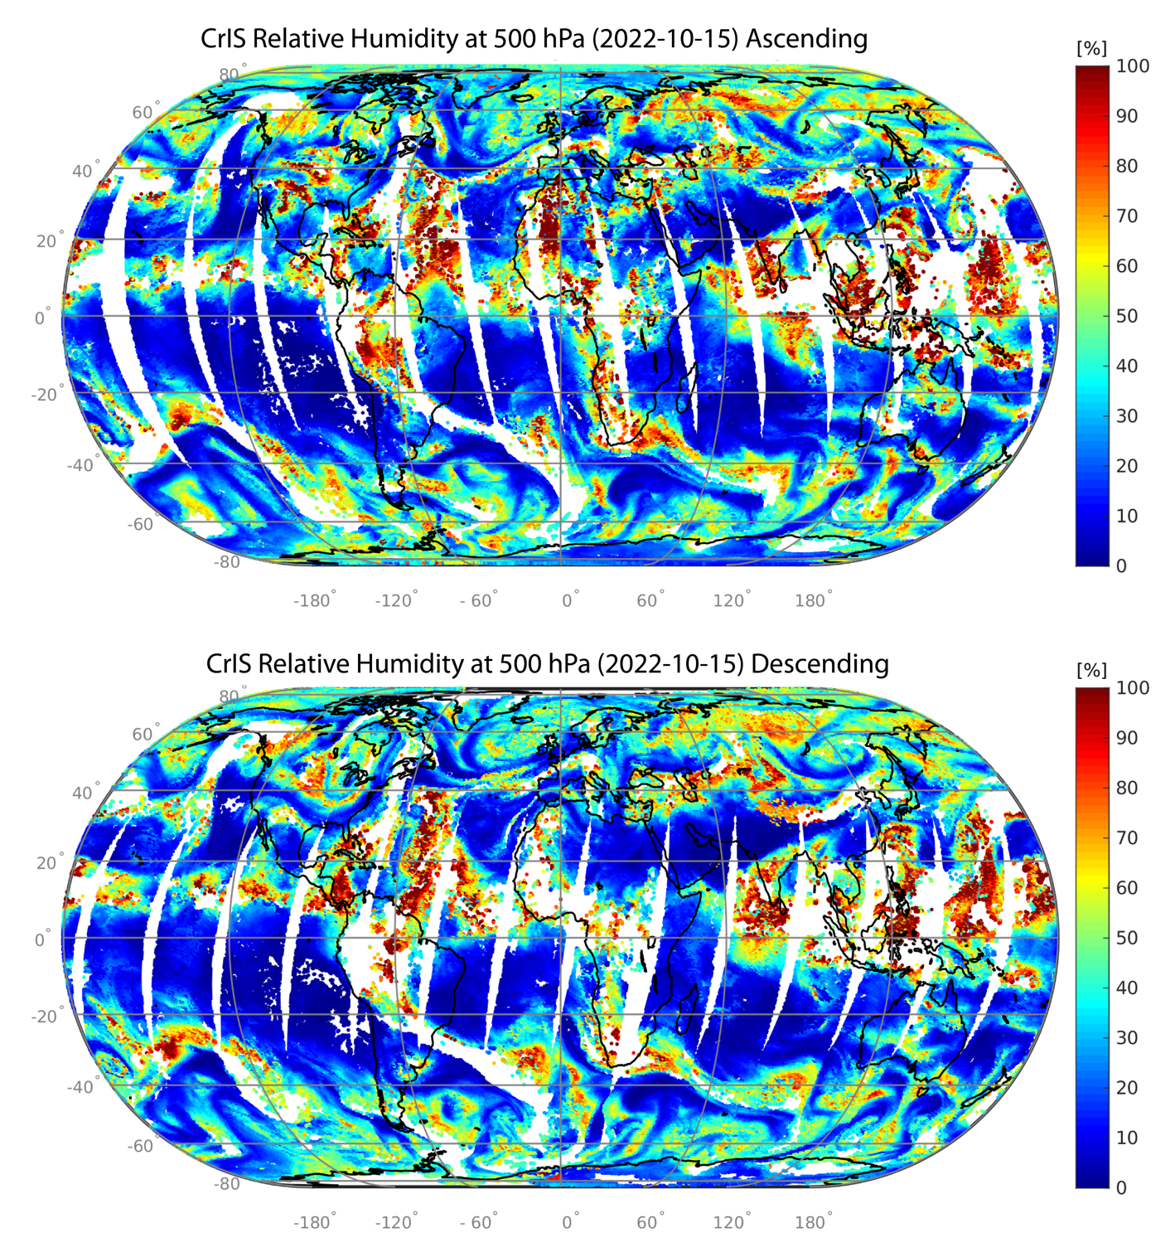
Figure 2.1.1. NOAA-20 CrIS 500 hPa RH retrievals from the ascending (top) and descending (bottom) orbits on 15 Oct 2022.

The coverage has some holes from the cloud coverage but overall offers ample opportunity to track features and produce good mid-level tropospheric AMVs. A caveat to the CrIS triad is that SNPP CrIS must be switched from long IR spectral coverage to mid-wave (only one of the two is possible due to an instrument failure late in its life). Until this happens, AIRS offers a viable third set of measurements complementing the CrIS measurements from NOAA-20 and -21; AIRS will be drifting from 1335 local time equator crossing to later times in 2023 gradually ending up at 1550 local time in 2026. Figure 2.1.2 (adapted from Santek et al. 2019) illustrates the coverage and vertical distribution of 3D winds from AIRS retrievals over the north pole region on 6 January 2011 at 1200 UTC. Winds from 200 to 100 hPa are tracked in ozone retrievals and winds from 700 to 300 hPa are tracked from humidity retrievals.
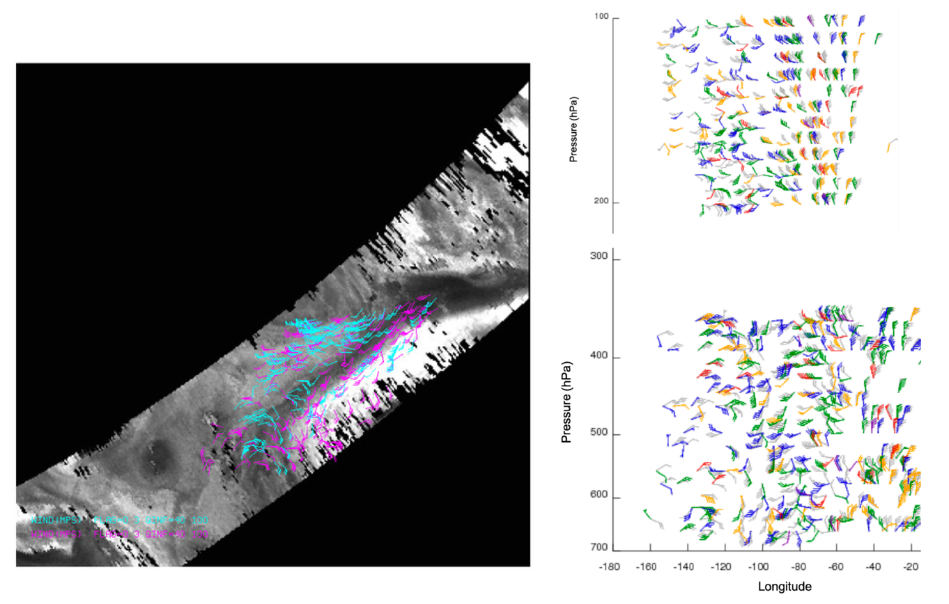
Figure 2.1.2. Coverage (left) and vertical distribution (right) of 3D winds from AIRS ozone and humidity retrievals over the north pole region on 6 January 2011 at 1200 UTC. Colors (in right panel) denote distance from the north pole with blue far and red close; gray is a model analysis.

CrIS and AIRS retrieval products will be generated using the Dual-Regression (DR) method (Smith et al. 2012, Weisz et al. 2013) that derives atmospheric profiles, surface parameters, and cloud properties simultaneously under clear and cloudy conditions from any of the current hyperspectral IR sounders (i.e., AIRS, IASI and CrIS) at single field-of-view (SFOV) resolution. It is noted that the DR retrieval approach is the core of the HSRTV (hyperspectral retrieval) software package, which is freely available through https://cimss.ssec.wisc.edu/cspp/. Since Dual-Regression is an IR-only algorithm the retrieval yield depends on the cloud coverage. Full temperature, humidity, and ozone profiles, i.e., from the surface to top-of-atmosphere (TOA), are provided only under clear-sky conditions. Under cloudy conditions, the profiles are given from the cloud top to TOA, although under thin and/or broken clouds levels below the clouds are included as well. As will be elaborated further below, WV and ozone feature tracking to produce AMVs is done in clear regions and above clouds only; therefore, a sufficiently large number of successive overlapping overpasses is required to collect enough clear profile retrievals to reach the desired yield in AMVs.

The AIRS polar methodology will be adapted for the global CrIS AMVs. In the polar regions, AIRS AMVs are extracted from a time sequence of three images. The input data files are three time-ordered humidity or ozone concentration images, each separated by 25 minutes, on many different pressure levels and forecast model output. Three images are used because consistency between vectors derived from each pair provides a measure of quality in the winds. The model output is used to determine a first guess for target tracking. The 6-, 9- or 12-hour forecasts are linearly interpolated to the middle-image time. From the middle image of the triplet, potential targets are determined by locating rectangular regions where the bi-directional gradient in the humidity or ozone exceeds a user-specified threshold. The target size is determined based on the spatial resolution of the images and the time interval between images. After evaluations of different target sizes, a 19 × 19 box was chosen as it resulted in the best coverage of AMVs. The search box, wherein the best match of the chosen target box is sought, in the first and third images is 40 × 40 pixels. Unlike tracking cloud or water vapor features in typical infrared images, tracking features in images from AIRS retrievals of humidity or ozone are in clear areas and above clouds. This results in regions that are unusable for deriving AMVs. If even one cloud pixel is in the target or search box, the cross-correlation cannot be computed, and that potential feature to track is discarded.

The initial target locations are investigated one by one to compute a displacement speed with the same feature at a time before and after the target image time. A first-guess wind is interpolated from the model forecast at the location and pressure surface on which the features are being tracked. This guess is used to calculate a position in the first and third images of the sequence where the feature should be. The image data within the target and larger search box regions are read. A cross-correlation is computed between the target and sub-regions throughout the search box for the first pair of images. The highest correlated point between the target array within the search box is found and the vector displacement between these two points is calculated. This process is then repeated for the second image pair. Once the intermediate wind vectors are determined, acceleration checks are performed. The intermediate vectors are compared to each other. If the difference in the u- or v-component is greater than 10 ms⁻¹, this vector is flagged as poor quality. The intermediate vectors are then compared to an interpolated model forecast wind vector. Departures greater than 10 ms⁻¹ from the guess u- and v-components are flagged for each wind vector, although these are still considered good wind vectors. Slow vectors, speeds less than 3 ms⁻¹, are flagged as unusable. There are two independent routines used for automatic quality control (QC) of the AMVs. The first utilizes the statistical properties of a computed quality indicator for each wind vector using several consistency tests. The Quality Indicator (QI) for each AMV is calculated by estimating consistency in the intermediate wind vector pairs, spatial coherence, and (optionally) the deviation from the model grid. This second quality measure is a two-stage, three-dimensional objective analysis, based upon a recursive filter analysis, which utilizes weighted numerical model information as a background field.

2.1.3) Proposed Activities for 2023-2024
Retrieval-tracked atmospheric motion vectors (AMVs) will be generated for ten days with global coverage. AMVs will be derived on 45 pressure levels from the lower stratosphere (100 hPa) through much of the troposphere, down to 800 hPa. Depending on the level, winds will be derived from ozone retrievals above the tropopause or humidity retrievals in the troposphere. The horizontal and vertical coverage of the AMVs will be analyzed to determine:
(a) completeness of global coverage (how extensive are the gaps created by IR retrieval difficulties in clouds
(b) the representativeness of the wind profiles to atmospheric flow at different levels (especially at mid-levels in the troposphere)
(c) similarity with ERA5 wind determinations

If possible, coverage over a hurricane situation will be studied, as an accurate depiction of mid-level flow is likely to have a significant positive impact on the track and intensity forecasts.

Results will be summarized and presented at appropriate symposia; after early feedback, a paper will be submitted for peer-review publication. This work will demonstrate the feasibility of global retrieval winds, illustrate the coverage possible, and quantify the difference with other motion estimates prevalent in ERA5 analyses. It builds on the retrieval and feature-tracking expertise at CIMSS. Model impact studies, if found desirable, would be proposed subsequently.

2.1.4) Milestones
The following is a list of the tasks and an estimated completion time in months after the start of the project. The nominal period of performance is 1 July 2023 – 30 June 2024.
- Identify a 10-day case study and acquire the CrIS and AIRS granules [+1 month]
- Apply the Dual-Regression (DR) algorithm to the CrIS and AIRS dataset to retrieve vertical profiles of ozone and humidity [+3 months]
- While #2 is in progress, begin processing in parallel the vertical profiles of ozone and humidity to create pressure level maps, and reproject the maps from the instrument swath to an appropriate geographic projection [+4 months]
- Organize the maps to facilitate the derivation of global 3D winds, using either triplets or doublets of images, depending on the swath overlap [+5 months]
- Derive the winds on 45 pressure levels for the 10-day period [+6 months]
- Analyze the derived 3D winds in terms of completeness in global coverage, both in the vertical and horizontal [+8 months]
- Validate the derived AMVs by comparing them to the ERA5 reanalysis wind field [+8 months]
- Write and submit a paper on the results of the project [+10 months]

2.1.5). References
Santek, D, S. Nebuda, and D. Stettner, 2019: Demonstration and Evaluation of 3D Winds Generated by Tracking Features in Moisture and Ozone Fields Derived from AIRS Sounding Retrieval. Remote Sens. 2019, 11, 2597, https://doi.org/10.3390/rs11222597
Smith, W.L., E. Weisz, S. Kirev, D.K. Zhou, Z. Li, E.E. Borbas, 2012: Dual-Regression Retrieval Algorithm for Real-Time Processing of Satellite Ultraspectral Radiances. J. Appl. Meteorol. Clim. 2012, 51, 1455–1476, https://doi.org/10.1175/JAMC-D-11-0173.1
Weisz, E., W.L. Smith, N. Smith, 2013: Advances in simultaneous atmospheric profile and cloud parameter regression-based retrieval from high-spectral resolution radiance measurements. J. Geophys. Res. Atmos. 2013, 118, 6433–6443, https://doi.org/10.1002/jgrd.50521

Management, Facilities and Reporting

Management and Personnel
The Cooperative Institute for Meteorological Satellite Studies (CIMSS) is a scientific research unit within the Space Science and Engineering Center (SSEC). Dr. David Santek, Principal Investigator, has a successful research career working in the atmospheric sciences in studies pertaining to derivation of atmospheric winds from space-based passive infrared remote sensing data. Dr. Santek’s research has involved the extensive use of NOAA weather satellite data. Dr. Santek will be responsible for overseeing and managing the activities described above. The CIMSS Executive Director - Science, Wayne Feltz, will also provide oversight to the project. Mr. Feltz oversees the day to day operations of SSEC scientific research, and provides management and coordination for the more than 50 current CIMSS research grants and contracts. The Project Leaders provide the important expertise to the research components of this proposal. Project Leaders are responsible to the Director for their individual research tasks, presenting their results at meetings and conferences, and submitting reports on their findings.

Facilities
The Space Science and Engineering Center (SSEC) is a research facility within the Office of the Vice Chancellor for Research and Graduate Education (OVCRGE) of the University of Wisconsin-Madison. The Center is located in a 15 story building on the UW-Madison campus. Within SSEC, the Cooperative Institute for Meteorological Satellite Studies (CIMSS) was established in 1980 to formalize and support cooperative research between the National Oceanic and Atmospheric Administration’s (NOAA) National Environmental Satellite, Data, and Information Service (NESDIS) and the UW-Madison’s Space Science and Engineering Center. Sponsorship and membership of the Cooperative Institute was expanded to include the National Aeronautics and Space Administration (NASA) in 1988. CIMSS was awarded continuing status as a NOAA Cooperative Institute following an open competition in 2020.

CIMSS was established to focus on the development and testing of the operational utility of new weather satellite observing systems to improve weather forecasts. University-based Cooperative Institutes such as CIMSS have proved to be very cost effective organizations for conducting research and development programs. Much of the work at CIMSS focuses on developing weather analysis and forecasting techniques that best use the latest advances in meteorological satellite sensing techniques and technology. The key applications of this satellite data are to improve operational forecasts and warnings. A major activity within CIMSS involves the validation activities for current and future satellite imagers and sounders. In particular, validation of the existing GOES imager and sounder products and Suomi NPP/JPSS imager and sound products is an ongoing process that involves both NOAA employees and University scientists working within CIMSS. Dedicated high altitude aircraft missions of the NASA ER-2 have obtained observations from accurate airborne instrumentation (HIS/SHIS/NASTI) coincident with satellite observations and with ground based observations. Other ongoing activities at CIMSS include the validation of the NOAA JPSS/SUOMI NPP Cross-track Infrared Sounder (CrIS) radiances, forward model calculations and retrieval algorithm and validation of the VIIRS instrument on the JPSS platform. An important further connection is the UW-Madison involvement in the Department of Energy Atmospheric Radiation Measurement (ARM) program, which is making routine measurements of atmospheric radiation and atmospheric state parameters at three diverse climate (tropical, mid-continental, arctic) sites.

CIMSS serves as an international center for research on the interpretation and uses of operational and experimental satellite observations for a wide variety of atmospheric and oceanographic studies and for their potential operational applications. The CIMSS international role is further strengthened through its visiting scientist program that hosts sabbaticals for several foreign scholars each year.

CIMSS relationship with the UW-Madison Department of Atmospheric and Oceanic Sciences provides graduate student research support to more than fifteen students per year. The education/research center link provides an excellent path for young scientists entering geophysical fields.

Interactive Computing and Visualization
The Man computer Interactive Data Access System (McIDAS) was first developed at SSEC over 45 years ago. During that period, it has continued to evolve with advances in technology. McIDAS-X is an integral element in meteorological support for launches at Johnson Space Center and Cape Canaveral, in converting many satellite data formats into data for AWIPS at NWS locations, in staging data from NOAA CLASS, and in many other NASA and NOAA centers and systems. It has been distributed to several hundred locations through the world and is the backbone of the national meteorological systems of Australia, Spain, Greece and other nations.

SSEC is a national leader in on-going research into better data visualization techniques for the physical sciences. The VisAD software package developed at SSEC has been distributed worldwide to hundreds of research organizations interested in high performance visualization techniques required for large, complex data sets. VisAD is used as the software core for the next generation of McIDAS, McIDAS-V. McIDAS-V is freely available from the McIDAS website and via EUMETCast and is being used worldwide for integrating different meteorological data types into 2- and 3-D displays.

SSEC Data Center
The SSEC Data Center's Satellite Data Services receives real-time, full resolution data from the GOES-16/17/18, Himawari, COMS, METEOSAT, MTSAT, FY2, FY4 geostationary satellites, and NOAA, METOP, JPSS, Suomi NPP, EOS and FY1/3 polar orbiting (POES) meteorological satellites. It also receives the Eumetcast, GEOnetcst, NWS NOAAport data streams and other alphanumeric, grid, model and radar data feeds. The Data Center has been archiving GOES data since 1978, and has access to all GOES imager and sounding data since that time. Over 8 TBs of data are ingested daily, of which, approximately 1TB of the geostationary data are archived. The current archive of geostationary data exceeds 2.9 PBs, all of which are online and accessible by UW CIMSS researchers.

Reporting

An Annual Progress Report will be provided via grants online to the NOAA Grants Management Division and to the NOAA/NESDIS/STAR Cooperative Institute Program Officer as part of the CIMSS Cooperative Agreement reporting requirements.

Vitae

David A. Santek
Cooperative Institute for Meteorological Satellite Studies
Space Science and Engineering Center /University of Wisconsin-Madison
1225 West Dayton St, Madison, WI 53706
Tel: (608) 263-7410; E-mail: dasantek@wisc.edu

Institution: Space Science and Engineering Center (SSEC), Madison, WI
Position: Scientist/Program Manager
Education: Ph.D., Atmospheric and Oceanic Sciences, University of Wisconsin-Madison, 2007
M.S., Meteorology, University of Wisconsin-Madison, 1978
B.S., Atmospheric and Oceanic Sciences, University of Michigan, 1975

Professional Background:
2008 – present Scientist, SSEC, UW-Madison
2004 – 2008 Program Manager/Researcher, SSEC, UW-Madison
1996 – 2004 Software Development Manager, SSEC, UW-Madison
1991 – 1996 Team Leader, SSEC, UW-Madison
1978 – 1991 Science Applications Developer, SSEC, UW-Madison

Relevant Experience:

D. Santek has been associated with many satellite data and remote sensing projects during his entire career at SSEC, including visualization, product development, data ingest, numerical model impacts. Also, he has led the development of several innovative techniques for extracting winds from satellite data.

He is the Principal Investigator (PI) and development manager for the Man computer Interactive Data Access System (McIDAS), a weather satellite data visualization and analysis tool in continuous development since 1973, supported, and used worldwide at many national weather services, research institutes, universities, and industry.

Since 1995, he is the PI of the SSEC Data Ingestor (SDI) system. This hardware/software system ingests and decodes data from the GOES-R GRB, GOES GVAR, NOAA AVHRR, and MTSAT. It has been used at NOAA national centers, NWS offices, NASA centers, and international locations. The SDI, along with the McIDAS software, was used during the GVAR era in NOAA/NESDIS operations for generating satellite images that were distributed in real-time to the National Weather Service.

Since 2001, he has led the development and continues to be the CIMSS task leader for the satellite-derived winds algorithm as applied to data from polar orbiting satellites. This has been applied to data from MODIS (Terra and Aqua) and AVHRR (NOAA and Metop). These polar satellite winds are used in more than 10 Numerical Weather Prediction (NWP) centers worldwide, including NCEP, NASA/GMAO, US Navy, ECMWF, and the UK Met Office.

Select Publications:
Santek, D., S. Nebuda, D. Stettner, 2019: Demonstration and Evaluation of 3D Winds Generated by Tracking Features in Moisture and Ozone Fields Derived from AIRS Sounding Retrievals. Remote Sens., 11, 2597.
Santek, D., R. Dworak, S. Nebuda, S. Wanzong, R. Borde, I. Genkova, J. García-Pereda, R. Galante Negri, M. Carranza, K. Nonaka, K. Shimoji, S.M. Oh, B.-I. Lee, S.-R. Chung, J. Daniels, J., W. Bresky, 2019: 2018 Atmospheric Motion Vector (AMV) Intercomparison Study. Remote Sens., 11, 2240.
Santek, D., 2010: The Impact of Satellite-Derived Polar Winds on Lower-Latitude Forecasts, Monthly Weather Review, 138(1), 123-139.
Boukabara, S., et al., D. Santek, 2015: S4: An O2R/R2O Infrastructure for optimizing, satellite data utilization in NOAA numerical modeling systems: A significant step toward bridging the valley of Death. Bull. Amer. Meteor. Soc., 97(12), 2359-2378.
Hoover, B. T., D. A. Santek, A. Daloz, Y. Zhong, R. Dworak, R. A. Petersen, and A. Collard, 2017: Forecast Impact of Assimilating Aircraft WVSS-II Water Vapor Mixing Ratio Observations in the Global Data Assimilation System (GDAS). Wea. Forecasting, 32, 1603–1611, https://doi.org/10.1175/WAF-D-16-0202.1
Lazzara, M. A., R. Dworak, D. Santek, D, B. Hoover, C. Velden, J. Key, 2014: High-Latitude Atmospheric Motion Vectors from Composite Satellite Data, Journal of Applied Meteorology and Climatology, 53(2), 534-547.
Lukens, K. E., K. Ide, K. Garrett, H. Liu, D. Santek, B. Hoover, R. Hoffman, 2022: Exploiting Aeolus Level-2B Winds to Better Characterize Atmospheric Motion Vector Bias and Uncertainty, Atmos. Meas. Tech. Discuss. [preprint], https://doi.org/10.5194/amt-2021-277, accepted, 2022.
Poli, P., et al., D. Santek, 2017: Recent Advances in Satellite Data Rescue. Bull. Amer. Meteor. Soc., 98, 1471–1484, https://doi.org/10.1175/BAMS-D-15-00194.1
Posselt, D.J., L. Wu, K. Mueller, L. Huang, F.W. Irion, S. Brown, H. Su, D. Santek, and C.S. Velden, 2019: Quantitative Assessment of State-Dependent Atmospheric Motion Vector Uncertainties. J. Appl. Meteor. Climatol., 58, 2479-2495, https://doi.org/10.1175/JAMC-D-19-0166.1

UW-Madison CIMSS Data Sharing Plans

Task 2.1: CIMSS Research Toward Determining Global Three-Dimensional Winds by Tracking Features In Temporal Sequences of Polar Weather Satellite Humidity and Ozone Retrievals FY23

1. Principal Investigator contact and types of environmental data and information to be created during the course of the project

David Santek, Task Lead, Cooperative Institute for Meteorological Satellite Studies (CIMSS), University of Wisconsin-Madison, dave.santek@ssec.wisc.edu, 608-263-7410

This project will not generate publicly available environmental information.

2. Type of collection method

N/A

3. Tentative date by which data will be shared

N/A

4. Standards to be used for data/metadata format and content

N/A

5. Policies addressing data stewardship and preservation

N/A

6. Procedures for providing access to data and prior experience in publishing such data

N/A

