Task 2.3: CIMSS Support for Generation of 3D Atmospheric Motion Vectors from the ECO1280 Nature Run

Project Lead: David Santek

Budget :$125,000
CIMSS Support Scientists: Tim Olander, Dave Stettner, Rich Dworak

NOAA/ASPB Collaborator: Lidia Cucurull (NOAA/OAR/AOML)

2.3.1) Project Description
A system was developed at CIMSS to generate simulated Atmospheric Motion Vectors (AMVs) by tracking moisture features from a time sequence of model output grids. This has been applied to regional and global models, including the GEOS-5 Nature Run (G5NR). These simulated AMVs provide a 3D distribution of winds on pressure surfaces which can be used in Observing System Simulation Experiments (OSSEs), for example, to evaluate the impact of passive winds derived from future hyperspectral infrared instruments.

The goal of this project is to apply the AMV simulator to the ECMWF Cubic Octahedral (ECO1280) Nature Run grids and develop a configurable system to define satellite constellations and orbits to sample the AMVs for use in OSSEs described in Task 2.2.

2.3.2) Background/Accomplishments
The AMV simulator is based on the heritage winds algorithm developed and maintained at CIMSS over more than two decades. There are three components to the heritage algorithm: target selection, feature tracking, and quality control:
- From a time sequence of three grids, potential targets are determined in the middle time grid by locating rectangular regions where the bi-directional gradient in the humidity field exceeds a user-specified threshold.
- The initial target locations are investigated one by one to compute a displacement speed with the same feature at a time before and after the target grid time. A cross-correlation is computed between the target and sub-regions throughout the search box for the first pair of grids. The highest correlated point between the target array within the search box is found and the vector displacement between these two points is calculated. This process is then repeated for the second grid pair.
- There are two independent routines used for the automatic quality control (QC) of the AMVs. The first is a gross error check, which discards winds where the acceleration between the vector pairs is large. The second utilizes the statistical properties of a computed Quality Indicator (QI) for each wind vector by estimating consistency in the intermediate wind vector pairs and a 3D spatial coherence.

This algorithm was used to generate AMVs (winds) by tracking specific humidity features on eight tropospheric pressure levels (200, 250, 300, 400, 500, 600, 700, 850 hPa) from the 7 km G5NR. In order to simulate AMVs from a hyperspectral IR sounder, two additional steps were required:
- Winds were only retained in clear sky and above cloud by using a cloud-top pressure grid.
- Subsequently, those winds retained in #4 were sampled based on a low earth orbiting (LEO) satellite and a prescribed swath width; in this case, Starlink satellites in a 60º inclined orbit with a swath width typical of a hyperspectral IR instrument (e.g., CrIS scans +/- 50º resulting in a 2200 km swath).
The resulting AMVs for one time period (1-hour time window) are depicted as red wind barbs in Figure 2.3.1. From a single LEO satellite orbit, it requires an entire day of orbits to achieve global coverage of the winds.

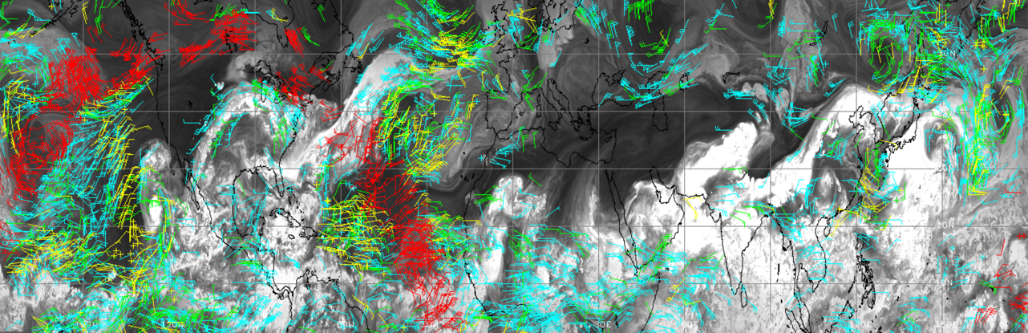
Figure 2.3.1: Winds derived from the G5NR moisture fields over the Northern Hemisphere on eight pressure levels, where yellow, green, cyan wind barbs are at low, middle, and high levels, respectively. The red wind barbs are those sampled by the Starlink orbit within a 1-hour time window.
In the first year of the project, we accomplished our goals which were to convert the AMV simulator to use the ECO1280 grids and implement our first version of an orbit and swath simulator. The result was the generation of 2 months (June and July 2016) of simulated clear sky and above cloud AMVs as viewed from nine LEO satellites flying in three time-separated triplets, in three orbits at local equator crossing times of 1330, 0930 0530. Figure 2.3.2 depicts the spatial coverage for one orbit (100 minutes). An example of the ECO1280 AMVs derived in a 3-hour window for the northern hemisphere, color-coded by pressure, is shown in Figure 2.3.3.

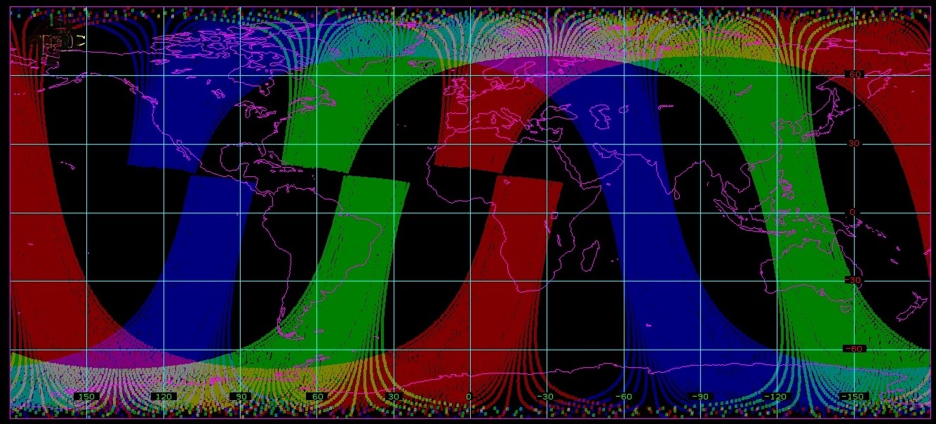
Figure 2.3.2: Polar-orbiting satellite swath coverage for a single orbit (100 minutes) from three satellite constellations at local equator crossing times of 0530 (red), 0930 (green), and 1330 (blue). The 1330 orbit is for NOAA-20 and the swath width is based on the CrIS instrument. The other two orbits were computed by modifying the right ascension of the ascending node of the NOAA-20 orbit.

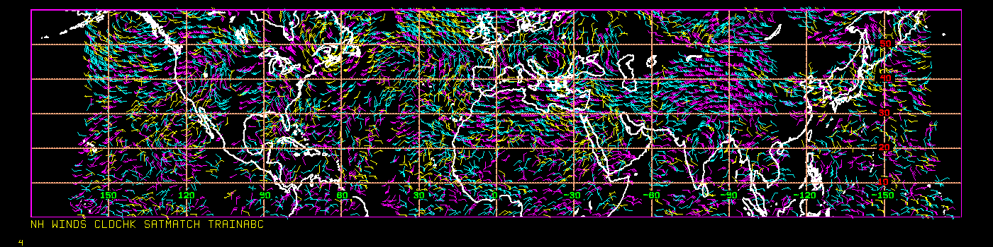
Figure 2.3.3: AMVs derived from the ECO1280 in a 3-hour time window covering latitudes from the equator to 60N. Yellow AMVs are below 700 hPa; cyan 400-700 hPa; and magenta above 400 hPa.
Initial statistics from this first case study are encouraging with the simulated AMVs having a u- and v-component wind bias of 0.1 to 0.3 m s⁻¹ and RMS difference of 2.0 to 2.5 m s⁻¹ when compared to the ECO1280 winds.

2.3.3) Proposed Work and Technical Approach:
There are three main goals for this second year: Refine the AMV simulator, generalize the orbit/swath simulator, and generate AMV datasets based on additional satellite configurations for OSSEs.

(1) Modifications are needed for the ECO1280 AMV simulator to correct anomalies that affect
<< 1% of the winds:
- There is a gross error check to ensure that the derived AMV u- and v-components do not deviate by more the 10 m s⁻¹ from the ECO1280 wind field. However, occasionally AMVs are retained that do not meet that threshold; although, they are discarded during post-processing. We will diagnose and correct the simulator code where the gross error check is originally applied, as this error may affect the quality control of the other winds.
- For AMVs derived centered near 0000 UTC (the day boundary), the post-processing step to assign a time to each AMV occasionally fails, resulting in AMVs being discarded. The AMV is assigned the time that the satellite is viewing that ground location, extracted from daily netCDF files. We suspect that for AMV times very close to 0000 UTC, the correct netCDF file is not being accessed.
(2) The first version of the satellite orbit/swath simulator is based on a triplet of satellites flying in formation with the same ground track. This results in complete swath coverage. Another possible satellite configuration is flying in orbits that are offset from each individual satellite, resulting in only partial swath overlap where the winds could be derived. This will require generalizing our current orbit simulator, and when implemented will be very powerful to examine orbits, swath overlap, and AMV coverage when defining future missions.

(3) Continue to generate AMVs for new simulated orbits. Also, improve the performance of the algorithm to reduce the amount of time needed to create new AMV datasets.

The final output continues to be a dataset of AMVs, sampled according to simulated LEO satellite orbit(s) and instrument specifications. The AMVs are stored in BUFR format, binned by model cycle, for use in OSSEs.

2.3.4) Milestones
The following list contains the tasks and an estimated completion time in months after the start of the project:
- Diagnose and correct anomalies (gross error check and time assignment) in the code that affect << 1% of the winds [+2 months]
- Manually configure an orbit configuration that results in only partial swath overlap and create an AMV dataset [+4 months]
- Generalize the orbit simulator to automatically handle orbits with only partial overlap [+5 months]
- As needed, create additional AMV datasets and improve overall performance [+4 to +9 months]
- Write and submit a paper on the AMV simulator [+9 months]

