Weighting Function Lab
GOES-16 Short Course
Urban Meteorology, NYC, 2018

When you look at Water Vapor imagery to ascertain regions of turbulence, a natural question might be: Where in the atmosphere is the information displayed in the water vapor imagery coming from? We know that water vapor absorbs energy in the region between 5 and 8 micrometers (see figure below), and that water vapor’s distribution in the atmosphere is variable, so that absorption (and re-emission) will occur at levels that vary from day to day, and with the synoptic situation.
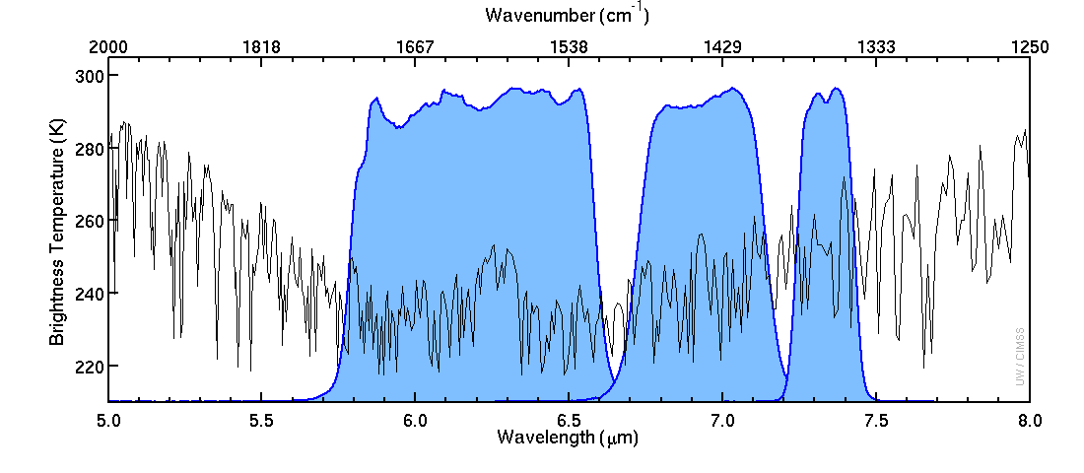
Band 10
(7.34 μm)
Band 9
(6.95 μm)
Band 8
(6.19 μm)
Figure 1: Spectral Responses for Bands 8-10 (shaded in blue) and the satellite-sensed temperature above a US Standard Atmosphere. Cooler temperatures in this region result from absorption of energy by water vapor
Weighting Functions describe from where in the atmosphere the energy sensed by the satellite originates. These weighting functions are calculated – assuming clear skies – using a radiative transfer model, and are available at each radiosonde station over North America at 0000 and 1200 UTC at this website: http://cimss.ssec.wisc.edu/goes/wf . Note that it can take several hours for the webpage to update because of transmission lags in the sounding data.
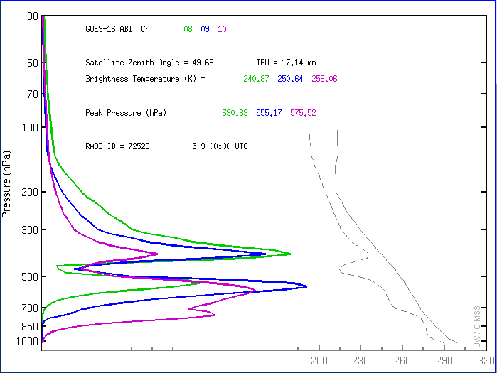
Figure 2: Weighting Functions for 72528 (KBUF) at 0000 UTC on 9 May 2018
Figure 2 (above) shows the weighting functions at Buffalo NY at 0000 UTC on 9 May 2018. Most of the 6.19 μm energy that is being sensed originates from about 700 mb, with a peak at 390 mb. Note how that thin layer of moisture at about 400 mb affects all the weighting functions – but absorption occurs more readily at 6.19 μm compared to the longer wavelengths so the peak for the longer wavelength channels is lower in the atmosphere. If that thin layer of moisture at ~400 mb were a bit thicker, perhaps the 6.95 μm weighting function would have a higher peak.
In this lab exercise, you’ll use (http://cimss.ssec.wisc.edu/goes/wf/examples/ABI/) a website that looks at Weighting Functions for theoretical atmosphere (The USA Standard Atmosphere, for example). Real-time Weighting Functions are at http://cimss.ssec.wisc.edu/goes/wf .
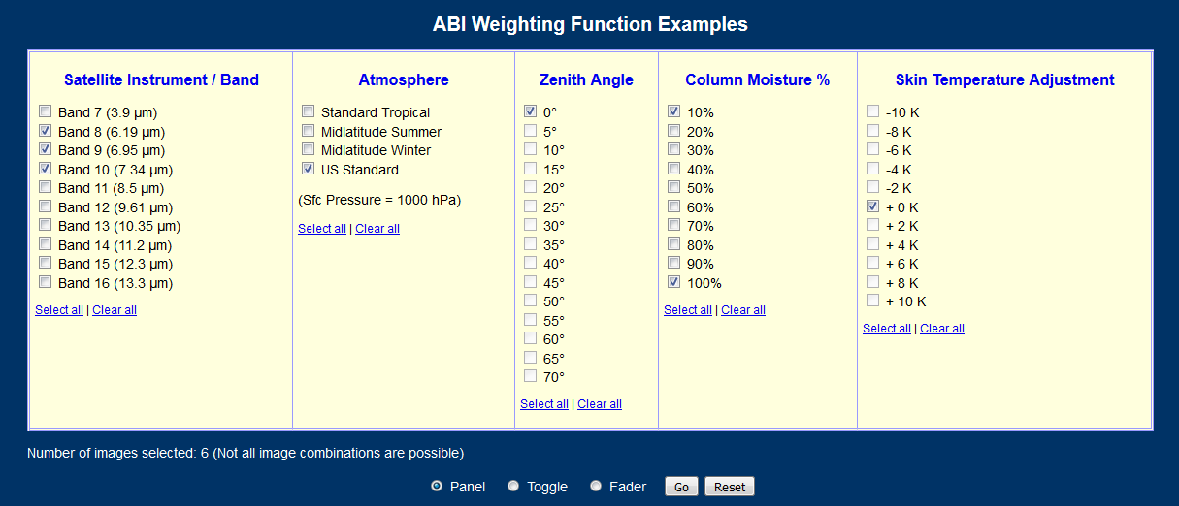
Figure 3 Weighting Function Selection Panel
Choose the three Water Vapor channels on ABI: 6.19, 6.95 and 7.34 μm, the US Standard Atmosphere, and column moistures of 10% and 100%. Click, and you’ll see six panels.
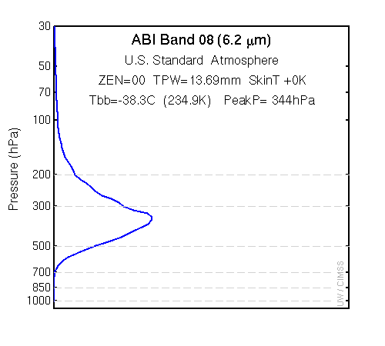 | 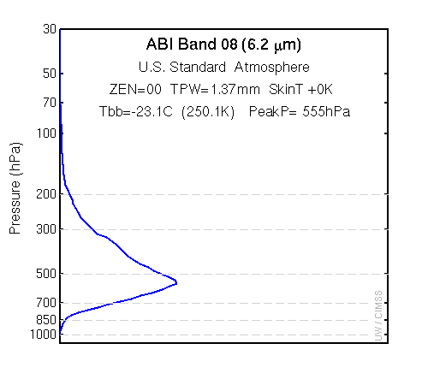
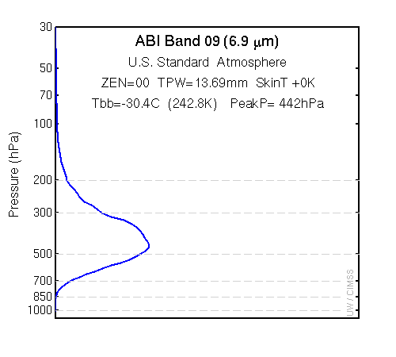 | 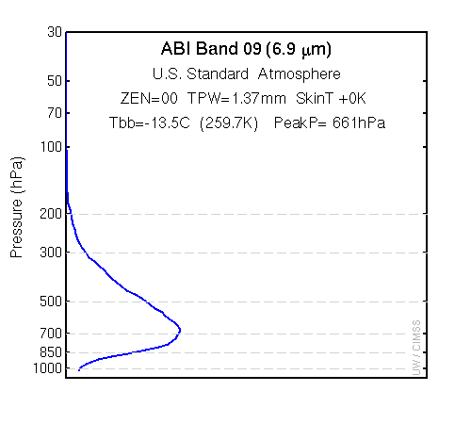
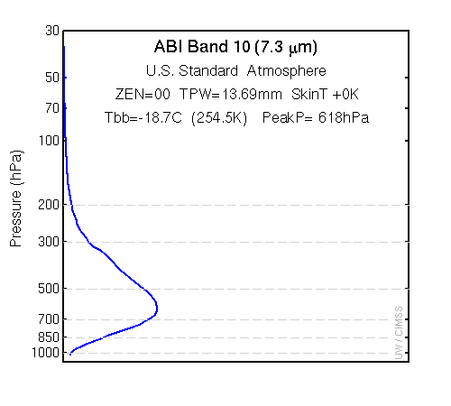 | 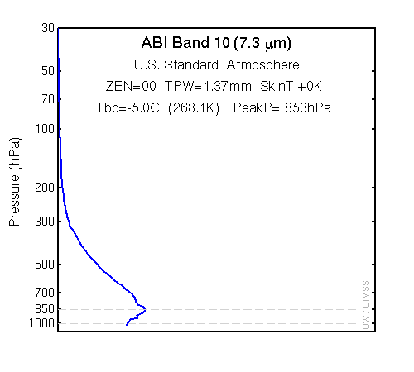

Based on the above, or what you have on your computer screen – they should match – answer the following questions.
- Which Water Vapor band has the coldest brightness temperature? _____________

- Experiment with the web application. Does the water vapor band with the coldest brightness temperature vary with satellite zenith angle, with moisture content, or with skin temperature adjustments? Circle the correct answer: Yes No.

- Make the skin temperature warmer. Compare the Midlatitude Summer and Midlatitude Winter atmospheres with 10% and 100% moisture content. Does the water vapor brightness temperature change (for upper-level or low-level Water Vapor – 6.19 μm or 7.34 μm) when the Skin Temperature changes? Why or why not?

- The outline of the coast of Lake Superior, or Hudson Bay, is occasionally visible in water vapor bands. In which band is this mostly likely to occur? Why? In which season is this most likely to occur, and why?

- Examine the Low-Level water vapor information in the Weighting Function lab by comparing Zenith Angles of 0 (that is, at the sub-satellite point, or nadir) and at 45 and 75 degrees. How does the brightness temperature change as the satellite zenith angle increases?

  - The Low-Level Water Vapor (7.34 μm) shows a strong system over the NW Territories of Canada. Two days later it is over the Great Lakes and it has warmed. Can you tell just from those two data points whether or not it has weakened? Why or why not?

